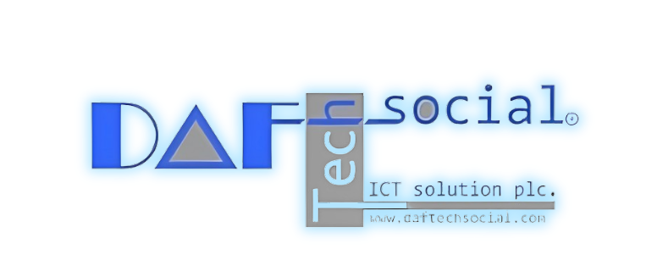

REQUIREMENT ANALYSIS DOCUMENT

VEHICLE PROFICIENCY ASSURANCE SYSTEM OROMIA TRANSPORT AGENCY

2024

Revision Summary

|  |  |  |  |
| --- | --- | --- | --- |
| Revision # | Revision Date | Description of change | Authors |
| 0.1 | May 17, 2024 | First Draft | Abeer Mohammed , Tamire G/Mariam ,  Hermela Tesfaye |
| 0.2 | June 10, 2024 | Template changes , comments on the general requirements of the Vehicle Proficiency  Assurancemodule | Abeer Mohammed, Tamire G/Mariam, Hermela Tesfaye |

Distribution

|  |  |  |  |  |
| --- | --- | --- | --- | --- |
| Recipient name | Title | Name of Deliverable | Date | Version |
| Oromia Transport Agency | VPA | Requirement Analysis document | May 17, 2024 | 0.1 |
| INSA | VPA | Requirement Analysis document | May 17, 2024 | 0.1 |
| Oromia Transport Agency | VPA | Requirement Analysis document | June 24, 2024 | 0.2 |
| INSA | VPA | Requirement Analysis document | June 24, 2024 | 0.2 |
| Oromia Transport Agency | VPA | Requirement Analysis document | July 10, 2024 | 0.3 |
| INSA | VPA | Requirement Analysis document | July 10, 2024 | 0.3 |

Document Approval

|  |  |  |  |
| --- | --- | --- | --- |
| Organization Responsibility | Name | Signature | Date |
|  |  |  |  |
|  |  |  |  |

Contents

Revision Summary i

Distribution i

Document Approval ii

Contents iii

List of Table vi

List of Figures vii

Executive Summary 1

General Information 2

Purpose of this document 2

Intended Audience 2

Definitions, Acronyms, and Abbreviations 3

1. Introduction 4

Overview 4

Purpose of the system 4

Scope 5

Objective 6

General Objective 6

Specific Objectives 6

1. Assumptions, Dependencies, constraints 7

Assumptions 7

Dependencies 7

Constraints 7

1. The current system 8

Overview of the current system 8

Business process model 9

Limitations 18

1. Proposed System 20

Overview 20

Product Perspective 21

User classes and characteristics 22

Product Features 24



**2024**

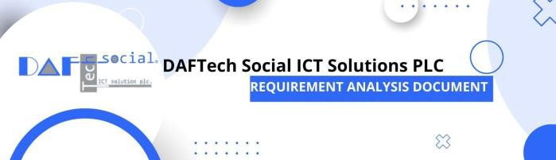

Operating Environment 26

Functional Requirements 28

1. Non-Functional Requirements 30

Overview 30

Security 30

Performance 31

Usability 32

Overview 32

User Benchmarks 32

User Interface Design 33

Maintainability 33

Overview 33

Modularity 33

Documentation: 33

Support 33

Reliability 34

System availability 34

Data integrity 34

Scalability 34

Overview 34

Scalability of Customers 34

Scalability of Concurrent Users 34

Scalability of Data 35

Scalability of Hardware 35

Disaster Recovery 35

Design 35

Data Backup: 35

1. Conceptual System model 36

Functional Models 36

Operational Scenarios 36

Use Case Model 53

1. Project Risk and Mitigation Strategies 132

General Statement 132

Detailed Risk and Mitigation 133



**2024**



References 137

Appendix A (Reports) 138



**2024**



List of Table

Table 1 Use case table 55

Table 2 Personal information use case 78

Table 3 new vehicle registration use case 79

Table 4 map vehicle to owner use case 80

Table 5vehicle approval use case 81

Table 6field and technical inspection use case 83

Table 7assign plate use case 83

Table 8issue ORC use case 84

Table 9 annual inspection use case 85

Table 10 issue AIS use case 86

Table 11 valuation use case 88

Table 12 assign owner use case 89

Table 13 change service type use case 90

Table 14 ban use case 91

Table 15Temporary deactivation use case 92

Table 16 lost material use case 93

Table 17 result of vehicle use case 93

Table 18 Give operator license use case 94

Table 19 organization registration use case 96

Table 20 Importer plate use case 97

Table 21 organization license use case 97

Table 22 user registration use case 98

Table 23 role and permission use case 99

Table 24 Activation user use case 100

Table 25 system registration use case 101

Table 26 stock registration use case 102

Table 27stock transfer use case 103

Table 28 inspection data use case 104

Table 29 online registration use case 105

Table 30 shelf registration use case 106

Table 31 folder registration use case 107

Table 32 Folder mapping use case 108

Table 33 file assign to officer use case 109

Table 34 risk management 136

List of Figures

Figure 1 new vehicle registration business process 10

Figure 2 annual inspection business process 11

Figure 3 vehicle valuation business process 12

Figure 4Service change business process 13

Figure 5 Ban Business process 14

Figure 6 temporary deactivation business process 15

Figure 7 lost material business process 16

Figure 8 Transfer business process 17

Figure 9 Cancelation business process 18

Figure 10 material replacement use case diagram 56

Figure 11 vehicle assign to officer use case diagram 57

Figure 12 vehicle file search use case diagram 58

Figure 13 vehicle folder mapping use case diagram 59

Figure 14 Folder registration use case diagram 60

Figure 15shelf registration use case diagram 61

Figure 16 system management use case diagram 62

Figure 17vehicle organization use case diagram 63

Figure 18 stock transfer use case diagram 64

Figure 19 stock registration use case diagram 65

Figure 20 Online booking use case diagram 66

Figure 21inspection organization use case diagram 67

Figure 22 temporary plate return use case diagram 68

Figure 23ban use case diagram 69

Figure 24service change use case diagram 70

Figure 25ownership change use case diagram 71

Figure 26 new vehicle registration use case diagram 72

Figure 27 annual inspection use case diagram 73

Figure 28 personal information registration use case diagram 74

Figure 29 public operator license use case diagram 75

Figure 30 payment use case diagram 76

Figure 31 user information sequence diagram 110

Figure 32 register vehicle sequence diagram 111

Figure 33 map vehicle to owner sequence diagram 112

Figure 34approve vehicle sequence diagram 113

Figure 35 field and technical inspection sequence diagram 114

Figure 36 plate assignment sequence diagram 115

Figure 37 issue ORC and AIS sequence diagram 116

Figure 38 annual inspection sequence diagram 117

Figure 39annual inspection sequence diagram 118

Figure 40 valuation sequence diagram 119

Figure 41operator license sequence diagram 120

Figure 42user registration sequence diagram 121

Figure 43stock registration sequence diagram 122

Figure 44 stock data sequence diagram 123

Figure 45 inspection organization sequence diagram 124

Figure 46user registration sequence diagram 125

Figure 47register vehicle information sequence diagram 126

Figure 48system setting sequence diagram 127

Figure 49shelf data sequence diagram 128

Figure 50 folder registration sequence diagram 129

Figure 51map vehicle sequence diagram 130

Figure 52 find file sequence diagram 131

Executive Summary

This document outlines the functionalities of the VPA, a core component of the Transport Management System (TMS). The VPA streamlines vehicle registration processes, encompassing ownership registration, changes in ownership and service type, temporary plate returns, and vehicle bans. It promotes safety through annual inspections, lost vehicle material management, and a dedicated Operator License module for public transport vehicles. Additionally, the VPA integrates Vehicle Organizations Management and stock management functionalities for a holistic approach.

Benefits:

* The VPA promotes efficiency and organization within the transportation landscape by:
* Automating registration processes.
* Simplifying vehicle ownership management.
* Enhancing safety through inspections and license management.
* Providing a centralized platform for data management.
* Enabling online services for user convenience.

This document serves as a foundation for further requirement analysis and development of the VPA.

General Information Purpose of this document

The sole purpose of this document is to document all requirements that were gathered during the

requirement elicitation stage and the development stage of the Vehicle Proficiency Assurance (VPA), and to document analysis results in narrowing the gap between requirements and the system design. VPA

Intended Audience

This document is primarily intended for two key audiences:

* Project Team Members: document serves as a foundational guide for all project team members throughout the entire VPA development lifecycle. It ensures a clear understanding of the system's functionalities and user needs.
* Consultants: The consultant is included as an intended audience for the Requirement Analysis document because their specialized expertise and independent perspective can provide valuable guidance and validation for the project. Consultants often have deep experience in the relevant domain, which allows them to identify potential gaps or alternative solutions that the internal team may have overlooked. Their review and endorsement of the requirements can lend credibility to the analysis, while also fostering better stakeholder engagement and knowledge transfer within the organization. By involving the consultant in the requirement analysis phase, the project team can leverage the consultant's insights to enhance the quality and effectiveness of the document.

Definitions, Acronyms, and Abbreviations

RAD Requirement Analysis Document

GUI Graphical User Interface

TSMS Transport Management System

ORC Ownership Registration Certificate (“Libre”)

AIS Annual Inspection Statement (“Bolo”)

API Application Programming Interface

VPA Vehicle Proficiency Assurance

1. Introduction Overview

This Requirement Analysis Document (RAD) serves to define and comprehensively address the

functional and non-functional requirements for the Vehicle Proficiency AssuranceService (VPA) module, the initial core component of the Transport Management System (TMS). As the first module slated for development and implementation, this document focuses exclusively on the VPA functionality within the broader TMS (Transport management System) framework. It outlines the module's purpose, functionalities, system interfaces, and overall operational scope.

Transport management system (TMS) is an advanced application which, without embodying intelligence as such, aims to provide innovative services relating to different modes of transport and traffic management and enable various users to be better informed and make safer, more coordinated, and 'smarter' use of transport networks.

Purpose of the system

The core purpose of the Vehicle Proficiency Assurance (VPA) is to automate and streamline the vehicle registration process. This translates to:

* + Increased efficiency: Replacing manual processes with a digital system reduces processing time and minimizes errors.
  + Improved data management: The VPA acts as a centralized repository for all vehicle registration data, ensuring accuracy, accessibility, and easier data analysis.
  + Enhanced user experience: The user-friendly interface simplifies vehicle registration and management tasks for users.
  + Streamlined administration: The system empowers administrators to manage user access, track activities, and generate reports efficiently.

Ultimately, the VPA aims to create a more organized and efficient vehicle registration ecosystem, benefiting both users and administrators.

Scope

In Scope

1. The VPA system will have three web applications one for the zonal and regional users of the agency, one for inspection organizations and one for clients of the agency. In addition to that it will have mobile application for operator license
2. The VPA system will have functionalities of the following business processes
   1. New vehicle Registration
   2. Annual Inspection with the following services
      1. Recording the result of annual inspections
      2. Machine integration with the machine result of the vehicle
      3. Owner for registering the vehicle’s annual result and fill other required fields for the service to be provided
   3. Change Ownership
   4. Change Service Type
   5. Ban/lift ban of Vehicle
   6. Temporary deactivation / reactivation of vehicles
   7. Transfer of vehicles from zone to the other zone and region
   8. Cancelation of vehicle
   9. Organization management of the following organizations
      1. Annual Inspection
      2. Repair Shop
      3. Spare Part Shop
      4. Importer
      5. Assembly Plant
      6. Dealer
      7. Tire repair shop
      8. Vehicle Rental
      9. Auto Club Consultant
      10. Rebuilder
      11. Performance Accessories
   10. Public API for inspection organizations and clients of the organization
3. Payment integration will be conducted with Telebirr, CBE Birr and Sinke mobile banking when the clients provide the necessary documentations.

Out of Scope

1. The developer will not configure The environments and the interactions between the environments like server network and so on
2. The end product will be delivered based on the functional and non-functional requirements of the RAD Document
3. The online service for the clients of the agency will be for registration of basic information of the clients and annual inspection of vehicles
4. Integration of third party organizations will be only with telebirr, CBE, Sinqe bank, custom office and inspection organizations if enough information is provided from the agency.



**2024**



Objective General Objective

The primary objective of this requirement analysis document is to define the functionalities and specifications for the Vehicle Proficiency Assurance (VPA) as well the non-functional requirements in a way that aligns with the Agency's needs and goals.

Specific Objectives:

1. Enhance Customer Satisfaction:
   * Reduce processing time for vehicle registration applications.
   * Improve the accuracy and completeness of registration data.
   * Offer user-friendly interfaces for easy access and interaction with the VPA.
   * Implement online services for convenient registration renewals and transactions (if applicable).
2. Promote Efficient and Transparent Service Delivery:
   * Automate manual registration processes to streamline workflows.
   * Design functionalities that ensure transparency and accountability in vehicle registration procedures.
   * Enable real-time data access for authorized personnel to facilitate informed decision- making.
3. Optimize Operational Costs:
   * Leverage technology to reduce resource utilization and minimize administrative overheads.
   * Streamline data management for efficient record keeping and retrieval.
   * Identify opportunities to streamline processes and eliminate redundancies.
4. Support System Sustainability:
   * Consider scalability to accommodate future growth in user base and data volume.
   * Ensure system design promotes maintainability and facilitates future upgrades.

By achieving these specific objectives, the VPA will contribute to the overall goal of improving customer satisfaction, service delivery, operational efficiency, and system sustainability for the Agency.

1. Assumptions, Dependencies, constraints

Assumptions

* + Stakeholders have a clear understanding of the current vehicle registration processes and challenges.
  + Required hardware and software infrastructure will be available to support the VPA implementation.
  + Users have basic computer literacy and internet access (if applicable for online services).
  + Legal and regulatory frameworks governing vehicle registration will remain relatively stable during development.

Dependencies

* + Successful implementation of the VPA depends on the availability of a reliable central database to store vehicle registration data.
  + Integration with existing government systems like Telebirr might be necessary and will require collaboration with relevant authorities.
  + User training and support mechanisms will be established to ensure user adoption and efficient system utilization.

Constraints

* + Budgetary limitations may influence the scope and functionalities of the VPA.
  + Development timelines need to be realistic and consider resource availability.
  + Data security and privacy regulations must be strictly adhered to during system design and implementation.
  + Existing IT infrastructure capabilities might impose limitations on certain functionalities.

1. The current system Overview of the current system

The existing system serves as the core platform for managing the vehicle services operations of the agency. The key functionalities of the system include:

* + New Vehicle Registration: This module handles the comprehensive registration process for new vehicles, capturing and storing all relevant vehicle and owner details, generating unique registration numbers and process of filling the field of field and technical inspection, payment process, assigning plates, ORC and AIS for the respective vehicles.
  + Annual Inspection: The system facilitates the annual inspection of registered vehicles, including scheduling inspections, recording inspection results, Assigning of AIS, and tracking compliance.
  + Valuation and Change of Ownership: This functionality manages the transfer of vehicle ownership, including updating registration details, conducting vehicle valuations, calculating associated fees.
  + Service Change Management: The system allows for the recording and tracking of vehicle service history including body changes, service and body changes as well engine changes.
  + Vehicle Ban and Lift: The system provides the capability to impose and lift vehicle bans, which may be necessary due to legal, regulatory, or safety-related reasons.
  + Temporary Deactivation: The system supports the temporary deactivation of vehicle registrations, such as during periods of maintenance or non-use.
  + Vehicle Transfer: This module enables the seamless transfer of vehicles from one to the other or on regional levels
  + Vehicle Cancelation: The system handles the permanent cancelation of vehicle registrations, such as in cases of vehicle scrapping or decommissioning.
  + Stock Management: The system includes functionality for managing the agency's stocks related to Plates, AIS and or ORC with features for tracking stock levels.
  + Archive Management: The system provides a comprehensive archive for storing and retrieving historical records and physical documents related to the vehicle.
  + Organization Management: This process manages the organizations/ stakeholders of the agency this organizations are categorized in to different categories such as
    - Annual Inspection Organization
    - Repair Shop
    - Spare Part Shop
    - Importer
    - Assembly Plant
    - Dealer
    - Tire Repair Shop
    - Vehicle Rental
    - Auto Club Consultant
    - Rebuilder
    - Performance Accessories

These organizations with their staff members, owner’s equipment’s, Rooms and compounds will be registered in addition license of the organization will be generated from the system.

* + User Management: The system includes user administration capabilities, allowing for the registration, role-based access control, and activity logging of system users.
  + Reporting: The system generates a variety of reports, such as vehicle registration statistics, inspection records, ownership changes, and other data-driven insights, to support analysis, compliance, and decision-making. This reports will be shown on Annex I

This robust set of core services demonstrates the system's critical role in managing the agency's vehicle-related operations and maintaining the integrity of the vehicle registration and management processes.

Business process model

This document outlines the business process for the Vehicle Registration and Management System (VPA) module. The process will be broken down into the key services provided by the agency, and then each service will be further broken down into the individual steps within that service.

1. New Vehicle Registration Service

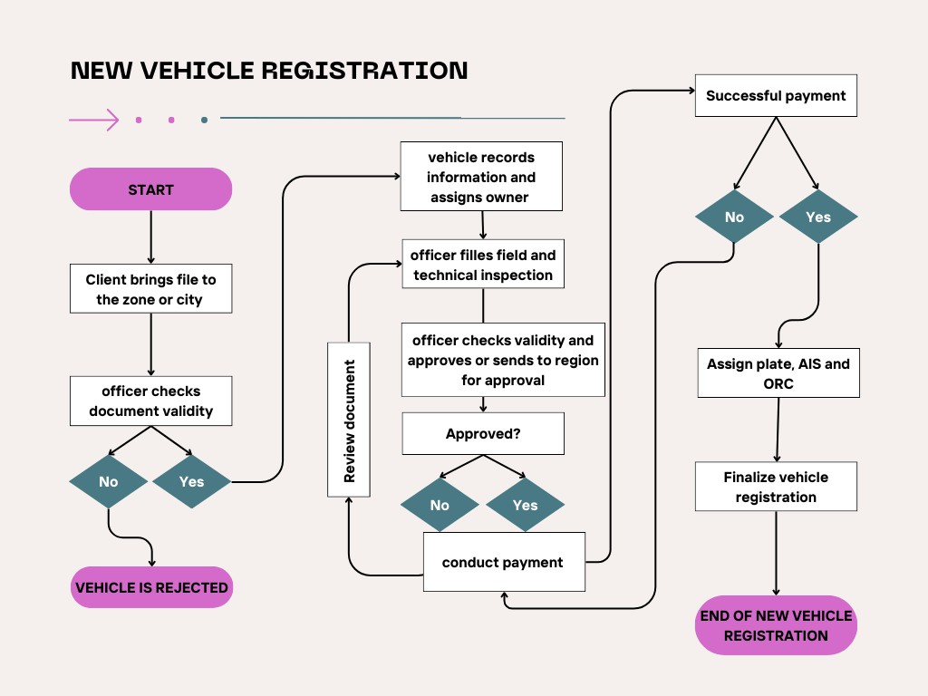

*Figure 1 new vehicle registration business process*

1. Annual Inspection service

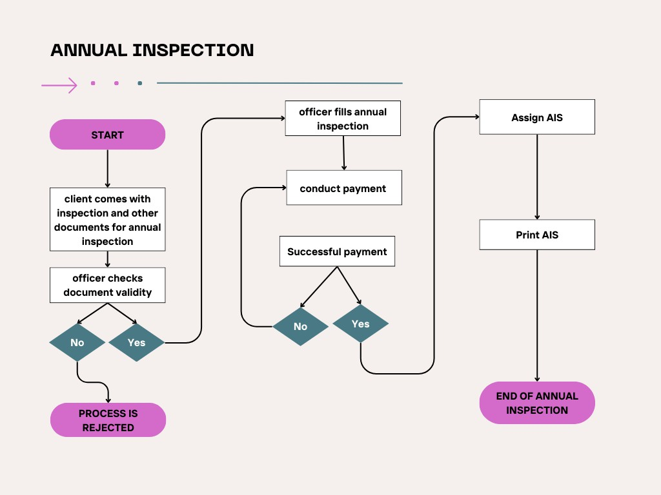

*Figure 2 annual inspection business process*

1. 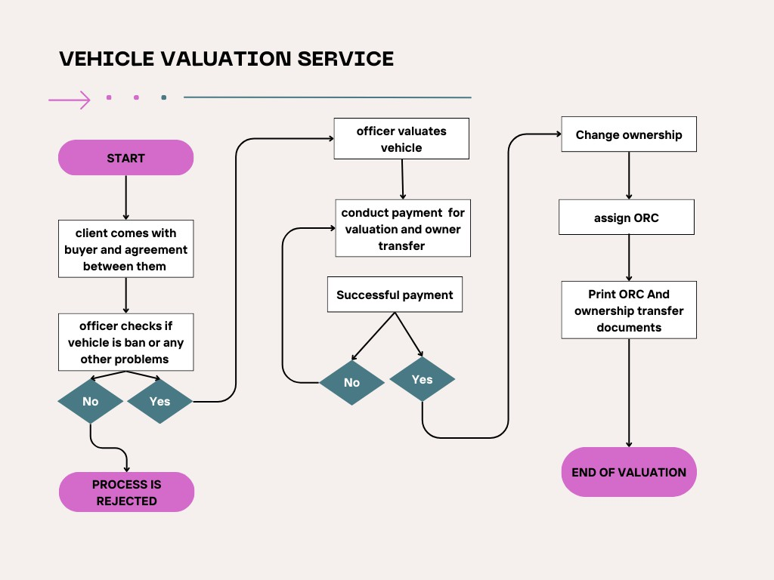Vehicle Valuation Service

*Figure 3 vehicle valuation business process*

1. Service change service

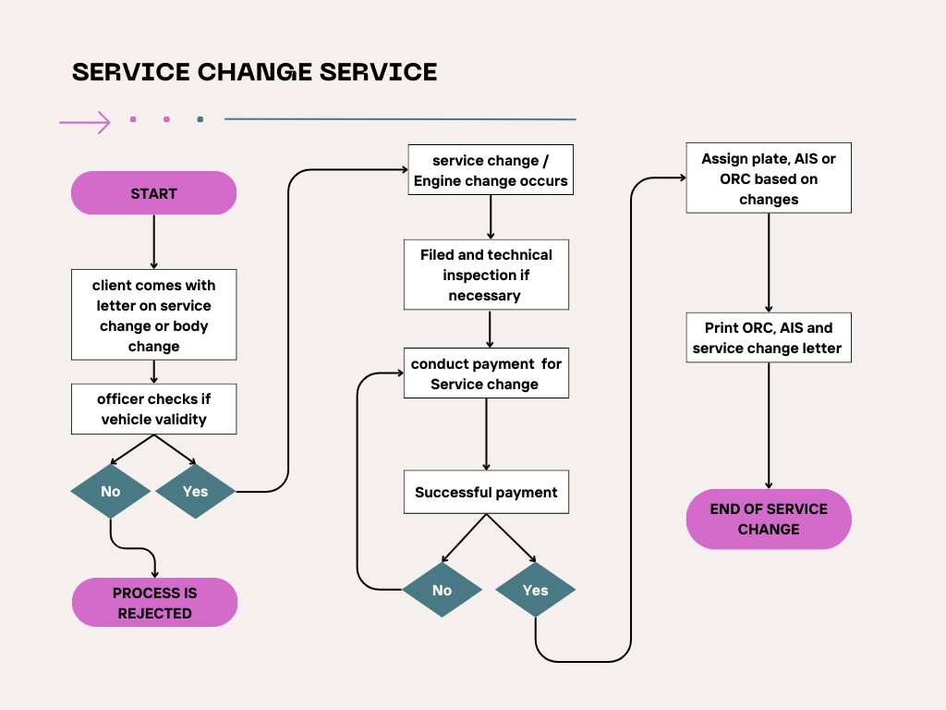

*Figure 4Service change business process*

1. Ban Service

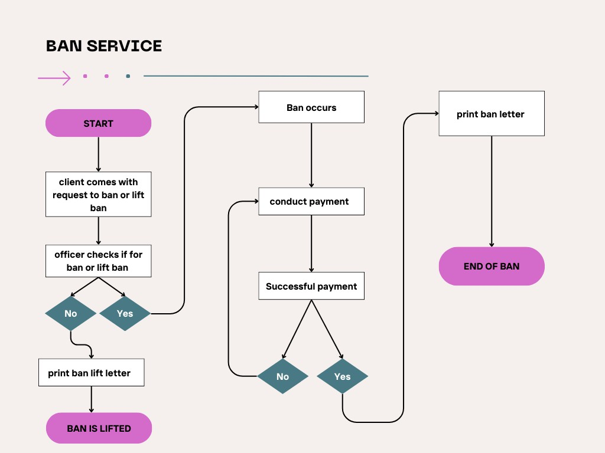

*Figure 5 Ban Business process*

1. Temporary Deactivation

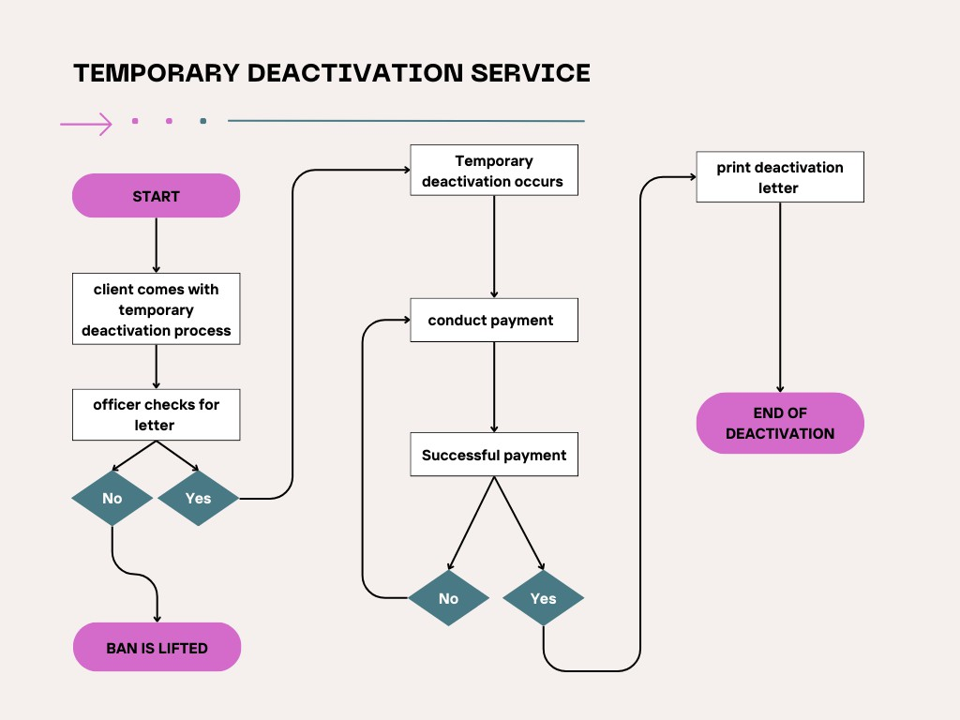

*Figure 6 temporary deactivation business process*

1. Replacing of Lost material

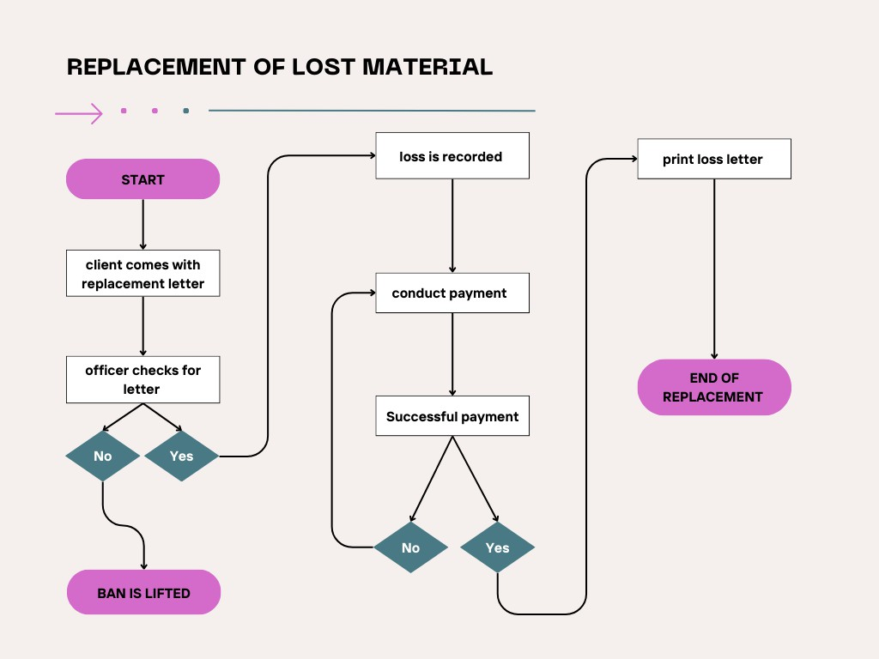

*Figure 7 lost material business process*

1. File Transfer Service

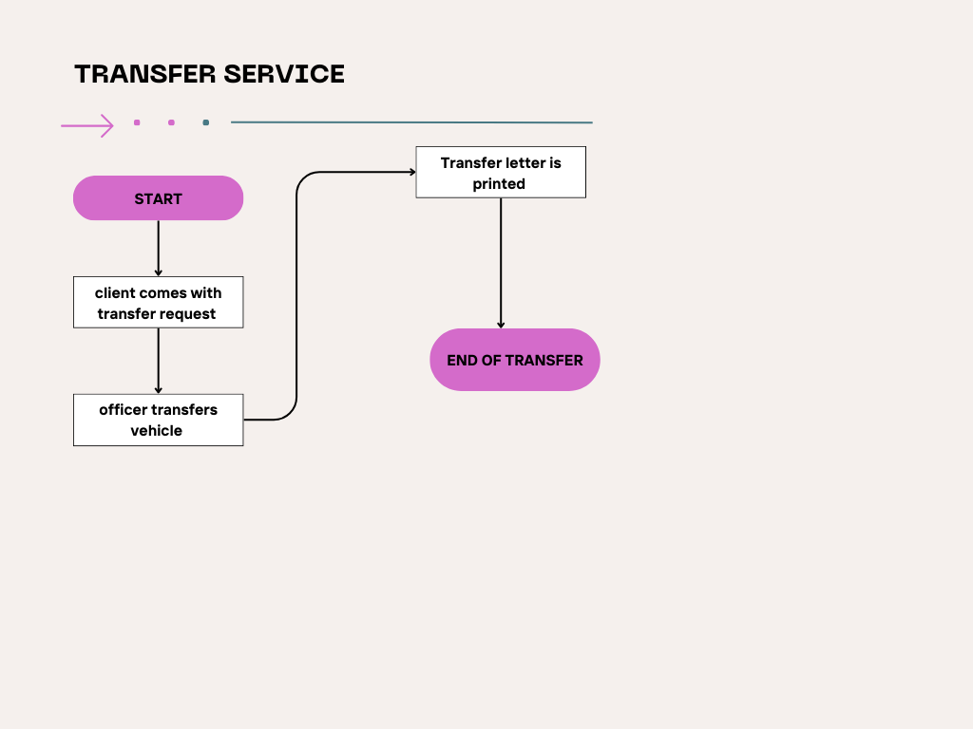

*Figure 8 Transfer business process*

1. Vehicle Cancelation service

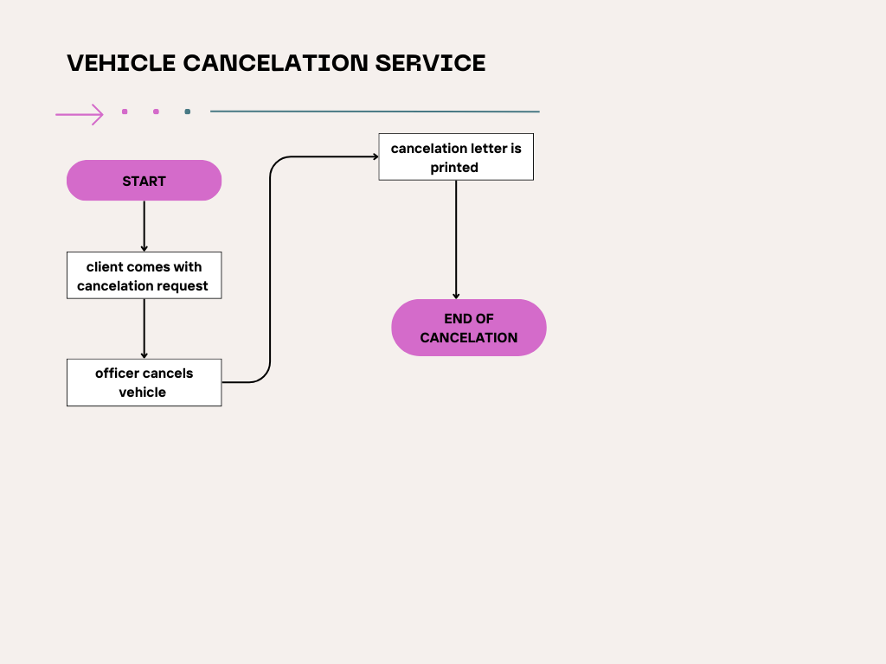

*Figure 9 Cancelation business process*

Limitations

Even though the system had many benefits and solved the agencies problem to some extent there were some limitations

1. Manual process:

Even though the system is somehow automated some services relay on manual processes some example of this processes are

* + Payment process: The system will order the payment but the payment process will be handled manually and then the finance user needs to update by going to the system again.
  + Inspection organizations: there was no way of handling the annual inspection result of vehicles from inspection organizations.

1. Limited Accessibility:

Some accesses are restricted to users especially external stakeholders like inspection organizations also regional users will not be able to update some data based on a given requirement

1. Scalability concerns

Due to the initial intention and design of the existing system, there is no place to accommodate future growth in data; in addition to that as the transaction grows the performance of the system keeps degrading.

1. Limited User Interface

The existing system’s user interface is outdated and lacks user-friendliness which hinders user experience and easy transactions.

1. Technological Obsolescence

The technology used by the existing system is outdated and out of support, which lead to compatibility issues, security vulnerabilities, and difficulty in maintaining or upgrading the system.

1. Data Management Issues

The existing systems have limited capabilities or processes for effective data management, leading to various challenges.

1. Inadequate data storage and archiving mechanisms, resulting in difficulties in retrieving or maintaining historical data.
2. Weak data validation and quality control measures, leading to inconsistent or inaccurate data.
3. Lack of data governance policies and procedures, causing confusion around data ownership, access, and usage.
4. Payment fully not addressed

The existing systems have limited payment processes for effective data validation and report generation

1. Proposed System Overview

The proposed VPA aims to revolutionize the vehicle registration process by offering a user-centric,

efficient, and secure platform. This system builds upon the functionalities of the current system while addressing its limitations and incorporating best practices for streamlined registration management.

Key Enhancements:

* + Enhanced User Experience: The VPA will prioritize a user-friendly interface accessible through a web portal or mobile application (depending on implementation). This will allow users to conveniently register vehicles, manage ownership changes, and access documents from any location with an internet connection.
  + Streamlined Workflows: Automated processes will minimize manual data entry, reducing processing time and error rates. Predefined workflows will guide users through the registration process efficiently.
  + Improved Data Management: The system will leverage a robust central database to ensure data accuracy, integrity, and accessibility. Integration with relevant databases (e.g., national ID database) can further enhance data verification.
  + Increased Transparency and Accountability: The VPA will promote transparency by providing users with real-time application status updates and clear communication throughout the process. Additionally, robust audit trails will ensure accountability in registration activities.
  + Enhanced Security: The system will prioritize data security by implementing industry- standard security protocols. This includes user authentication, data encryption, and access controls to protect sensitive vehicle and user information.
  + Scalability and Sustainability: The VPA will be designed with scalability in mind to accommodate future growth in user base and data volume. The system will be maintainable, allowing for future upgrades and integrations as needed.
  + Online Service Integration (Optional): The system can be designed to integrate with online services for user convenience. This might include features like online appointment scheduling for vehicle inspections, online payment processing for registration fees.

Benefits:

By implementing the proposed VPA, the Agency can expect significant improvements in several areas:

* + Increased Customer Satisfaction: Faster turnaround times, user-friendly interface, and convenient access to services will lead to improved customer satisfaction.
  + Enhanced Service Delivery: Efficient workflows and automated processes will streamline vehicle registration, leading to faster service delivery.
  + Improved Operational Efficiency: Reduced manual tasks, integrated data management, and online services will contribute to increased operational efficiency.
  + Reduced Costs: Automation and streamlined processes can potentially minimize administrative overheads and resource costs.
  + Data-Driven Decision Making: Reports generated by the VPA will provide valuable insights into registration trends, enabling data-driven decisions to improve services.
  + Transparent and Accountable System: The VPA promotes transparency and accountability in vehicle registration processes, fostering trust with users and stakeholders.

This overview provides a high-level understanding of the proposed VPA and its potential benefits. Specific functionalities and functionalities will be further elaborated upon in the detailed design documents.

Product Perspective

The proposed VPA is a software application designed to serve the needs of various stakeholders within the vehicle registration ecosystem. Here's a breakdown of the product perspective from different viewpoints:

End Users (Vehicle Owners/Operators):

* + Core Needs: Efficient and user-friendly platform for registering new vehicles, managing ownership changes, and accessing vehicle documents.
  + Desires: Online access to services, real-time tracking of application status, mobile app for convenient registration management.
  + Concerns: Data security and privacy ease of use, clear instructions and support mechanisms.

Agency Staff (Administrators, Data Entry Personnel):

* + Core Needs: Streamlined workflows for processing registration applications, efficient data management tools, robust user access control for security.
  + Desires: Automated data validation, integration with external databases, comprehensive reporting functionalities for trend analysis.
  + Concerns: System downtime impacting service delivery, user training requirements, adequate system support.

Management (Decision Makers):

* + Core Needs: Improved operational efficiency through automation, data-driven insights for policy and service improvement.
  + Desires: Scalable system to accommodate future growth, transparent and accountable registration processes, real-time data on registration trends.
  + Concerns: System security and data integrity, cost-effectiveness of the solution, return on investment (ROI) from the system implementation.

Overall Product Vision:

The VPA product vision is to create a user-centric and efficient platform that streamlines vehicle registration processes for all stakeholders. The system will prioritize ease of use, data security, and transparency while promoting operational efficiency and informed decision-making.

This product perspective helps ensure that the VPA development aligns with the needs and expectations of all involved parties, leading to a successful and user-centric system.

User classes and characteristics

The system will have the following primary user classes, each with their own set of characteristics and requirements:

1. Data Encoder
   * Characteristics:
     + Responsible for Encoding the information of vehicles for new vehicle registration
   * Key Requirements:
     + Ability to record information of vehicles
     + Ability to record owner information and assign to vehicle
     + Ability to scan available documents of vehicles
2. Zonal Officer
   * Characteristics:
     + Responsible for approving of vehicle
     + For assigning plate , ORC , and AIS
     + Annual inspection of vehicle
     + Valuation and ownership transfer
     + Service change
     + Ban and lift ban of vehicle
     + Temporary plate return
     + Replacement of materials
     + Transfer to zone and or region
     + Cancelation of vehicle
     + Organization registration
   * Key requirements:
     + Ability to record information of vehicles
     + Ability to do all services given by the agency as stated in the characteristics
     + Ability to view different reports
3. Regional User
   * Characteristics
     + Responsible for managing the stock of the Agency (Plate, ORC, AIS)
     + Responsible for approving vehicles that are not in the authority of

zonal user

* + - Responsible for managing the vehicle users of the agency
    - Responsible for managing role and permission of the users
    - Responsible for vehicle cancelation
    - Responsible for managing organizations
    - Responsible for managing the different settings of vehicles
  + Key requirements
    - Ability to change data’s of vehicle information based on request
    - Ability to see the reports of zones
    - Ability to approve some services

1. System Administrator

* Characteristics
  + Responsible for activating the device of users
  + Responsible for supporting the tasks of users
  + Monitors system performance and troubleshoots any issues
* Key requirements
  + Ability to view audit reports
  + Ability to view device status of user devices

1. Finance user

* Characteristics
  + Responsible for setting the price of each services
  + Responsible for ordering payments of each services
* Key requirements
  + Ability to manage the price of each service
  + Ability to view payment reports
  + Ability to change payments

1. Archive user

* Characteristics
  + Responsible for mapping vehicle documents to its respective folder
  + Responsible for getting the vehicle file for officer
  + Responsible for mapping the vehicle to officer based on the count of total files
* Key requirements
  + Ability to manage the archive of vehicles
  + Ability to view archive reports

1. Stakeholder / vehicle owner

* Characteristics
  + Responsible for applying online for new plate registration
  + Responsible for applying online for AIS annually
* Key requirements
  + Ability to view own vehicle

1. Inspection Organization User

* Characteristics
  + Responsible for registering the annual visual and machine result



**2024**



of vehicle

* Key requirements
  + Ability to view annual inspected vehicles

Product Features

1. Personal Information Registration management
   1. Register information of owners
   2. Generate unique owner identification number
2. Vehicle Registration Management:
   1. Register new vehicles (including vehicle information, owner information, and plate number registration)
   2. Generate unique vehicle identification numbers
   3. Assign owner
   4. Conduct field and technical inspection
   5. Payment process
   6. Issue plate
   7. Issue ownership registration certificates
   8. Issue annual inspection certificates (AIS)
   9. Generate reports(Appendix A)
3. Ownership Transfer Management:
   1. Facilitate the transfer of vehicle ownership
   2. Estimate vehicle value based on defined rules
   3. Generate transfer letters and new ownership certificates
4. Service Type Change Management:
   1. Allow to change the service type , body and engine of their registered vehicles
   2. Issue plate ORC and AIS based on the needed changes
5. Vehicle Banning Management:
   1. Allow authorized users to ban vehicles from certain services based on specified reasons
   2. Remove restrictions based on the evidences shown
6. Temporary Plate Return Management:
   1. Allow officers temporary deactivate vehicle and owners to return plate for their registered vehicles
7. Material Replacement Management:
   1. Allow officers to replace lost or damaged vehicle materials (e.g., license plates, registration certificates)
   2. Issue replacement documents
   3. Generate reports(Appendix A)
8. Annual Inspection Management:
   1. Facilitate the annual inspection of registered vehicles
   2. Issue annual inspection certificates (AIS) for vehicles that pass the inspection
   3. Generate reports(Appendix A)
9. Public Operator License Management:
   1. Manage the application and inspection process for public transport vehicle operators
   2. Issue annual certificates for qualified operators and vehicles
10. File Transfer of Vehicles
    1. Transfer file from one zone to the other
    2. Transfer files from zone to other region
    3. Return transfer (while returning change plate, AIS, ORC and or service of vehicles)
    4. Manage rejected vehicle files from other regions
    5. Generate reports(Appendix A)
11. Illegal document management
    1. If an illegal document is registered then change the document to illegal so that the legal file can be registered and restrict any actions for that vehicle
12. Vehicle Organizations Management:
    1. `Manage vehicle organizations, including issuing certificates and handling annual inspections for organizations
    2. Generate reports(Appendix A)
13. System Management:
    1. User management (add, modify, and revoke user access)
    2. Track user activities and evaluate individual user performance
    3. Manage system settings and configurations
    4. Manage documents or reference numbers for each services provided
14. Stock Management:
    1. Manage the organization's vehicle inventory (e.g., plates, AIS, ORC)
    2. Generate reports(Appendix A)
15. Public API Integration:
    1. Develop a public API module for annual inspection organizations to integrate with the VPA
16. Online Booking and Services:
    1. Provide online booking and services for AIS and plate-related activities
17. Archive Management:
    1. Manage the archive of vehicle registration records
    2. Track the current location of vehicles
    3. Generate reports(Appendix A)
18. Payment management of vehicle services
    1. Manage payment order of services
    2. Integrate with telebirr , cbe and sinke bank
    3. Generate report (Appendix A)
    4. Void payments

Operating Environment

The Vehicle Proficiency Assurance (VPA) is designed to operate within a robust and secure IT infrastructure, catering to the needs of government transportation authorities and regulatory bodies. The system is envisioned to be deployed as three web application first for the zone and regional users

, second for inspection organization users and the third for vehicle owners (clients of the agency) the above environments will be set by the agency. In addition to that the developer will provide android app for Operator license.

Hardware and Infrastructure (client responsibility)

* The Transport management website will have three web applications (For regional and zonal users, for organizations and for stakeholders) in addition to Android applications on selected actions.

The client has two options for hosting the web and Android applications: Cloud-based Virtual Machines:

* This option involves hosting the applications on cloud-based virtual machines provided by cloud service providers.
* The key benefit of this approach is that the client can leverage the best deals and offerings from various cloud providers, which can be more cost-effective and flexible compared to on-premises hosting.

On-Premises:

* This option involves hosting the applications on the client's own on-premises servers.
* If the client chooses this route, the servers should meet the following minimum hardware specifications:
  + 256 GB RAM
  + 10 TB storage
  + 32 cores
  + Linux operating system

The choice between cloud-based virtual machines and on-premises hosting will depend on various factors, such as the client's IT infrastructure, budget, security requirements, and scalability needs. Cloud-based hosting can offer more flexibility and potentially lower upfront costs, while on-premises hosting may provide more control and customization options.

The client should carefully evaluate their requirements, compare the pros and cons of each option, and then make an informed decision on the most suitable hosting approach for their Transport management website and applications.

Operating System and Software

* The VPA will be designed to run on enterprise-grade operating systems, like Linux
* The application layer of the VPA will be developed using modern web technologies, such as .NET for back end and Angular for front end coupled with robust application frameworks and libraries.
* The system will utilize a scalable and highly available database management system, such as Microsoft SQL Server, to store and manage the vehicle registration data.
* Robust backup and disaster recovery mechanisms will be implemented, leveraging techniques like database replication, regular backups, and off-site storage of critical data.
* The VPA will be designed to integrate with various third-party systems, such as payment gateways, through well-documented APIs and secure communication protocols.

Security and Compliance

* The VPA will be designed with a strong focus on data security, privacy, and compliance with relevant regulations and standards
* The system will incorporate role-based access controls and advanced encryption mechanisms to safeguard sensitive vehicle registration data.
* Comprehensive logging and audit trails will be implemented to track user activities and enable thorough monitoring and analysis of system events.
* Regular security assessments, penetration testing, and vulnerability management processes will be employed to identify and address potential security risks.

By operating in this secure and scalable hybrid cloud environment, the Vehicle Proficiency Assurance (VPA) will be able to meet the evolving needs of transportation authorities, providing a robust and reliable platform for managing vehicle registration processes.



**2024**



Functional Requirements

The Vehicle Proficiency Assurance (VPA) serves as the foundation for the entire Transport Management System (TMS). Designed to streamline vehicle registration processes, the VPA manages a comprehensive range of functions. This includes ownership registration certificates, facilitating changes in ownership and service type, processing temporary plate returns, and even implementing vehicle bans. Additionally, the VPA promotes safety through functionalities like managing annual vehicle inspections and lost vehicle materials. Furthermore, the system incorporates a dedicated Operator License module specifically for public transport vehicles. To ensure a holistic approach, the VPA also integrates a Vehicle Organizations Management sub module, allowing for the effective management of entities associated with vehicles. This comprehensive set of features paves the way for a more efficient and organized transportation landscape.

Major Functionalities:

1. Registration of New Vehicles: The system will allow users to register their vehicles by providing relevant information such as the make, model, year, Chassis Number and other relevant information of vehicles, validation some of the input fields and uploading documents. The system will also generate a unique vehicle identification number for each vehicle registered.
   1. Registration of Vehicle Owners: The system will allow users to register their vehicle owners by providing personal information such as name, address, contact information, and ID. The system will also generate a unique owner identification number for each registered owner.
   2. Registration of Plate Numbers: The system will allow users to First register the plates in the stock management sub system then let them assign to the specified Vehicle. The system will also generate a unique plate number identification for each registered plate number.
   3. Ownership Registration Certificate and AIS: The system will generate an ownership registration certificate for each registered vehicle owner. Additionally, the system will support the issuance of an Annual Inspection Certificate (AIS) to vehicles that have passed the annual inspection.
2. Changing Ownership of Vehicles: The system will allow users to change the ownership of their vehicles by estimating the value of the vehicle based on the rules given by the manager and will give the new owner system generated letters and ownership certificate number.
3. Changing Service Type of Vehicles: The system will allow users to change the service type of their vehicles by providing relevant information such as the vehicle identification number and the new service type.
4. Banning of Vehicles: The system will allow authorized users to ban a vehicle from being Evaluated and getting limited services based on specific reasons given by the manger
5. Temporary Plate Return of Vehicles: The system will allow users to request a temporary plate return for their registered vehicle, which will be valid for a specified period.
6. Replacement of Material of Vehicles: The system will allow users to report lost or damaged material of their registered vehicle such as license plates, registration certificates, or other important documents. The system will also support the issuance of replacement documents.
7. Annual Inspection of Vehicles: The system will facilitate the annual inspection of registered vehicles and issue an Annual Inspection Certificate (AIS) to vehicles that have passed the inspection.
8. Public Operator License: The vehicle used for public transport services may need to be inspected to ensure that it meets safety and operational standards. These standards will be set by the system administrator or manager Once the application and inspection results are received, they will be reviewed to ensure that all required information and documentation have been provided and that the operator and vehicle meet the qualifications for the annual certificate. If the application is approved and the vehicle passes the inspection, the annual certificate will be issued to the operator, allowing them to provide public transport services for the following year.
9. File transfer of Vehicles: The system will manage the file transfer of vehicles from one zone to the other and to other region it also manages the returned vehicles transferred to other regions if the vehicle changed its Plate, AIS, and ORC and or service type then this will be managed by the system.
10. Illegal document management: The system will be able to manage illegal documents in case they are registered.
11. Vehicle Organizations Management: The system will include a module to manage vehicle organizations. And give certificate for the organizations and for Annual inspection organizations it will have more task that will be detailed on the requirement analysis document.
12. System Management: This functionality allows authorized users to manage the different settings that will be useful for Vehicle Proficiency Assurance.

User Management: This functionality allows authorized users to manage the organization's staff and assign roles and permissions. It includes the ability to add new users, modify existing user accounts, and revoke access to the system. In addition to that tracking the user activities by log file and evaluate the performance of individual user having split ip differ from report all system developed. Since one zone can manage different zones based on its given privilege the zonal user can access some data’s of the given zone’s access.

1. Stock Management: This functionality allows authorized users to manage the organization's vehicle inventory. It includes the ability to add Plates, AIS and ORC.
2. Prepare public API module for Annual inspection organization to integrate with the system.
3. Online booking and give services on AIS, ORC and plate.
4. Archive management of Vehicle Proficiency Assurance module: This functionality allows the user to manage the archive of the vehicles and to know the current location of the vehicle.
5. Payment management of Vehicle Proficiency Assurance module: This functionality allows the user to manage the payment process of all services that require payment and integration with telebirr , cbe and sinke bank
6. Non-Functional Requirements Overview

Non-functional requirements are an important aspect of software development as they specify the underlying characteristics of the system that support its functional requirements. These requirements encompass areas such as security, performance, reliability, maintainability, and usability, among others. The design of the TMS will give great attention to these non-functional requirements in order to ensure the system is secure, performs well, is reliable and maintainable, and is easy to use. By carefully considering and addressing these requirements, the TMS will be able to effectively support the operations and deliver the desired benefits.

Our extensive experience in providing software solutions and our in-depth knowledge of the needs and requirements has been instrumental in the construction of the non-functional requirements for the TMS. In addition, our situation analysis of the current systems and processes of the services and the two system analysis workshops we conducted have provided valuable insights and have informed the development of these requirements. The non-functional requirements for the TMS have been carefully crafted to ensure that the system meets the needs of the services and delivers the desired benefits. They have been developed through a thorough and systematic process that takes into account the unique needs and priorities of the services, as well as relevant regulations and standards.

Security Overview

The security of TMS data is of critical importance. As such, the TMS is designed to be decentralized, with servers that are not accessible by the public. This narrows the scope of work needed to protect this sensitive data.

Physical security:

* Ensuring that the TMS servers are kept in secure locations at services, such as locked server rooms with limited access
* Regularly checking the security of the server room

Implementing strict access controls for authorized personnel, with only TMS authorized personnel accessing facilities.

Network security:

* Implementing firewalls to prevent unauthorized access to the network
* Implementing encryption for all sensitive data transmitted over the network
* Regularly monitoring network activity and implementing measures to prevent or detect potential security breaches

Access control:

* Implementing strict access controls for authorized personnel, including the use of unique login credentials and role-based permissions
* Regularly monitoring user activity and implementing measures to prevent or detect potential security breaches
* Regularly conducting security audits to ensure that access controls are effective and in compliance with relevant regulations

Data security:

* Implementing encryption for all data stored on the TMS servers
* Regularly backing up data to prevent data loss in case of a disaster or security breach
* Regularly conducting security audits to ensure that data is being handled and stored in compliance with relevant regulations

Disaster recovery:

* Implementing measures to prevent data loss in case of a disaster, such as regular backups and disaster recovery plans
* Regularly testing disaster recovery plans to ensure their effectiveness in the event of a disaster
* Implementing measures to prevent or minimize the impact of a disaster on the TMS system, such as redundant servers and robust network infrastructure.

Performance Overview:

The performance of the TMS is of utmost importance as it is a key component of the daily operations of services. In order to ensure that the TMS can handle the workload of the services it serves, specific performance requirements have been put in place. These requirements take into account the current hardware specifications of the system and are designed to ensure that the TMS operates smoothly and efficiently.

Basic Operations:

Basic operations of the TMS, such as vehicle registration should not take more than 20 seconds. This ensures that the system is responsive and user- friendly, allowing services to efficiently serve their customers.

Analytic Operations:

Generating reports is a crucial aspect of the TMS, and it is important that these operations are completed in a timely manner. 80% of the reports that will be generated in the TMS will not take more than 4 minutes to complete. Highly complex reports, such as those requiring extensive data analysis, may take up to 15 minutes to generate for the largest services.

Scalable Performance:

The TMS is designed to be scalable, allowing it to handle increasing workloads without experiencing any appreciable degradation in performance. Our situation analysis projects that the largest TMS will have 225,000 Vehicles currently, and the TMS is able to handle this increased workload without any notable decrease in performance. With minor architectural modifications, the system can be scaled up to handle exponentially larger workloads for services of much larger sizes. With minor architectural modifications, the TMS can be scaled up to handle even larger workloads for services of much larger sizes.

Usability Overview

Usability is a critical aspect of the TMS system, as a well-designed and secure architecture is of little use if it cannot be effectively utilized by the employees of the services. Ensuring that the system is easy to use and understand is essential for maximizing efficiency and productivity within the services. In this section, we will outline the various usability requirements and considerations that have been taken into account in the design and development of the TMS system.

User Benchmarks

The TMS has been designed with usability in mind, with the aim of making it easy for all users to navigate and perform basic operations. For users with IT literacy level of being comfortable with email and messaging applications, all basic TMS operations should be easily accessible.

Configuration work, such as the configuration of the services, will require an advanced user, usually the system admin at services. These users should have a strong understanding of the TMS system and be comfortable with more complex operations.

User Interface Design

In the User interface design section, it is important to ensure that the TMS has a consistent and intuitive layout, with clear and concise labels and instructions to guide the user through different tasks. The system should be easy to learn and use, even for those with limited experience in similar applications. Aesthetics are also important, as an attractive and visually pleasing user interface can greatly improve the overall user experience. To achieve these goals, we will follow a user-centered design approach, considering the needs and preferences of our target users throughout the design process. Additionally, we will conduct usability testing to ensure that the system is intuitive and easy to use, and make any necessary adjustments based on user feedback. Overall, our goal is to create a user interface that is efficient, effective, and enjoyable to use, resulting in a seamless and enjoyable experience for our users.

Maintainability Overview:

Maintainability is a crucial aspect of any software system, including the TMS. Ensuring that the system is easy to maintain and update is essential to ensuring its continued functionality and effectiveness. This includes the ability to easily add new services to the system, as well as the ability to make updates and modifications as needed.

Modularity:

To facilitate maintainability, the TMS has been designed with modularity in mind. This means that different parts of the system are designed to be independent and self- contained, allowing for easy modification or replacement of individual components without affecting the overall system. This modular design also makes it easier to add new services to the system, as each TMS can be treated as a separate module that can be easily integrated into the overall system.

Documentation:

In order to ensure that the TMS is easy to maintain, comprehensive and detailed documentation is essential. This includes technical documentation for developers, as well as user documentation for those who will be using the system. This documentation should be clear and concise, and should cover all aspects of the system's design and functionality.

Support:

To ensure that the TMS is always running smoothly, it will be important to provide ongoing support for the system. This includes providing assistance to users with any issues they may encounter, as well as regularly performing best practices to ensure the system is functioning optimally. In order to provide this support, it will be necessary to have a dedicated team of experts who are familiar with the system and able to quickly address any issues that may arise.

Reliability

System availability:

The TMS should have a high level of availability, meaning that it should be accessible and functional for the majority of the time. This is important because services rely on the TMS for various processes such as license and plate services, and any downtime could negatively impact their operations. To ensure high availability, the TMS will be designed with redundant systems and failover mechanisms in place. Notwithstanding hardware damages and failures, the TMS will have an estimated 95% availability.

Data integrity:

The TMS will be responsible for storing and manipulating sensitive data, such as customer billing information and employee payroll. It is crucial that this data is protected and kept safe from corruption or loss. To ensure data integrity, the TMS will be designed with various security measures in place, such as data backup and recovery mechanisms.

Scalability Overview:

The scalability of the TMS is of great importance as it will be used by 55 cities and zones of the agencies, each of which may have different levels of growth in the next three years. Furthermore, the TMS should be designed in a way that the addition of services beyond the 55 cities and zones should not require an extensive modification of system architecture. TMS’s grow in terms of the number of customers they serve, the transactions and services they host and the number of users that use their systems. As such, the architecture should have a methodological approach to all these variables.

Scalability of Customers:

The TMS should be able to handle an increasing number of customers at each TMS, taking into account the projections of customer growth in the next years as outlined in the situation analysis. Customers should be hosted on TMS servers without any noticeable change in system performance.

Scalability of Concurrent Users:

The TMS should be able to handle an increasing number of concurrent users, up to a minimum of 150 at a time, without any noticeable degradation in performance. This accounts for the projected growth of each TMS in the next three years.

Scalability of Data:

The TMS should be able to handle an increasing amount of data, including vehicle and driver data, without any noticeable degradation in performance. The storing of data like driver and vehicle documents and the like should consider the database congestion impacts that could result over extended use of the system.

Scalability of Hardware:

The TMS should be able to operate effectively on a variety of hardware configurations, including potential upgrades or replacements, without the need for extensive redesign or redevelopment.

Disaster Recovery

Disaster recovery is a crucial aspect of any system, and the TMS is no exception. As services provide essential services to customers, it is important to ensure that the system is able to recover from any potential disasters that may occur. This includes data loss, which is a common disaster for services.

Design:

The TMS is designed to use two servers, which greatly helps in preventing any major disasters from occurring. In the event that a disaster does occur, the system has an automatic, continuous backup feature configured to ensure that all changes are continuously backed up. This helps to mitigate the risk of data loss and ensures that the system can recover quickly from any potential disasters.

Data Backup:

In addition to the automatic, continuous backup feature, the TMS is also designed to consider options for backing up data in ways that cannot be damaged. This includes the use of multiple backup servers and offsite storage options. This helps to further protect the system and ensure that it is able to recover from disasters with minimal impact on operations.



**2024**



1. Conceptual System model Functional Models

The functional models describe the high-level functionality and behaviors of the system

Operational Scenarios

Owner Personal information registration Overview

The owner (Personal information) registration technical service process is the initial process for the whole Transport management system. This service will include the registration of vehicle owner’s information.

Major Steps

The major steps in personal information registration are:

1. Information registration

The system will allow users to register their vehicle owners by providing personal information such as name, address, contact information, and ID. The system will also generate a unique owner Registration number for each registered owner. Before registration the system will validate the owners of vehicle or persons by their id number, phone number and email if applicable.

New Vehicle Registration Technical Service Process Overview

The vehicle registration technical service process is one of the core processes in the TMS. In our system analysis, we have made the deployment of technical services, including the survey for technical services, a part of the work issuance of ownership of registration certificate (Libra), and AIS (Bolo) etc. process documented in a different section within this document. The technical service process initiates the work issuing the Vehicle Registration Ownership Certificate process that is based on, the six processes

Major Steps

The major steps in the vehicle registration process are:

1. Vehicle Information Registration
2. Ownership assignment
3. Field and technical Inspection Registration
4. Payment
5. Assignment of Plate number
6. Issue Ownership Registration and AIS Certificate
7. Vehicle Information registration

The vehicle information registration is the initiation point of the technical service process of the VPA. The system will allow users to register their vehicles by providing relevant information such as the make, model, year, Chassis Number and other relevant information of vehicles, validation some of the input fields and uploading documents. The system will also generate a unique vehicle Registration number for each vehicle registered.

1. Vehicle ownership assignment

The owner assignment is the next process after the registration of vehicle information and owner information. The owner can be an organization, or owner the registration of organizations will be different as of person since personal information will concentrate on individuals that will be used for different purposes like drivers, institution owners, organization owners

1. Field and technical Inspection Registration

Following successful vehicle owner registration, the VPA seamlessly transitions into the field and technical inspection process. This crucial step ensures vehicle roadworthiness by allowing authorized users, to record detailed results of both on-site ("field") and technical inspections directly within the system. Captured data can encompass a wide range of parameters.

1. Payment

Following the successful field and technical inspection, the VPA seamlessly integrates with a secure payment gateway to facilitate a smooth and efficient payment process. This user-friendly interface caters specifically to authorized payment personnel, empowering them to collect fees associated with various Vehicle Proficiency Assurance services.

1. Assignment of Plate

With successful payment processing, the VPA seamlessly transitions to the next stage. The system automatically flags the vehicle as ready for plate assignment.

1. Ownership Registration Certificate and AIS

Following successful plate assignment, the VPA marks the new vehicle registration process complete. To finalize this stage, the system interacts with the stock management module. This ensures efficient inventory control:

* + ORC Issuance: The VPA verifies the availability of ORCs (Ownership Registration Certificates) within the chosen city/zone's stock. Upon confirmation, the system electronically generates a unique ORC for the vehicle, containing details like ownership information and vehicle specifications. The VPA can then initiate the printing of a physical ORC.
  + AIS Issuance: Similarly, the VPA checks the stock of Annual Inspection Stickers (AIS) for the designated city/zone. If available, the system generates a digital AIS record linked to the vehicle's registration data. Alternatively, the VPA can trigger the printing of a physical AIS sticker from the city/zone's stock for placement on the vehicle's windshield.

2.1.3 Actors

* Data Encoder: encodes the initial information of the vehicle
* Zonal/City officer: the user approves the registered vehicle and the gives other services based on the request.
* Regional user: The user approves vehicles that are beyond the decision of the zonal/regional user

Annual Inspection Renewal of Vehicle Overview

The system will allow the users to give AIS to the vehicles on a yearly basis. Based on the result of the vehicle provided from inspection organizations.

Major Steps

The major steps in annual inspection renewal is

1. The user fills the information for annual inspection
2. The owner needs to bring the required documents and reference numbers based on the setting set by the agency.
3. Payment collection
4. AIS issuance

Information for annual inspection

The information for the annual inspection is the initiation point for getting annually inspection Service for the vehicle owner. This process can have two options

* + The owner will come to the vehicles city or zone
  + The owner will book online and then come and take the AIS (this will be further discussed on the online booking service functional requirement )

Payment Collection

Following the successful registration of annual inspection, the VPA seamlessly integrates with a secure payment gateway to facilitate a smooth and efficient payment process. This user-friendly interface caters specifically to authorized payment personnel, empowering them to collect fees associated with various Vehicle Proficiency Assurance services.

AIS issuance

After payment, the VPA checks the stock of Annual Inspection Stickers (AIS) for the designated city/zone. If available, the VPA can trigger the printing of a physical AIS sticker from the city/zone's stock for placement on the vehicle's windshield.

Actors

* Zonal/City officer: the user registers the initial information and prints AIS

Changing Ownership of Vehicle Technical Service Process Overview

The system will allow users to change the ownership of their vehicles by estimating the value of the vehicle based on the rules set by the manager and will give the new owner system generated letters and ownership certificate number.

Major Steps

The major steps in the technical service process are:

1. Vehicle valuation
2. Payment Collection
3. Assign ownership
4. Issue Ownership Registration Certificate Vehicle Valuation

The vehicle valuation is the initiation point of the ownership transfer technical service process. The Vehicle valuation is the process of determining the current fair market value of a vehicle. This is an

important consideration for anyone buying, selling, or financing a car, truck, or other motor vehicle.

Payment Collection

Payment Process the next process after the vehicle’s valuation has occurred. The system shall allow the finance user to collect payment for the Issuance of ORC for the new owner.

Assign ownership

Changing the legal ownership of a vehicle from one person to another is an important process that needs to be handled properly. Transferring of ownership occurs after the successful payment of the vehicle valuation and ownership transfer payment.

Issue Ownership Registration Certificate

The Issuance of ownership registration certificate is the next process after the assignment of ownership in the Changing of ownership of a vehicle technical service process. The system will generate an ownership registration certificate for each registered vehicle owner. Additionally, the system will support the issuance of an Annual Inspection Certificate (AIS) to vehicles that have passed the annual inspection.

Actors

* Zonal/city officer: the user is responsible for registering the valuation and assigning of the owner
* Finance user: the user is responsible for collection of payments

Changing Service Type of Vehicles Technical Service Process Overview

The system will allow users to change the service type of their vehicles by providing relevant information such as the vehicle identification number and the new service type.

Major Steps

The major steps in the technical service process are:

1. Change the service type
2. Payment Collection
3. Issue of Plate, AIS and or ORC
   1. Change Service Type of Vehicle

The changing the service type of the vehicle is the initiation point of the ownership transfer technical service process. The system will allow users to change the service type of their vehicles by providing relevant information such as the vehicle identification number and the new service type.

* 1. Payment Collection

Payment Process the next process after the vehicle’s plate number registered of the technical service process. The system shall allow the ORTMS casher (user) to collect payment for the Issuance of ownership certificate and AIS.

* 1. Issue Plate, AIS and or ORC

The Issuance of plate, AIS and or ORC is the next process after the assignment of the service change process of the system. The system will generate an ownership registration certificate for each registered vehicle owner. Additionally, the system will support the issuance of an Annual Inspection Certificate (AIS) to vehicles.

Actors

* Zonal/city officer: the user is responsible for registering the valuation and assigning of the owner
* Finance user: the user is responsible for collection of payments

Banning of Vehicles Technical Service Process Overview

The system will allow authorized users to initiate the process of banning a vehicle from the Transportation Management System (TMS). This process involves capturing the necessary information about the vehicle, validating the reasons for the ban, and updating the vehicle's status in the system.

Major Steps

The major steps in the technical service process for banning a vehicle are:

1. Initiate Vehicle Ban
2. Validate Ban Reason
3. Update Vehicle Status
   1. Initiate Vehicle Ban

The process of banning a vehicle is initiated by an authorized user (e.g., law enforcement officer, regulatory authority) providing the necessary information about the vehicle, such as the license plate, VIN, or registration details. The user will also input the reason for the ban, which must be a valid and supported reason within the TMS system.

* 1. Validate Ban Reason

The TMS system will validate the provided reason for the ban to ensure it is a valid and supported reason for banning a vehicle. This may involve checking against a list of approved ban reasons, verifying the legal or regulatory basis for the ban, or consulting with other authorities as necessary.

* 1. Update Vehicle Status

If the ban reason is valid, the TMS system will update the vehicle's status to "Banned" and record the reason for the ban. The system will also generate any necessary documentation or notifications related to the vehicle ban, such as informing the vehicle owner, updating law enforcement records, or triggering any required administrative or legal processes.

Temporary Plate Return of Vehicles Technical Service Process Overview

The system will allow users to return temporary license plates for their vehicles by providing the relevant information, such as the vehicle identification number and the temporary plate number. This process is necessary when a vehicle's permanent registration and license plates have been issued, and the temporary plates need to be returned.

Major Steps

The major steps in the technical service process for returning temporary license plates are:

1. Initiate Temporary Plate Return
2. Validate Plate and Vehicle Information
3. Update Vehicle Registration
4. Collect Temporary Plate
   1. Initiate Temporary Plate Return

The process of returning temporary license plates is initiated by the vehicle owner or an authorized representative. The user will provide the system with the vehicle's identification number and the temporary plate number that needs to be returned.

* 1. Validate Plate and Vehicle Information

The system will validate the provided information to ensure that the temporary plate is valid and belongs to the specified vehicle. This may involve checking the plate number against the vehicle's registration records and confirming that the plate is still active and has not been reported as lost or stolen.

* 1. Update Vehicle Registration

Once the plate and vehicle information are validated, the system will update the vehicle's registration status to reflect the return of the temporary plate and the issuance of the permanent license plates.

* 1. Collect Temporary Plate

The final step in the process is the physical collection of the temporary license plate. The user will be required to submit the temporary plate, and the system will confirm its return and deactivate the plate in the registration records.

Managing Replacement Material of Vehicles Technical Service Process Overview

The system will allow users to report and manage the loss of materials associated with a vehicle, such as license plates, registration documents, or other vehicle-specific items. This process ensures that the necessary actions can be taken to address the lost materials and update the vehicle's records accordingly.

Major Steps

The major steps in the technical service process for managing lost materials of vehicles are:

1. Report Lost Material
2. Verify and Validate Lost Material
3. Update Vehicle Records
4. Issue Replacement Material (if applicable)
5. Closure of Lost Material Report
6. Report Lost Material The process begins when a user (vehicle owner or authorized representative) reports the loss of a vehicle-related material, such as a license plate, registration certificate, or other important document or item. The user will provide the



**2024**



necessary information, including the vehicle identification number (VIN), the type of material lost, and the circumstances surrounding the loss.

1. Verify and Validate Lost Material The system will verify the reported loss by cross-checking the vehicle's records and the user's information. This step ensures that the reported loss is legitimate and not a fraudulent attempt.
2. Update Vehicle Records Once the loss is verified, the system will update the vehicle's records to reflect the missing material. This may include marking the lost item as invalid, generating a replacement request, or initiating any other necessary actions.
3. Issue Replacement Material (if applicable) Depending on the type of lost material and the applicable regulations, the system may allow the user to request and obtain a replacement item, such as a new license plate or registration document. The system will handle the issuance of the replacement material, including any required fees or documentation.
4. Closure of Lost Material Report The process concludes with the closure of the lost material report, indicating that the necessary actions have been taken and the vehicle's records have been updated accordingly.

Public Operator License Technical Service Process Overview

This system will allow Regional authorities to input vehicle specifications into the system, which then determines the appropriate license level based on pre-defined criteria set by the system administrator. These criteria could encompass factors like passenger capacity, safety features, and emissions standards. The system automatically generates the license and will be printed, streamlining the entire process. Furthermore, the system will be enhanced for online payments.

Major Steps

The major steps in the public operator license technical service process are:

* 1. Fill in the results of the operator license
  2. Payment process
  3. Give operator license

1. Fill in the result of the vehicle

Filling the result of the vehicle is the initial point for giving the operator license for the vehicle this process gets the information from the setting set by the regional users. The zonal/city officer will check on the result by visually inspecting the vehicle itself. Then automatic level of the vehicle is given to the owner

1. Payment Process

Following the successful level of the vehicle, the VPA seamlessly integrates with a secure payment gateway to facilitate a smooth and efficient payment process. This user-friendly interface caters specifically to authorized payment personnel, empowering them to collect fees associated with various Vehicle Proficiency Assurance services.

1. Operator License

After the successful payment process there will be operator license generated from the system for print out that can be done annually

Actors

* Zonal/City officer: the user is responsible for filling the operator license and printing the license of the vehicle
* Finance user: the user is responsible for collecting the payment

Transfer of vehicle files Service Process Overview

The VPA will enable the seamless transfer of vehicle registration files between different geographical zones and regions, facilitating the efficient management of vehicle data across jurisdictions. This functionality will be crucial for scenarios where vehicle owners relocate or when vehicles are transferred between different administrative areas.

Zone-to-Zone Transfer

* The system will allow authorized users to transfer vehicle registration files from one geographical zone to another within the same region.
* The transfer process will involve the secure migration of the vehicle's registration details, ownership information, and associated documentation from the source zone to the destination zone.

Zone-to-Region Transfer

* The VPA will also support the transfer of vehicle registration files from a specific geographical zone to a different region.
* This feature will be beneficial when a vehicle is registered in one region and the owner subsequently relocates to a different region, necessitating the transfer of the vehicle's registration data.

Major Steps

The major steps in the Transfer of vehicles service process are:

1. Conduct transfer
2. Payment process
3. Reject transfer
4. Return transfer
5. Conduct transfer

Transferring the vehicle file is the initial point for conducting transfers. The zonal/ city officer will conduct the transfer of vehicles.

1. Payment Process

Following the successful transfer of vehicle to generate transfer letter payment will be ordered, the VPA seamlessly integrates with a secure payment gateway to facilitate a smooth and efficient payment process. This user-friendly interface caters specifically to authorized payment personnel, empowering them to collect fees associated with various Vehicle Proficiency Assurance services.

1. Reject transfer

This step occurs when the vehicle is transferred to other region and the other region has rejected the vehicle due to many reasons. In this case the history will remain but the information of the vehicle will not be changed

1. Return transfer

This step occurs when the vehicle to other region and he was accepted but during that time the owner may change different data’s of the vehicle like Ownership transfer, service change. In addition to that the initial zone might be different from the returned zone in that case the regional user will be responsible for returning the data vehicle file.

* Zonal/City officer: the user is responsible for filling the operator license and printing the license of the vehicle
* Finance user: the user is responsible for collecting the payment
* Regional user : the user that returns transfer from other region to specified zone

Illegal document service process Overview

The VPA will enable the change of illegal documents in case they were registered in the system accidentally.

Major Steps

The major steps in the illegal document service process are:

1. Change vehicle to illegal

When changing the vehicle to illegal the changed vehicle will be limited to any activities of vehicle process in the system.

Actors

* Regional user : the user that changes the vehicle to illegal

Vehicle Organizations Management Technical Service Process Overview

The system will allow authorized users to manage vehicle organizations, including creating, updating, and deactivating organizations as well as generating license for each organizations. The organizations category will be as previous categories.

Major Steps

The major steps in the vehicle organizations management technical service process are:

1. Registration of vehicle organizations
2. Payment process
3. License generation
   1. Registration of organizations

Filling the general information of organizations is the initial process for managing the organizations of the agency. All organizations will have the same process of registration except Importer organizations this will have a different use case for license generation.

* 1. Payment Process

After the successful registration of organizations and its different information related to the organizations identity like address, owners, office and number of vehicles for only importer license the payment process will start for license generation.

* 1. License Generation

After the successful payment process the license of the vehicle the license of the organization will be generated and printed for the organization. The license will be renewed annually and can be replaced if lost

Actors

* Regional user: For registering of organizations and generating license
* Zonal/City officer: For registering of organizations based on the given permission or the regional user
* Finance user: For payment process

System Management Technical Service Process Overview

The system management technical service process is a crucial component of the TMS, responsible for the efficient administration and maintenance of the overall system. This process encompasses various sub-processes, including user management, system configuration, and performance monitoring

Major Steps user management sub process

The major steps in the user management technical service process are:

1. User registration
2. Role and permission assignment
3. Activation deactivation of users 1 User Registration

The user registration is the initial step for the whole management of the system. This insures the

appropriate access control and accountability for all system actions. Since one zone can manage different zones based on its given privilege the zonal user can access some data’s of the given zone’s access

1. Role and permission assignment

After the successful registration of owners the next step will be to assign role and permission for users based on their selected role modules.

1. Activation and Deactivation of Users

The initial stage of a user is as active but due to different circumstances the user might be activated or deactivated.

Major steps in system configurations

The major steps in the system configurations technical service process are:

* 1. Registration of system configurations

1. Registration of system configurations

The registration of system configurations is the initial step for the Vehicle Proficiency Assurance module. If the registration of system configurations is successful then the Vehicle Proficiency Assurance module will not have trouble.

Actors

* System Administrator : Responsible personnel for managing the vehicle registration system setting and user management module
* Regional user: Responsible personnel for managing the vehicle registration system setting and user management module

Stock management Technical Service Process Overview

The stock management technical service process is the process that is responsible for managing the stocks of Plates, ORC and AIS materials of the agency. Each of this processes are handled in the system differently but since they have major steps they will be covered in steps of stock management.

Major Steps

The major steps in the stock management technical service process are:

1. Stock registration
2. Transfer stock to zone/city Stock Registration

The stock registration is the initial for stock registration management system

Transfer stock to Zone/City

After the successful registration of stocks then the regional user will select the needed list of stocks and transfer to the selected city or zone for plate assignment

Actors

* + Regional User: The user is responsible for registration and transfer of stock from the region to the zone.

Prepare public API module for Annual Inspection Organization Overview

The public API module is designed to allow annual inspection organizations to integrate seamlessly with the vehicle registration system. This integration ensures that inspection data can be securely and efficiently transmitted between the inspection organizations and the registration system. The API will handle data submissions, status updates, and validation processes.

Major Steps

The major steps are:

1. Submit Inspection Data: Sending inspection results to the vehicle registration system. Send to agency for approval

Actors

* + Inspection Organization: The entity performing the annual vehicle inspections.
  + API Gateway: The intermediary that handles API requests and responses.
  + Agency Officer: The official at the agency who reviews the inspection data.

Online booking for plate, AIS and ORC Overview

The vehicle registration system offers a for car owners, allowing them to conveniently register their personal details, vehicle specifications, and upload all necessary documents directly through the system, streamlining the registration process and also request related services for a specific vehicles .

Major Steps

The major steps in the online booking process are:

1. Personal and vehicle information registration
2. Send to agency for approval
3. Vehicle Approval
4. If vehicle rejected delete data
5. Personal and vehicle information registration

The process is the initial for requesting for plate, ORC and AIS of a vehicle online. This process helps the user for easily filling the general information of his/her vehicle

1. Send to agency for approval

After the successful registration of the vehicle then the owner will send to the zone/ city of the zone for approval and take the vehicle to that zone/city

1. Vehicle approvals

After the vehicle is sent to the zone then the officer will check the documents and the vehicle personally and approve the vehicle.

1. Delete rejected data

If the vehicle is known to be illegal or didn’t qualify then the officer can delete the vehicle permanently.

Actors

* + Vehicle Owner: The individual who owns the vehicle and initiates the registration process.
  + Agency Officer: The official responsible for reviewing and approving the vehicle registration and documents.
  + Zone/City Agency: The local authority where the vehicle is inspected and approved.

Archive management for Vehicle Proficiency Assurance service Overview

The system will allow managing the archives of the vehicle this process starts from registration of shelf, folder to mapping the vehicle to the folder. In addition to that the service will provide with the daily whereabouts of the file.

Major Steps

The major steps in the archive management process are:

1. Shelf registration
2. Folder registration
3. Vehicle folder mapping
4. Vehicle file search
5. Vehicle file assign to officer
6. Shelf Registration

The process is the initial for archive management the shelf registration will help to register the shelves of the city/zone.

1. Folder Registration

The second process after shelf registration is the folder registration this process will help to register the folders of the vehicle and the capacity they hold.

1. Vehicle folder mapping

After the successful registration of shelf and folder and vehicle has finished registration then vehicle folder mapping will occur this helps the zone/city to properly and orderly put their files.

1. Vehicle folder search

After the vehicle and folder have been mapped successfully then when the vehicle’s file is needed it will be fetched and will be given to the officer

1. Vehicle assign to officer

The process is helpful to know which officer is taking the file and how many files he has taken in that day. This helps to distribute files equally to the officers as well know the exact location of the file. When the officer finishes the vehicle then the archive user will change the status as finished and the file returned to its receptive folder

Actors

* + Archive user: User responsible for managing the archive

Payment management service Vehicle Proficiency Assurance service Overview

The system will allow managing the payment process of vehicle services based on the order of payments.

Major Steps

The major steps in the archive management process are:

1. Payment order (Automatic)
2. Price selection
3. Send to payment gateways
4. Receive payment
5. Payment order

The process is the initial for payment management this process is automatically when the action for each service is conducted

1. Price Selection

The second process after payment order is price selection this process leads to payment gateways

1. Send to payment gateway

After the successful of price selection the system will send the payment to payment gateways of listed above

1. Receive payment

The payment gateways will update the status of the ordered payment. Actors

* + Finance user : User responsible for managing the payment

Use Case Model

|  |  |  |  |
| --- | --- | --- | --- |
| No | UC ID | UC Name | Description |
| 1. | UC-001 | Register Personal information | This use case describes the process of registering a new Owner in the TMS system |
| 2. | UC-002 | Register Vehicle | This use case describes the process of registering a new vehicle in the TMS system. |
| 3. | UC-003 | Map vehicle to owner | This use case describes the process of assigning owner to vehicle. |
| 4. | UC-004 | Vehicle Approval | The use case describes the process of approving the validity of a vehicle before giving other services to the client. |
| 5. | UC-005 | Field and technical Inspection | This use case describes the process of registering a new Field and technical Inspection in the TMS system |
| 6. | UC-006 | Assign plate number | This use case describes the process of assigning plate from the transferred stock of the given  zone/city |
| 7. | UC-007 | Issue certificate of Ownership, and AIS | This use case describes the process of assigning AIS and ORC and printing it so that the owner of the vehicle can attach the AIS to his/her  windshield and take the ORC. |
| 8. | UC-008 | Annual inspection information | This use case describes the process registering information regarding the annual inspection  process of the VPA module |
| 9. | UC-009 | Issue AIS | This use case describes the process of assigning AIS and printing it so that the owner of the vehicle can attach to his/her windshield. |
| 10. | UC-010 | Vehicle Valuation | This use case describes the process of determining the current fair market value of a vehicle using the system. This can occur by finding the vehicle by plate No / Chassis no and then the values of vehicles will be displayed  from the setting. |

|  |  |  |  |
| --- | --- | --- | --- |
| 11. | UC-011 | Assign Ownership of Vehicle | This use case describes the process of assigning ownership of a vehicle in the Transportation Management System (TMS). |
| 12. | UC-012 | Change Service Type of Vehicle | This use case describes the process of changing the service type of a vehicle registered in the  Transportation Management System (TMS). |
| 13. | UC-013 | Ban a Vehicle | This use case describes the process of banning a vehicle from the Transportation Management System (TMS). |
| 14. | UC-014 | Temporary Deactivation of Vehicles | This use case describes the process of returning a temporary deactivation/ activation and temporarily return plate for a vehicle in the TMS  system. |
| 15. | UC-015 | Managing Lost Material of Vehicles | This use case describes the process of managing the loss of materials associated with a registered  vehicle in the TMS system. |
| 16. | UC-016 | Fill in the result of the vehicle | This use case describes the process of filling the result of the vehicle |
| 17. | UC-017 | Give operator license | This use case describes the process of printing  the operator license for the vehicle owner |
| 18. | UC-018 | Vehicle Organization Registration | The use case describes the process of registering vehicle organizations |
| 19. | UC-019 | Importer plate mapping | The use case describes the process of assigning temporary plate numbers for importer organizations so that the return month of the  temporary plate |
| 20. | UC-020 | License generation | the use case describes the process of printing the  license for the organization |
| 21. | UC-021 | User registration | This use case describes the process of  registration of users that use the TMS system. |
| 22. | UC-022 | Role and permission assignment | This use case describes the process of assigning  roles and permissions for the user after successful registration |
| 23. | UC-023 | Activation and deactivation of user | This use case describes the process of deactivating and activating the user based on cu |

|  |  |  |  |
| --- | --- | --- | --- |
|  |  |  | different circumstances in the agency. |
| 24. | UC-024 | System registration | This use case describes the process of registration of system settings that later are going to be used for major transactions of the Vehicle Proficiency Assurance this settings will  be chosen as a drop down. |
| 25. | UC-025 | Stock Registration | This use case describes the process of registration of Stocks that can be transferred to cities/zones across the agency offices. This stocks will be generated by the palate types of the agency like (01, 02, 03, 04, police, transit, temporary and trailer) since the plate type can be managed by the regional user it can add  whenever needed. |
| 26. | UC-026 | Stock Transfer | This use case describes the process of Transferring Stock from the agencies’ regional  office to the different zone/city offices. |
| 27. | UC-027 | Submit Inspection Data | Inspection Organization submits inspection results to the vehicle registration system via the API. And the result of the machine will be integrated with the system to get information on  the results of the vehicle. |
| 28. | UC-028 | Register Personal and Vehicle Information | The vehicle owner logs into the online registration system and fills in the necessary  personal and vehicle information to initiate the request for a plate, ORC, and AIS. |
| 29. | UC-029 | Shelf Registration | This use case describes the process of  registration of shelf |
| 30. | UC-030 | Folder Registration | This use case describes the process of  registration of folder |
| 31. | UC-031 | Map vehicle to folder | This use case describes the process of mapping  the vehicle to the folder until the folder becomes full. |
| 32. | UC-032 | File assign to officer | This use case describes the process of assigning a file to officer and returning the file to its  respective folder when the officer finishes |
| 33. | UC-033 | Payment order | This use case describes the process of ordering  and conducting payment for each services that needed for payment |

*Table 1 Use case table*



USE Case Diagram

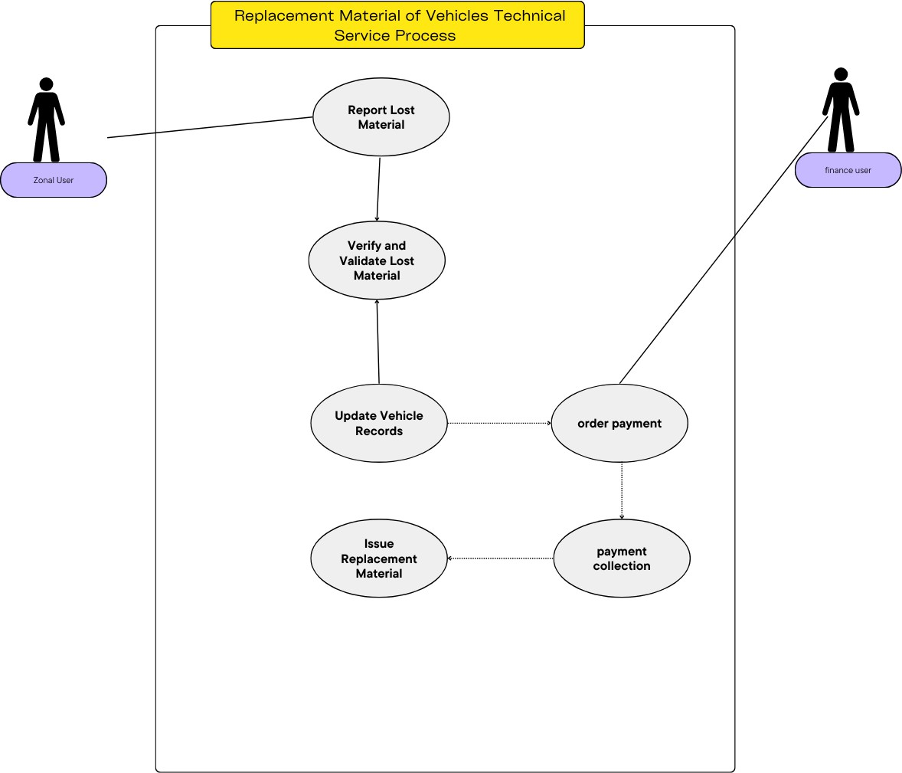

*Figure 10 material replacement use case diagram*

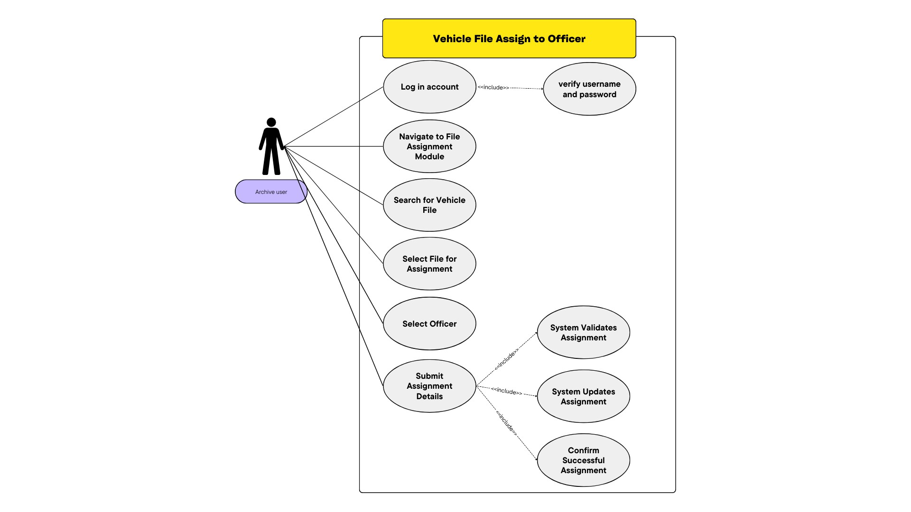

*Figure 11 vehicle assign to officer use case diagram*

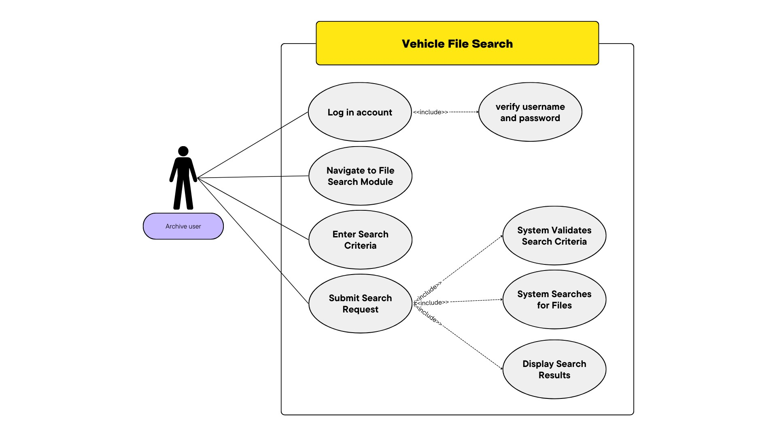

*Figure 12 vehicle file search use case diagram*

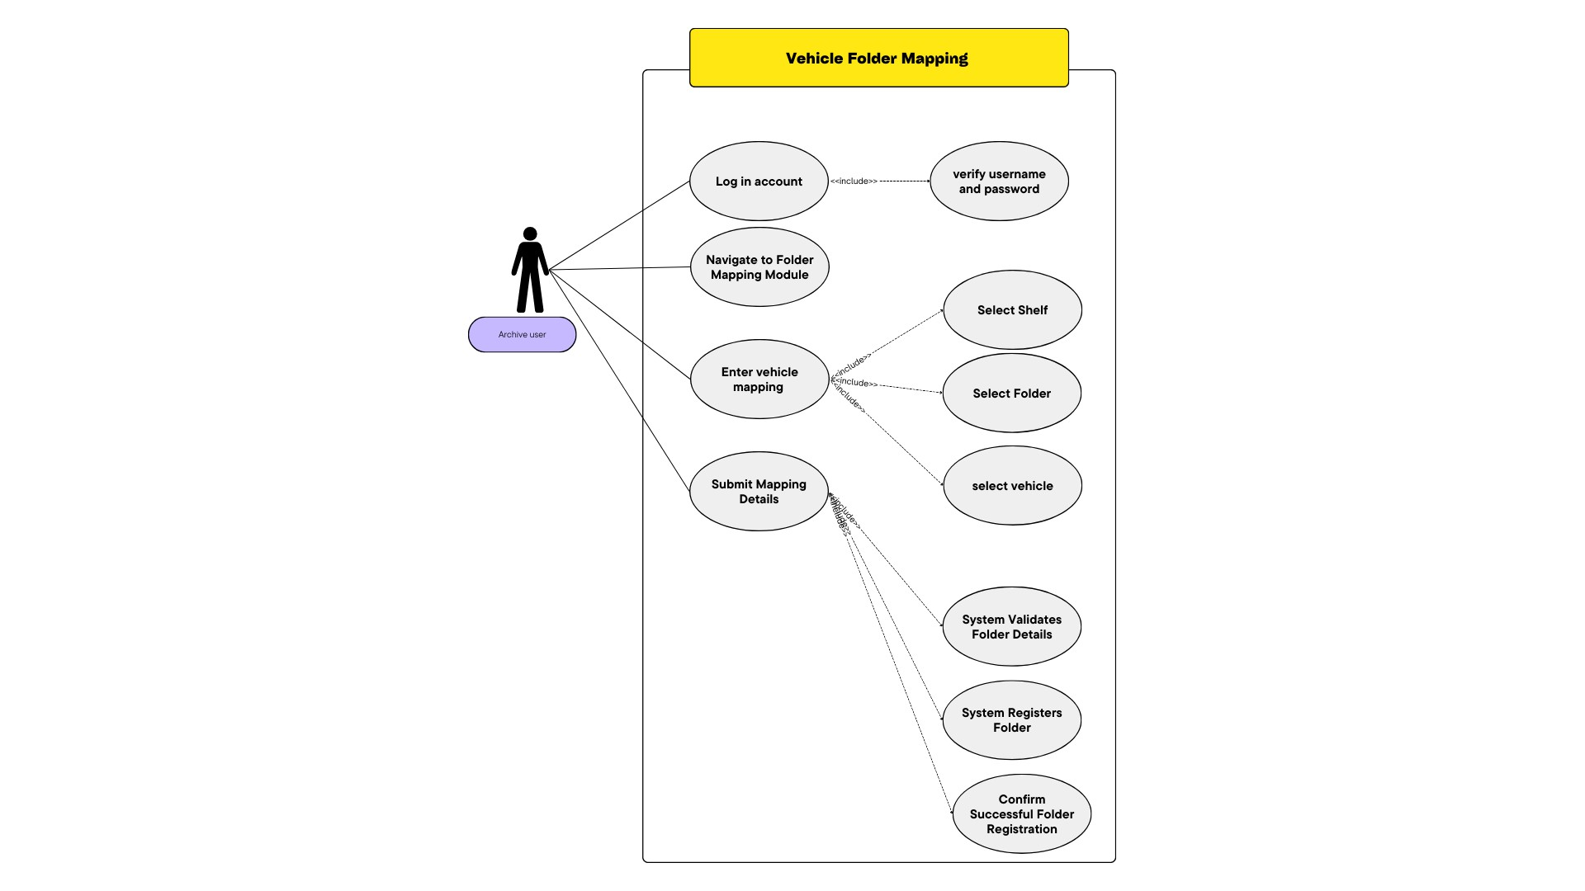

*Figure 13 vehicle folder mapping use case diagram*

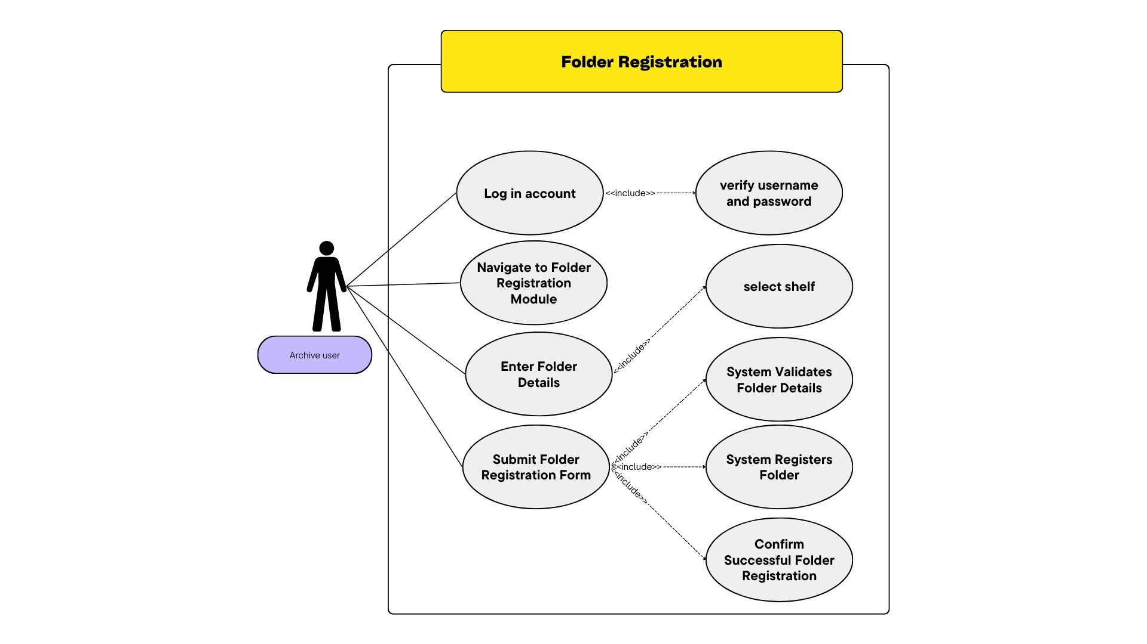

*Figure 14 Folder registration use case diagram*

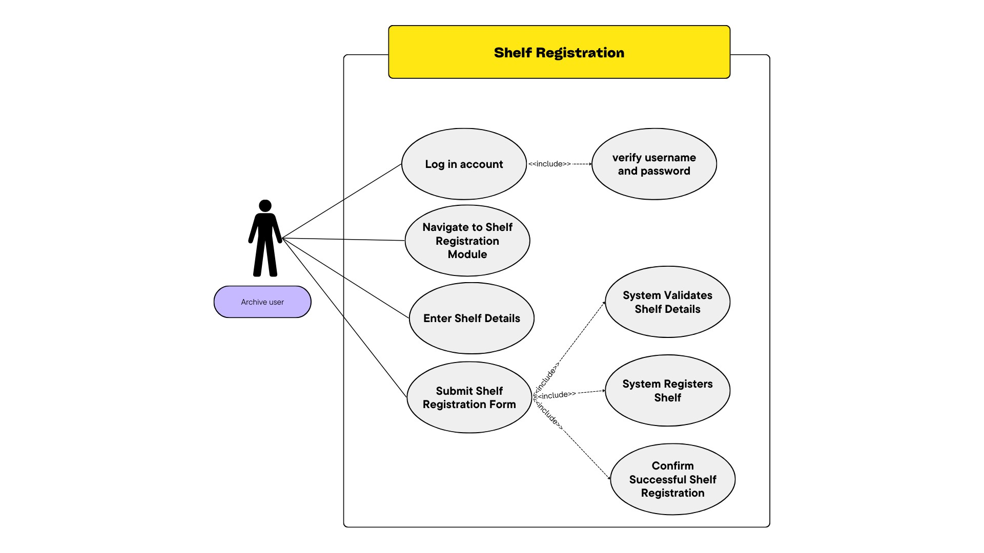

*Figure 15shelf registration use case diagram*

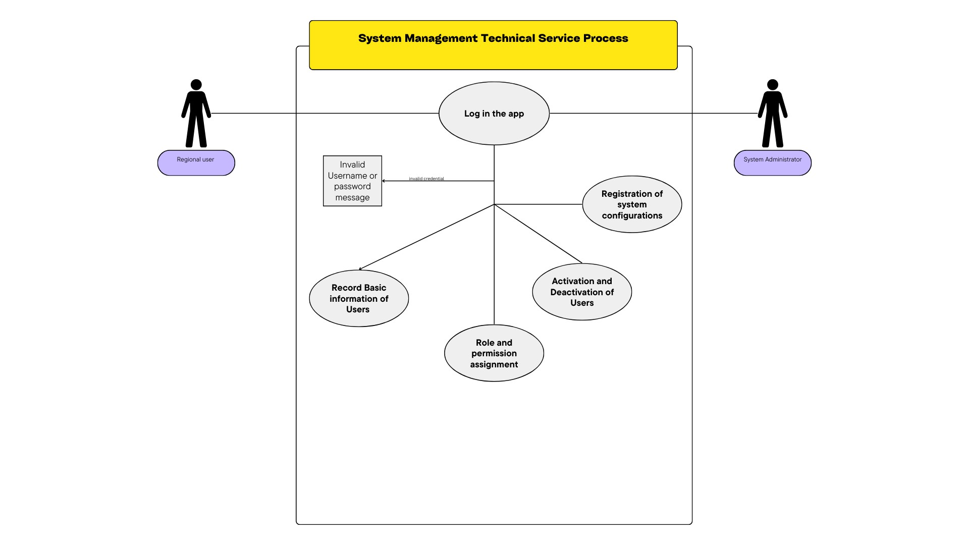

*Figure 16 system management use case diagram*

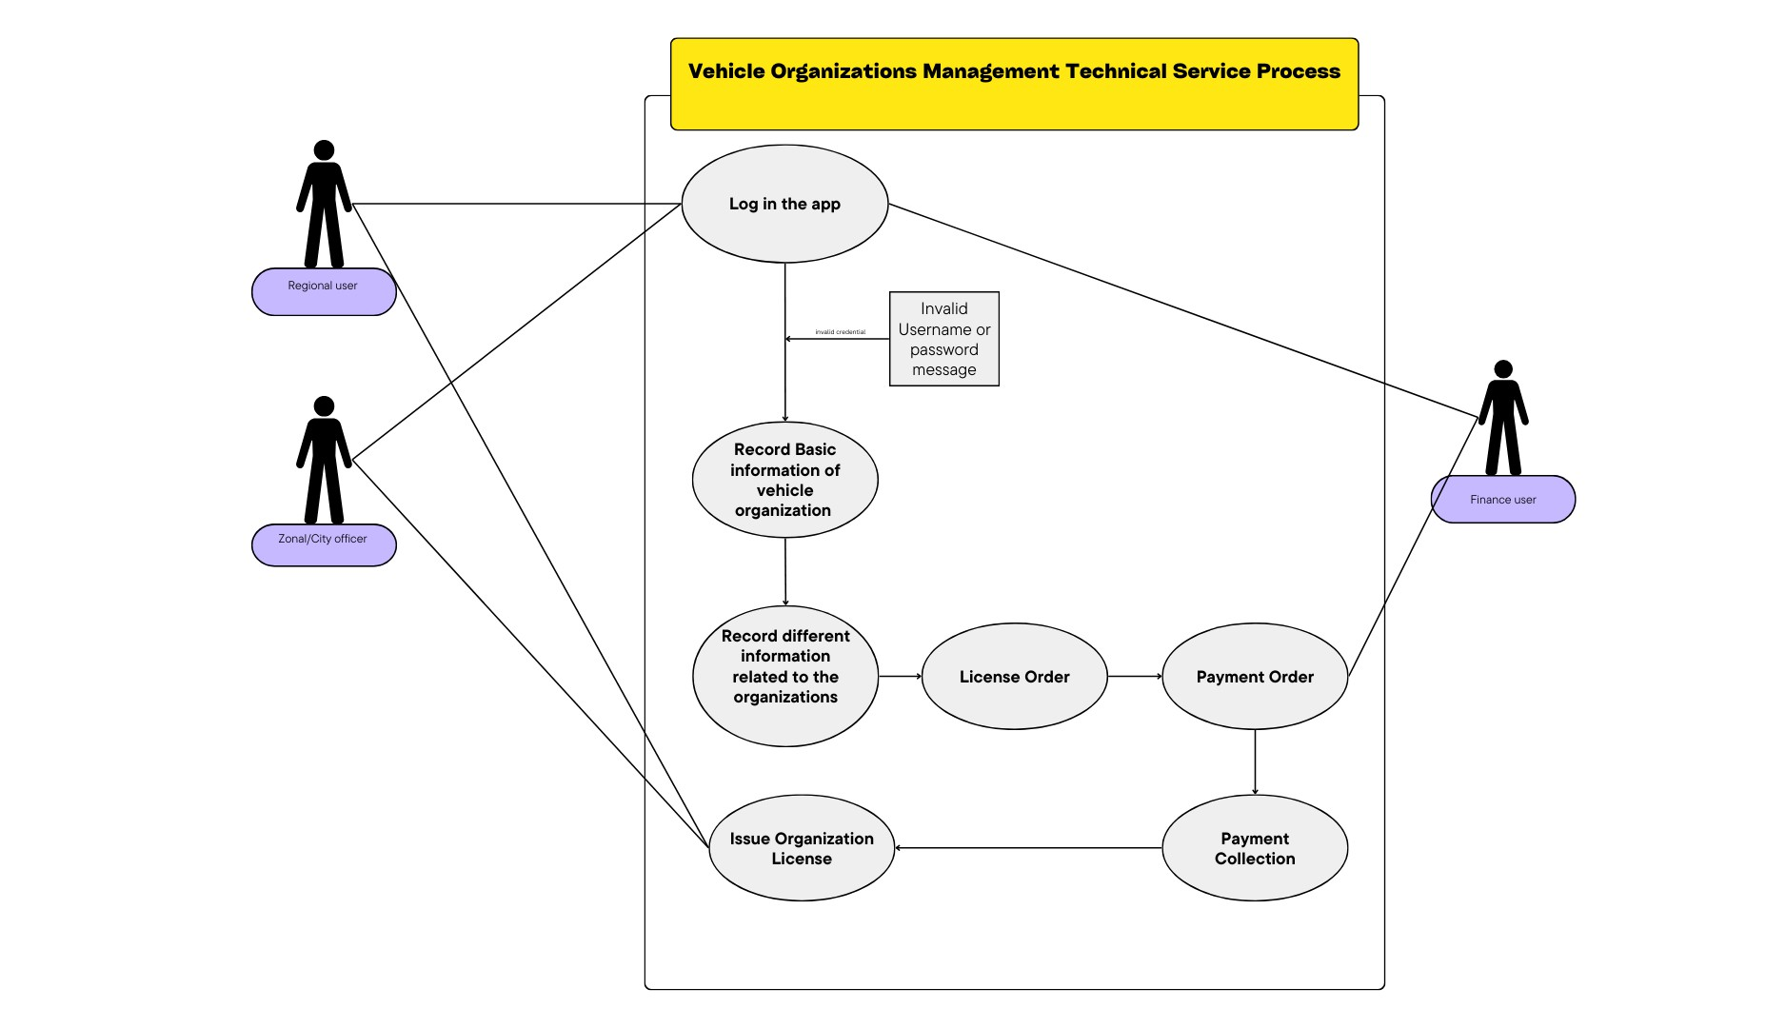

*Figure 17vehicle organization use case diagram*

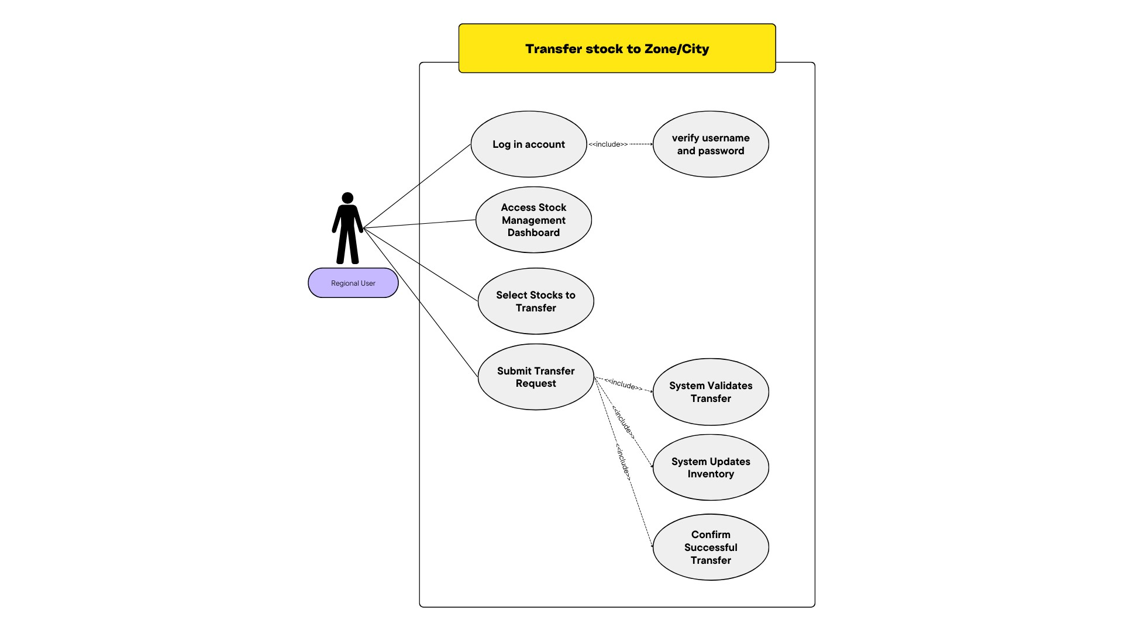

*Figure 18 stock transfer use case diagram*

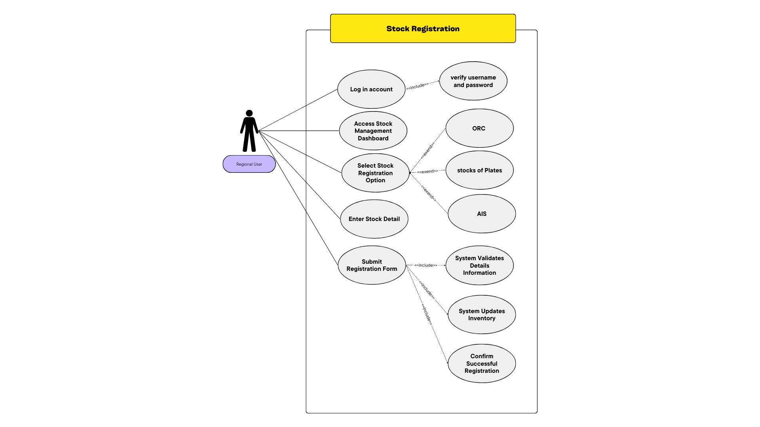

*Figure 19 stock registration use case diagram*

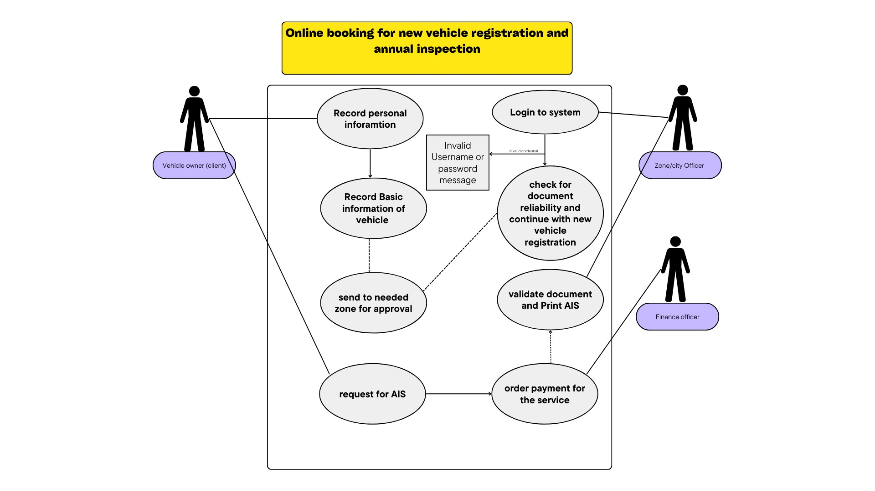

*Figure 20 Online booking use case diagram*

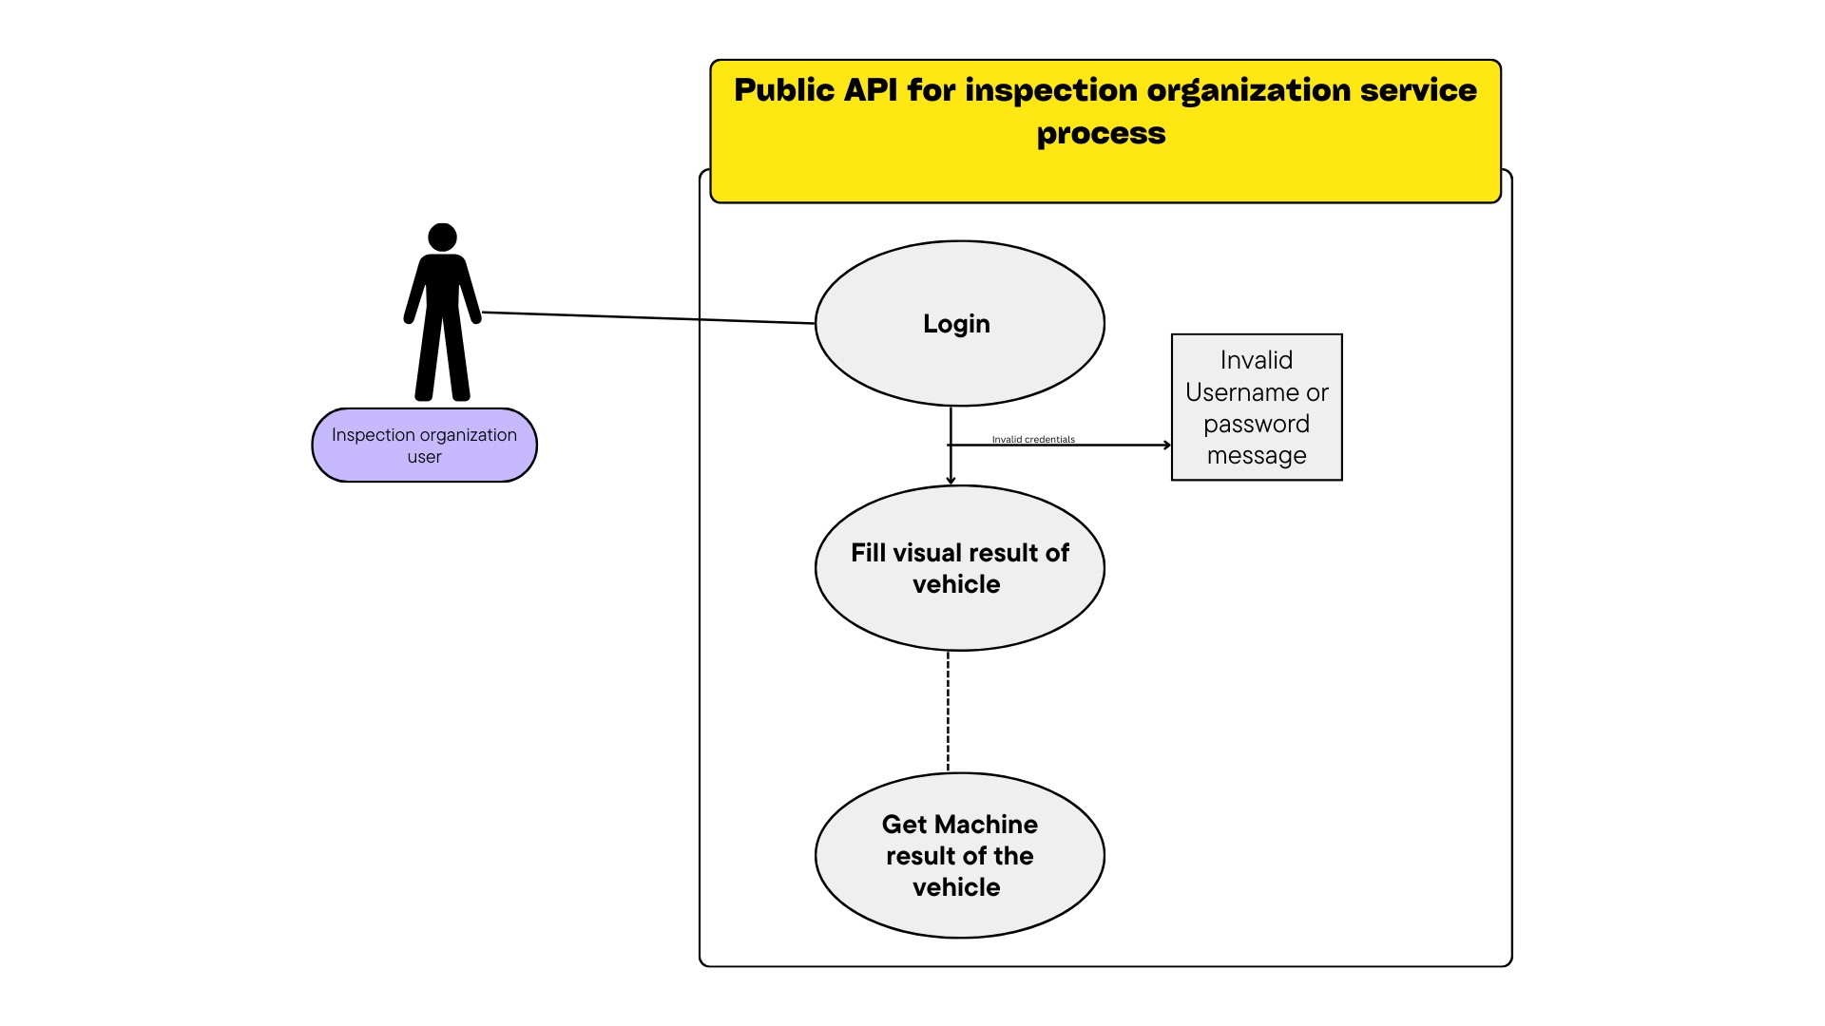

*Figure 21inspection organization use case diagram*

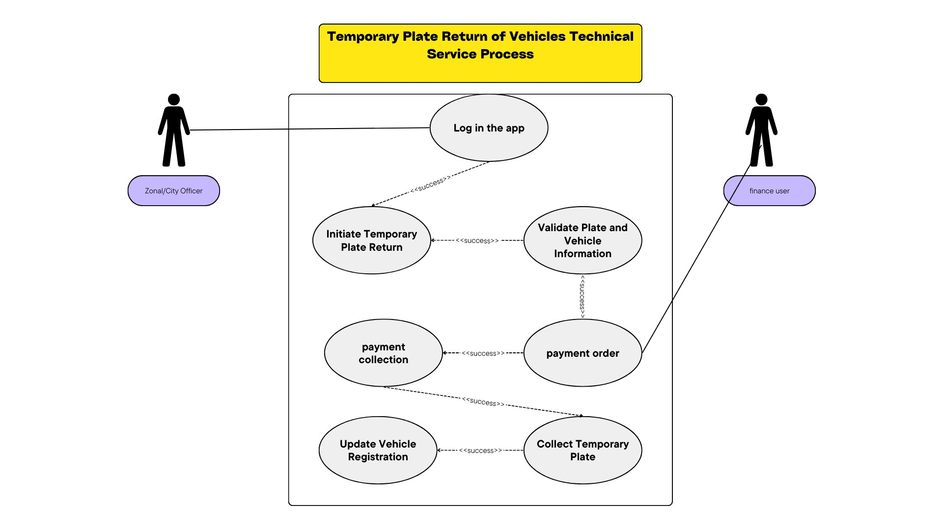

*Figure 22 temporary plate return use case diagram*

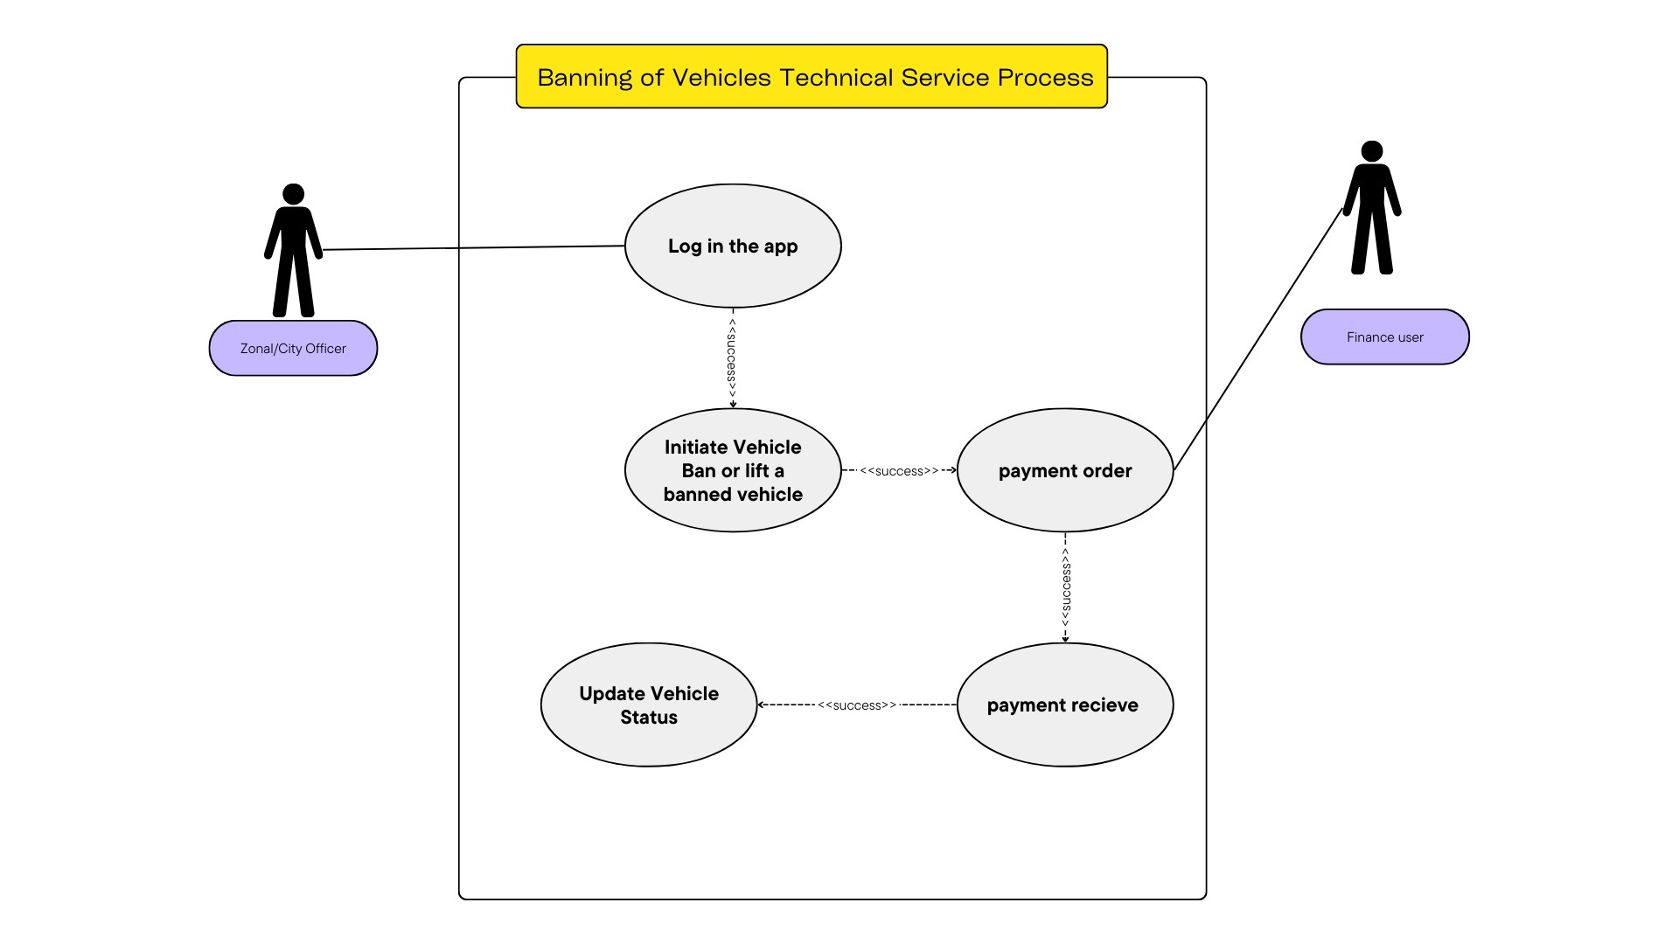

*Figure 23ban use case diagram*

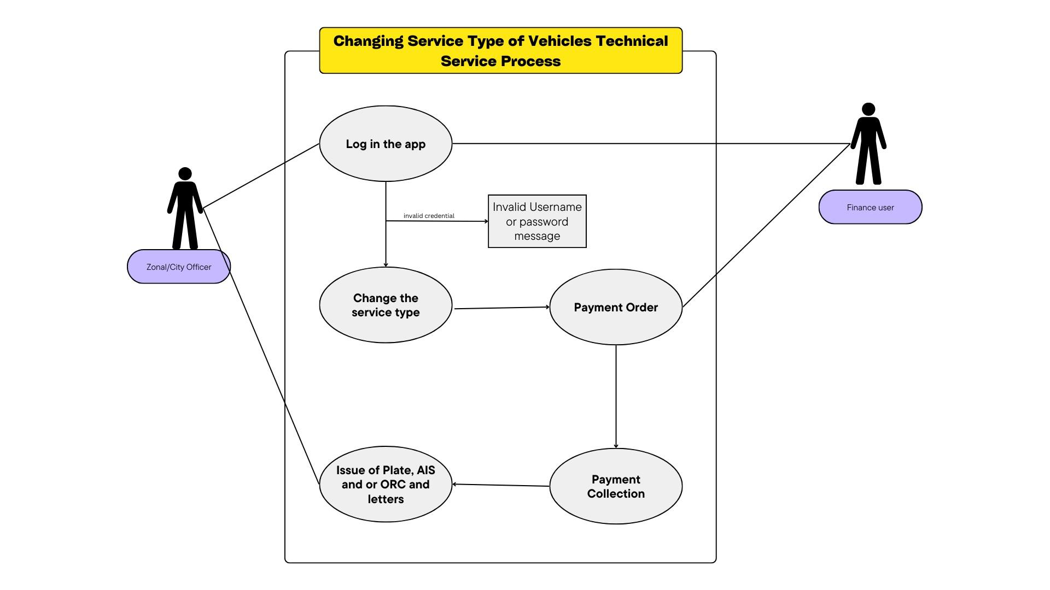

*Figure 24service change use case diagram*

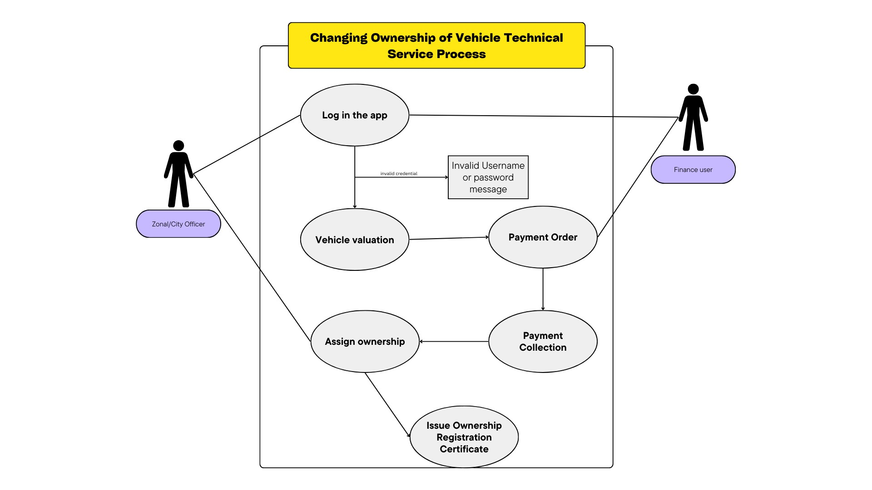

*Figure 25ownership change use case diagram*

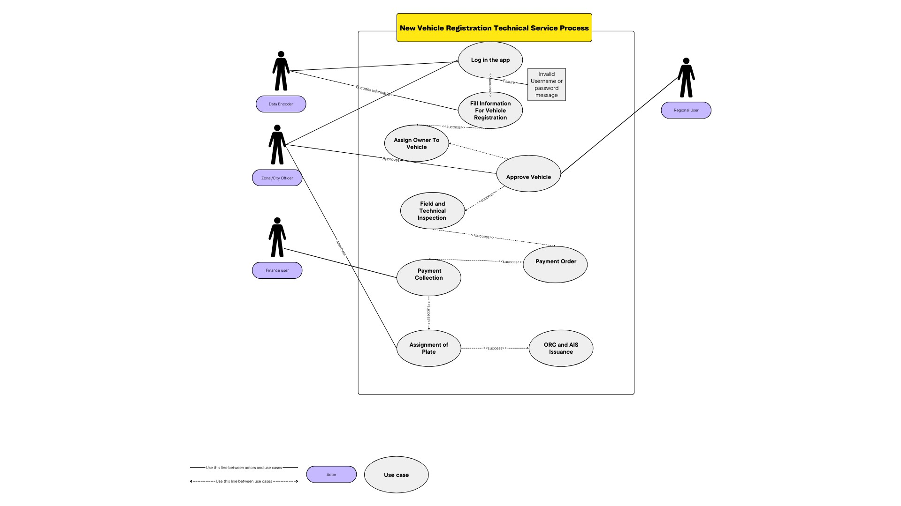

*Figure 26 new vehicle registration use case diagram*

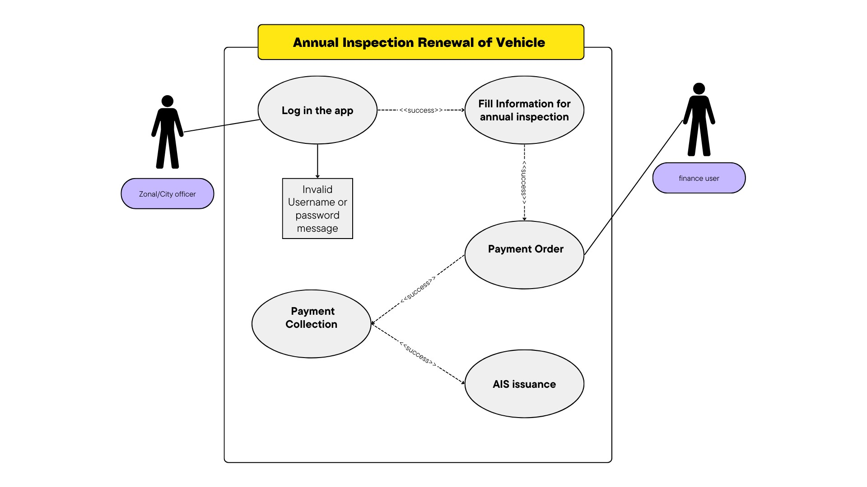

*Figure 27 annual inspection use case diagram*

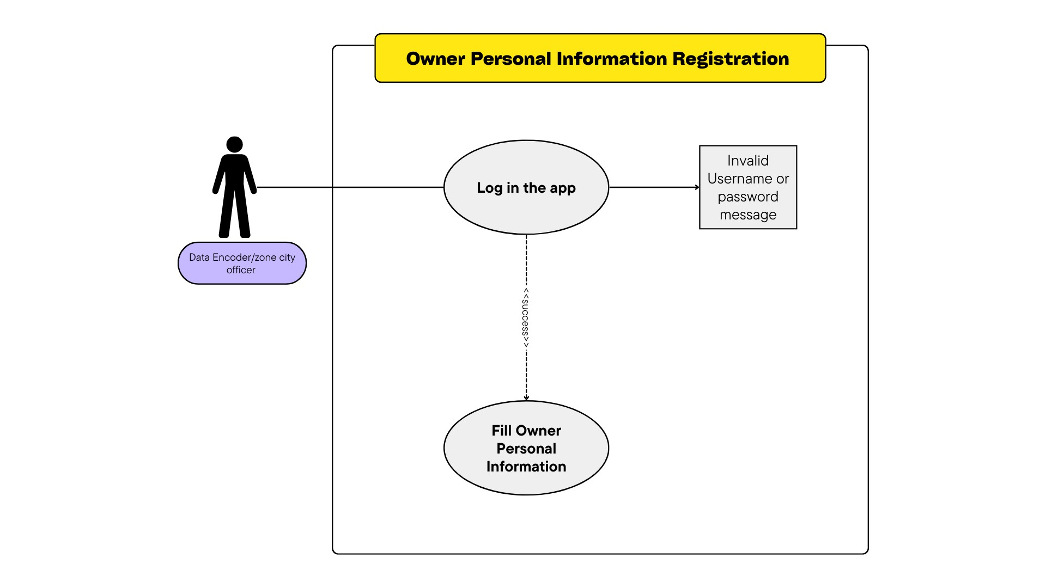

*Figure 28 personal information registration use case diagram*

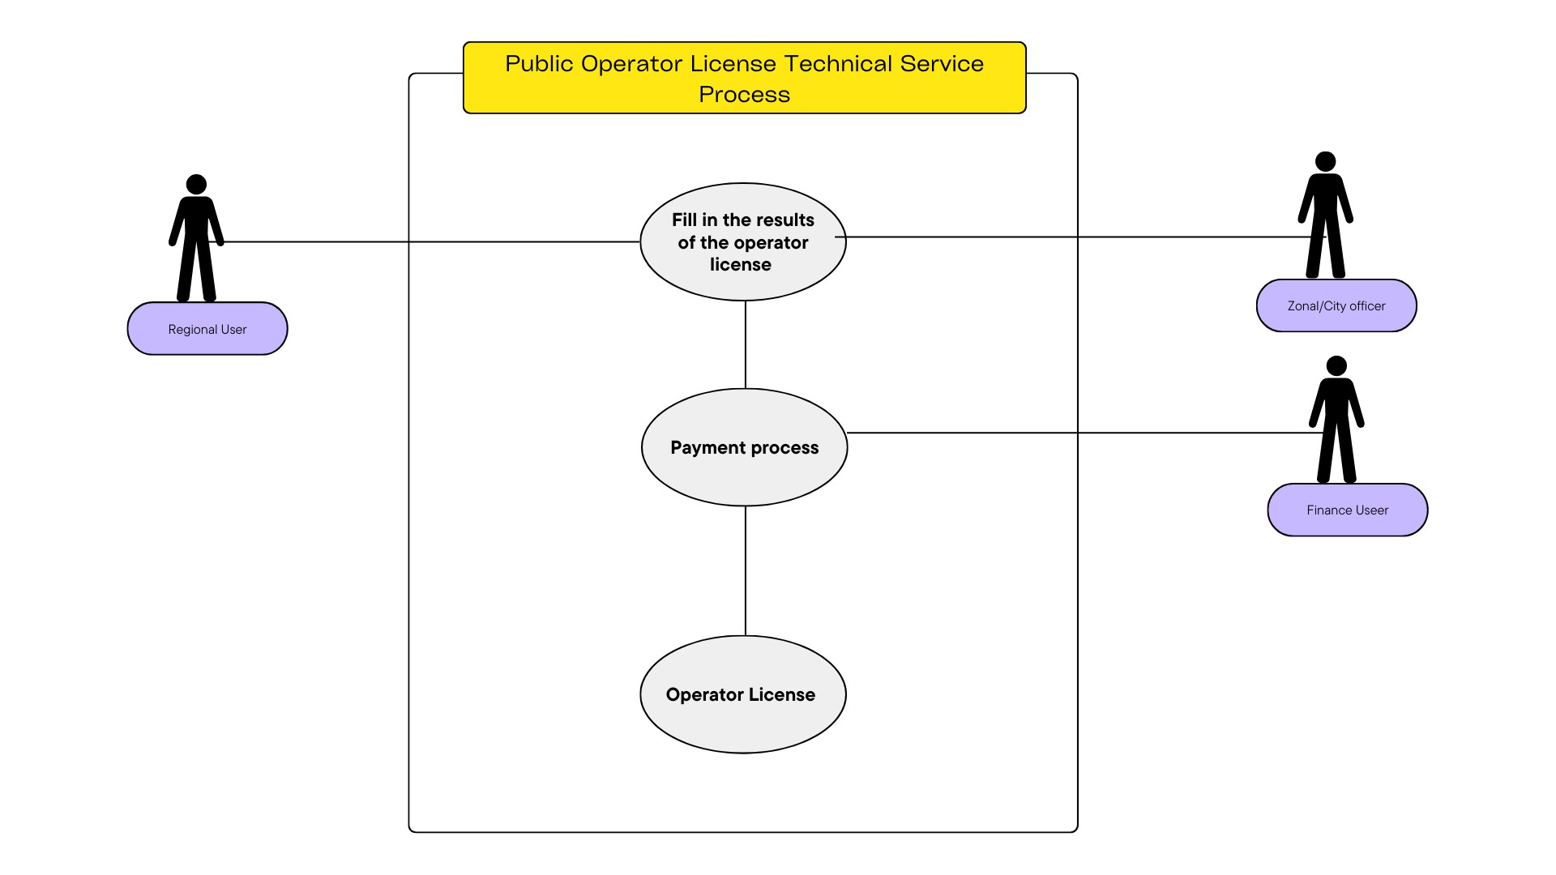

*Figure 29 public operator license use case diagram*

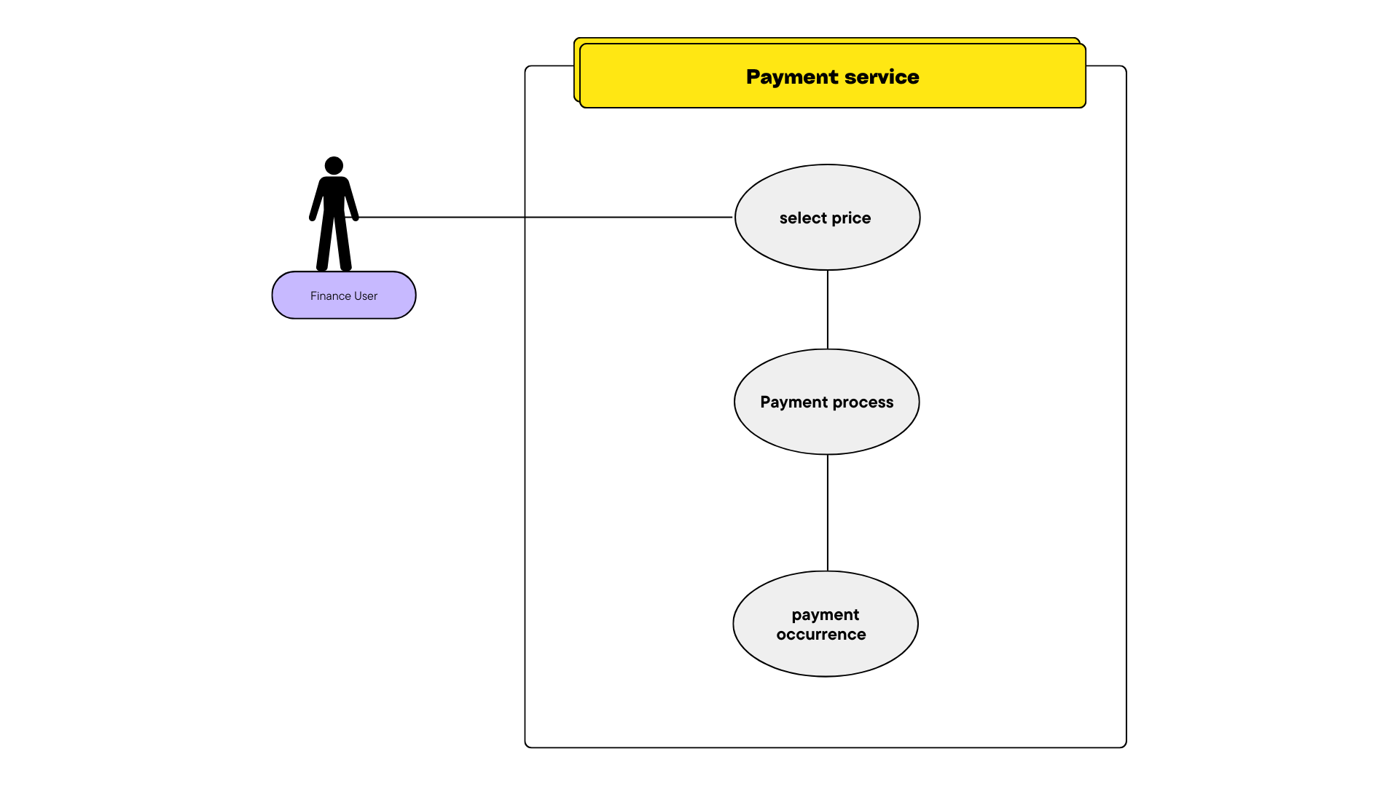

*Figure 30 payment use case diagram*



**2024**



Detail Description

|  |  |
| --- | --- |
| Use Case ID: | UC-001 |
| Use Case Name: | Register Personal information |
| Actors: | Data Encoder, Zone/city user |
| Description: | This use case describes the process of registering a new Owner in the TMS system |
| Trigger: | The personal information of the vehicle owner is needed to register vehicles and give other services to the system. |
| Preconditions: | The new owner has not been registered before |
| Normal Flow: | 1. The user navigates to personal information registration 2. The system displays owner lists with filter , add button 3. The user selects add 4. The user fills personal information with the address 5. The system validates the information 6. If the information is valid the system saves to database and if not the system displays error message so that the user can correct and register again 7. Use Case ends |
| Post conditions: | the owner has been saved to the system |
| Alternative Flow: | The user searches the owner   1. The system populates the owner 2. The user selects the edit button 3. The system populates edit field will all information 4. The user changes the asked information 5. The user selects the update button 6. If the changed information is valid the system saves to database and if not the system displays error message. 7. Use case ends |
| Exceptions: | The user may abandon the operation at any time |
| Priority: | High |



**2024**



|  |  |
| --- | --- |
| Frequency of Use: | Daily |
| Business Rules: |  |
| Special Requirements: |  |
| Assumptions: |  |
| Notes and TBD: |  |
| Sequence Diagram |  |

*Table 2 Personal information use case*

|  |  |
| --- | --- |
| Use Case ID: | UC-002 |
| Use Case Name: | Register Vehicle |
| Actors: | Data Encoder, Zone/City officer |
| Description: | This use case describes the process of registering a new vehicle in the TMS system. |
| Trigger: | There is a vehicle to be registered and given plate, AIS and ORC |
| Preconditions: | The new vehicle has not been registered before.  The mandatory fields or properties should be validated. |
| Normal Flow: | 1. The user navigates to new vehicle registration 2. The system will show the fields to be filled for new vehicle registration 3. The user fills the information 4. If the fields are valid the vehicle is successfully registered and registration number for the vehicle is generated if not the system will display error messages 5. End of use case |
| Post conditions: | The new vehicle information is stored in the vehicle database and can be accessed by authorized users. |
| Alternative Flow: | Edit Vehicle   1. The user navigates to vehicle menu 2. The user searches the vehicle by registration no 3. The system displays the information of the vehicle and edit button 4. The user clicks on edit button 5. The system redirects to the edit field of vehicle |



**2024**



|  |  |
| --- | --- |
|  | 1. The user fills the information and data to be changed 2. The user clicks on edit button 3. If the fields are valid the system updates the vehicle and redirects to vehicle details page if not the system displays error message. 4. end of use case |
| Exceptions: | The user may abandon the operation at any time |
| Priority: | Medium |
| Frequency of Use: | When a vehicle needs editing |
| Business Rules: |  |
| Special Requirements: |  |
| Assumptions: |  |
| Notes and TBD: |  |
| Sequence Diagram |  |

*Table 3 new vehicle registration use case*

|  |  |
| --- | --- |
| Use Case ID: | UC-003 |
| Use Case Name: | Map vehicle to owner |
| Actors: | Data Encoder, Zone/City officer |
| Description: | This use case describes the process of assigning owner to vehicle. |
| Trigger: | Vehicle is registered and ownership of vehicle needs to be registered |
| Preconditions: | The vehicle is registered The owner is registered |
| Normal Flow: | 1. after the successful registration of vehicle information the system suggests to navigate through owner assignment 2. the user selects the owner based on its ownership type (Training Center, private owners or organization) 3. if the user is not on the system there is a way to add owner information while being on that page 4. the owner is assigned successfully |



**2024**



|  |  |
| --- | --- |
|  | 5. end of use case |
| Post conditions: | the vehicle is ready for other process of vehicle |
| Alternative Flow: |  |
| Exceptions: | The user can assign the user later |
| Priority: | High |
| Frequency of Use: | Daily |
| Business Rules: |  |
| Special Requirements: |  |
| Assumptions: |  |
| Notes and TBD: |  |
| Sequence Diagram |  |

*Table 4 map vehicle to owner use case*

|  |  |
| --- | --- |
| Use Case ID: | UC-004 |
| Use Case Name: | Vehicle Approval |
| Actors: | Zonal/City officer, Regional user |
| Description: | The use case describes the process of approving the validity of a vehicle before giving other services to the client |
| Trigger: | Vehicle is registered successfully and is ready to be approved |
| Preconditions: | The vehicle is registered  The owner is mapped with the vehicle |
| Normal Flow: | 1. the officer navigates to vehicle details page 2. the officer finds the vehicle by the registration no 3. the officer clicks on the approve button 4. the system redirects to the edit page so that the officer can cross |

|  |  |
| --- | --- |
|  | check and approve   1. if all are correct the system approves the vehicle and returns a success message , if not the system will notify the errors of the vehicle 2. end of use case |
| Post conditions: | The vehicle is ready for field and technical inspection |
| Alternative Flow: | Administrative privileges needed for vehicle approval   1. the officer checks and doesn’t have privilege to approve the vehicle 2. the officer sends to the admin(Regional user) for approval 3. the admin(Regional user) will see the list of pending vehicles 4. the admin(Regional user)selects the vehicle to be approved 5. he has authority to approve the vehicle without the validations set by the system 6. the system approves and keeps the record |
| Exceptions: | The admin (regional user) can reject the vehicle |
| Priority: | High |
| Frequency of Use: | When there is vehicle to be approved |
| Business Rules: |  |
| Special Requirements: |  |
| Assumptions: |  |
| Notes and TBD: |  |
| Sequence Diagram |  |

*Table 5vehicle approval use case*

|  |  |
| --- | --- |
| Use Case ID: | UC-005 |
| Use Case Name: | Field and technical Inspection |
| Actors: | Zone/City officer |
| Description: | This use case describes the process of registering a new Field and technical Inspection in the TMS system. |

|  |  |
| --- | --- |
| Trigger: | Vehicle is approved and needs to record field and technical inspection |
| Preconditions: | 1. The vehicle should be registered and the owner should be mapped 2. The vehicle should be approved 3. If the same vehicles model have been registered then it gets the inspection information of the vehicle |
| Normal Flow: | 1. The officer goes to field and technical inspection of the vehicle detail 2. There is a button to add new field and technical inspection 3. If the model of the vehicle is already registered then the results of field and technical inspection will be shown 4. The officer will fill and correct the rest of the information 5. The officer will click on register button 6. If the fields are valid the field and technical inspection are saved to the system and the system will display success message if not the system will display error message with detailed errors 7. End of use case |
| Post conditions: | The new vehicle’s Field and technical Inspection information is stored in the database and can be accessed by authorized users. |
| Alternative Flow: | Edit field and technical inspection   1. The officer will get to the vehicle detail 2. The officer will select the active inspection 3. The officer will click on the edit button 4. The officer will correct the fields 5. If the fields are valid the system updates the field and technical inspection and displays success message if not the system will display error message with detailed errors |
| Exceptions: | The officer can fill the field and technical inspections separately |
| Priority: | High |
| Frequency of Use: | Daily |
| Business Rules: |  |
| Special Requirements: |  |
| Assumptions: |  |

|  |  |
| --- | --- |
| Notes and TBD: |  |
| Sequence Diagram |  |

*Table 6field and technical inspection use case*

|  |  |
| --- | --- |
| Use Case ID: | UC-006 |
| Use Case Name: | Assign plate number |
| Actors: | Zone/city officer |
| Description: | This use case describes the process of assigning plate from the transferred stock of the given zone/city |
| Trigger: | the vehicle is ready for plate assignment |
| Preconditions: | The payment should be done for a given service. |
| Normal Flow: | The officer navigates to the detail of the vehicle The officer clicks on the assign button  The officer selects the requirement for plate assignment  The system shows the plate no from the stock registered on that zone The officer assigns the plate to the vehicle  End of use case |
| Post conditions: | The vehicle will have a new registration number that will not be changed through the vehicles life time |
| Alternative Flow: | IF Vehicle is Backlog  The officers registers the plate The officer generates the plate The system shows the plate no  The officer assigns the plate to the vehicle |
| Exceptions: |  |
| Priority: | High |
| Frequency of Use: | Daily |
| Business Rules: |  |
| Special  Requirements: |  |
| Assumptions: |  |
| Notes and TBD: |  |
| Sequence Diagram |  |

*Table 7assign plate use case*

|  |  |
| --- | --- |
| Use Case ID: | UC-007 |
| Use Case Name: | Issue certificate of Ownership, and AIS |
| Actors: | Zone/city officer |
| Description: | This use case describes the process of assigning AIS and ORC and printing it so that the owner of the vehicle can attach the AIS to his/her windshield and take the ORC. |
| Trigger: | ORC and AIS is requested |
| Preconditions: | The plate of the vehicle is already assigned. |
| Normal Flow: | 1. The officer navigates to vehicle details page 2. The officer goes to ORC and AIS details 3. The officer orders the ORC and AIS 4. The system assigns ORC and AIS from the stock 5. The ORC and AIS is printed for use 6. End of use case |
| Post conditions: | The assigned ORC and AIS is stored in the database with unique Id. |
| Alternative Flow: |  |
| Priority: | Daily |
| Frequency of Use: |  |
| Business Rules: |  |
| Special Requirements: |  |
| Assumptions: |  |
| Notes and TBD: |  |
| Sequence Diagram |  |

*Table 8issue ORC use case*

|  |  |
| --- | --- |
| Use Case ID: | UC-008 |
| Use Case Name: | Annual inspection information |
| Actors: | Zone/city officer |
| Description: | This use case describes the process registering information regarding the annual inspection process of the VPA module |
| Trigger: | The vehicle is ready for annual inspection. |
| Preconditions: | The time is the annual inspection renewal period The vehicle is already registered  The vehicle is already inspected from inspection organizations The owner has other files needed to get the AIS |
| Normal Flow: | 1. The officer goes to the vehicle detail 2. The officer searches the vehicle 3. The officer views the annual inspection result and uploaded documents 4. The officer orders the AIS |
| Post conditions: | The Assigned AIS is stored in the database. |
| Alternative Flow: |  |
| Priority: | High |
| Frequency of Use: | Annual |
| Business Rules: |  |
| Special Requirements: |  |
| Assumptions: |  |
| Notes and TBD: |  |
| Sequence Diagram |  |

*Table 9 annual inspection use case*

|  |  |
| --- | --- |
| Use Case ID | UC-010 |
| Use Case Name | Issue AIS |
| Actors | Zone/city officer |

|  |  |
| --- | --- |
| Use Case ID | UC-010 |
| Description | This use case describes the process of assigning AIS and printing it so that the owner of the vehicle can attach it to his/her windshield. |
| Trigger | The AIS is ready for issuance |
| Preconditions | Payment is successful. |
| Normal Flow | 1. Zone/city officer assigns AIS. 2. System generates printout. 3. AIS is stored in the database. |
| Post conditions | The assigned AIS is stored in the database. |
| Alternative Flow |  |
| Exceptions | If there is no stock, a message for stock is empty.  If the stock number of the AIS is used, a message for stock is already assigned. |
| Priority |  |
| Effort/Complexity |  |
| Frequency of Use |  |
| Business Rules |  |
| Special Requirements |  |
| Assumptions |  |
| Notes and TBD |  |
| Sequence Diagram |  |

*Table 10 issue AIS use case*

|  |  |
| --- | --- |
| Use Case ID | UC-010 |
| Use Case Name | Vehicle Valuation |
| Actors | Zonal/city officer |
| Description | This use case describes the process of determining the current fair market value of a vehicle using the system. |
| Trigger | The owner of the vehicle wants to transfer the ownership to another |
| Preconditions | The vehicle's details (make, model, and year) are available.  The necessary data sources for vehicle valuation are integrated and accessible. |
| Normal Flow | 1. Zonal/city officer finds vehicle by plate number or chassis number. 2. System retrieves and displays vehicle values. 3. The officer goes to valuation tab 4. Execute valuation is displayed 5. The officer clicks on the execute valuation 6. The results of the valuation fields will be displayed and selectable fields will also be shown 7. The officer will fill in the fields 8. The system calculates the total value 9. The officer then saves 10. End of use case |
| Post conditions | The vehicle's valuation details are stored in the TMS database. Valuation Reports are printed |
| Alternative Flow | Edit valuation   1. The officer goes to the active valuation 2. The officer clicks on edit button 3. The officer edits the fields 4. The officer saves Cancel Valuation 5. The officer goes to the active valuation 6. The officer clicks on cancel valuation button 7. The system cancels the current process |
| Exceptions | If the vehicle's details are incomplete or inaccurate, the valuation process cannot be completed successfully.  If the data sources for vehicle valuation are unavailable or unreliable, the valuation cannot be accurately determined.  If the user does not have the necessary permissions or access to view the vehicle's valuation. |
| Priority | Medium |
| Frequency of Use | When vehicle ownership needs to change or vehicle needs to be valuated |
| Business Rules |  |

|  |  |
| --- | --- |
| Special Requirements |  |
| Assumptions |  |
| Notes and TBD |  |
| Sequence Diagram |  |

*Table 11 valuation use case*

|  |  |
| --- | --- |
| Use Case ID | UC-011 |
| Use Case Name | Assign Ownership of Vehicle |
| Actors | Zonal/city officer |
| Description | This use case describes the process of assigning ownership of a vehicle in the Transportation Management System (TMS). |
| Trigger | Valuation is finished and owner needs to be changed |
| Preconditions | * The necessary documents must be brought by the owner. * The vehicle is currently registered in the TMS system. * The current owner has the necessary documentation to transfer ownership. * The new owner has the required information and documentation to be registered as the new owner. * Payment has occurred |
| Normal Flow | 1. The officer goes to the active valuated vehicle 2. The officer clicks on the assign owner button 3. The officer changes the vehicle ownership to the new owner 4. The system saves the changes 5. End use case |
| Post conditions | The new owner's information is stored in the vehicle's registration records. The current owner is no longer liable for the vehicle's operation or ownership. The vehicle's status in the TMS system reflects the updated ownership. |
| Alternative Flow |  |
| Exceptions | * If the current owner does not have the required documentation or authority to transfer ownership. * If the new owner does not provide the necessary information or documentation to be registered as the new owner. * If the vehicle's existing registration or ownership information is incomplete or inaccurate preventing a successful transfer. |
| Priority |  |
| Effort/Complexity |  |
| Frequency of Use |  |
| Business Rules |  |

|  |  |
| --- | --- |
| Special Requirements |  |
| Assumptions |  |
| Notes and TBD |  |
| Sequence Diagram |  |

*Table 12 assign owner use case*

|  |  |
| --- | --- |
| Use Case ID | UC-012 |
| Use Case Name | Change Service Type of Vehicle |
| Actors | Zone/city officer |
| Description | This use case describes the process of changing the service type of a vehicle registered in the Transportation Management System (TMS). |
| Trigger | The vehicle has changed its service |
| Preconditions | * The owner needs to bring the necessary documents or reference number for conducting service change. * The vehicle is currently registered in the TMS system. * The vehicle's current service type is known. * The new service type is valid and supported by the TMS system * In case of each change cases letter is needed. |
| Normal Flow | 1. The officer get the detail of the vehicle 2. The officer navigates to service change tab 3. The system display change button 4. The officer changes the service, Engine or service and body of the vehicle 5. The officer uploads the required documents and reference number 6. The officer changes the vehicle 7. The officer changes the field and technical inspection if needed 8. End of use case |
| Post Conditions | * The vehicle's updated service type is stored in the TMS database. * The vehicle owner or authorized users can view the change in the vehicle's information. * Any necessary updates to the vehicle's registration, insurance, or other related documents are triggered or communicated to the relevant parties. |
| Alternative Flow |  |
| Exceptions | * If the vehicle's current service type cannot be determined or is not found in the TMS system. * If the new service type is not a valid or supported option in the TMS system. * If the user does not have the necessary permissions or access to change the vehicle's service type. |

|  |  |
| --- | --- |
| Priority |  |
| Frequency of Use |  |
| Business Rules |  |
| Special Requirements |  |
| Assumptions |  |
| Notes and TBD |  |
| Sequence Diagram |  |

*Table 13 change service type use case*

|  |  |
| --- | --- |
| Use Case ID | UC-013 |
| Use Case Name | Ban a Vehicle |
| Actors | Zone officer |
| Description | This use case describes the process of banning a vehicle from the Transportation Management System (TMS). |
| Trigger | The vehicle is banned from different organizations |
| Preconditions | * The vehicle is currently registered and active in the TMS system. * There is a valid reason or legal directive to ban the vehicle |
| Normal Flow | 1. The officer finds the vehicle 2. The officer goes to ban tab 3. The officer clicks on ban button 4. The officer files the fields 5. The system bans the vehicle from different services 6. End of use case |
| Post Conditions | * The vehicle's registration and ownership information is maintained in the TMS system but its status is marked as "Banned". * The vehicle cannot change ownership or service change in the TMS system until the ban is lifted. * Authorized users can view the vehicle's banned status and the reason for the ban. |
| Alternative Flow | Lift Ban   1. The owner brings letter of ban lifting 2. The officer checks the letter 3. The officer goes to vehicle detail 4. Officer navigates to ban tab 5. The officer clicks on lift ban button 6. The officer fills the fields 7. The system lifts the ban of the vehicle |
| Exceptions | * If the vehicle is not found in the TMS system * If the officer does not have the necessary permissions or access to ban |

|  |  |
| --- | --- |
|  | the vehicle.   * If the reason for the ban is not valid or supported by the TMS system. |
| Priority | Medium |
| Frequency of Use | When there is ban |
| Business Rules |  |
| Special Requirements |  |
| Assumptions |  |
| Notes and TBD |  |
| Sequence Diagram |  |

*Table 14 ban use case*

|  |  |
| --- | --- |
| Use Case ID | UC-014 |
| Use Case Name | Temporary Deactivation of Vehicles |
| Actors | Zonal User |
| Description | This use case describes the process of returning a temporary deactivation/activation and temporarily returning a plate for a vehicle in the TMS system. |
| Trigger | The owner needs to return the vehicle temporarily |
| Preconditions | * The vehicle is approved and has a plate. * The user has the necessary permissions to perform the temporary plate return. |
| Normal Flow | 1. The officer will find the vehicle 2. The officer navigates to temporary deactivation page 3. The officer then fills the required fields 4. The system deactivates the vehicle for other actions 5. End of use case |
| Post conditions | * The vehicle is temporarily deactivated. * The officer cannot do anything until the vehicle gets activated again. |
| Alternative Flow | Reactivation of vehicle   1. The officer navigates to the currently deactivated vehicle 2. The officer clicks on the activate button 3. The vehicle is activated |
| Exceptions | The vehicle cannot be deactivated if it is in process of something. |
| Priority | Medium |
| Frequency of Use | Whenever there is request for deactivation and activation |
| Business Rules |  |
| Special Requirements |  |
| Assumptions |  |

|  |  |
| --- | --- |
| Notes and TBD |  |
| Sequence Diagram |  |

*Table 15Temporary deactivation use case*

|  |  |
| --- | --- |
| Use Case ID | UC-015 |
| Use Case Name | Managing Lost Material of Vehicles |
| Actors | Zone/City officer |
| Description | This use case describes the process of managing the loss of materials associated with a registered vehicle in the TMS system. |
| Trigger | When the owner loses plate, ORC or AIS |
| Preconditions | * The vehicle is already registered in the TMS system. * The user (vehicle owner or authorized representative) has the necessary information to report the lost material, with evidence brought by the owner. |
| Normal Flow | 1. The officer gets the vehicle detail 2. The officer navigates to replacement of materials 3. The officer clicks on replace button 4. The officer selects the type of material (Plate,AIS or ORC) 5. The officer selects the type of replacement ( LOST , Damaged or error) 6. The officer fills other required information 7. The officer clicks on save button 8. The system saves the changed fields 9. End of use case |
| Post conditions | The vehicle's updated information, including the details of the lost material and any replacement actions, is stored in the TMS system and can be accessed by authorized users. |
| Alternative Flow |  |
| Exceptions | * The user's reported loss cannot be verified or validated by the system. * The system is unable to update the vehicle's records due to technical or data-related issues. * The replacement material cannot be issued due to legal or regulatory restrictions. * The user does not provide the required information or documentation to complete the lost material management process. |
| Priority | Medium |
| Frequency of Use | Whenever there is request for replacement |

|  |  |
| --- | --- |
| Business Rules |  |
| Special Requirements |  |
| Assumptions |  |
| Notes and TBD |  |
| Sequence Diagram |  |

*Table 16 lost material use case*

|  |  |
| --- | --- |
| Use Case ID | UC-016 |
| Use Case Name | Fill in the Result of the Vehicle |
| Actors | Regional user |
| Description | This use case describes the process of filling in the result of the vehicle. |
| Trigger | The setting for operator license needs to be filled |
| Preconditions | The setting for public operator license has been filled. The vehicle has been given a plate. |
| Normal Flow | 1. The officer gets the vehicle detail 2. The officer goes to operator license tab 3. The officer gets the information from the setting 4. The officer clicks on the check boxes 5. The system calculates the level of the vehicle based on the settings 6. End of use case |
| Post conditions | The setting has been recorded |
| Alternative Flow | Mobile application   1. The officer logs in via mobile application 2. The officer searches the vehicle by plate no 3. The officer fills the information 4. The system will calculate the level if the vehicle |
| Exceptions | The level of the vehicle will not be set if the process is incomplete. |
| Priority | High |
| Frequency of Use | One time |
| Business Rules |  |
| Special Requirements |  |
| Assumptions |  |
| Notes and TBD |  |
| Sequence Diagram |  |

*Table 17 result of vehicle use case*

|  |  |
| --- | --- |
| Use Case ID: | UC-017 |
| Use Case Name: | Give operator license |
| Actors: | Zonal/city officer |
| Description: | This use case describes the process of printing the operator license for the vehicle owner. |
| Trigger: | the vehicle needs leveling |
| Preconditions: | * The vehicle has been assigned plate * The vehicle annual operator license has started * Payment has occurred |
| Normal Flow: | 1. The officer gets the vehicle detail 2. The officer goes to operator license tab 3. The officer prints the operator license certificate |
| Post conditions: | * Payment will be ordered * After payment collection y]the owner will have printed result of the vehicle operator license |
| Alternative Flow: |  |
| Exceptions: |  |
| Priority: | Medium |
| Frequency of Use: | Annual |
| Business Rules: |  |
| Special Requirements: |  |
| Assumptions: |  |
| Notes and TBD: |  |
| Sequence Diagram |  |

*Table 18 Give operator license use case*



**2024**



|  |  |
| --- | --- |
| Use Case ID: | UC-018 |
| Use Case Name: | Vehicle Organization Registration |
| Actors: | Regional User / Zonal Officer |
| Description: | This use case describes the process of registering vehicle organizations Primary Actors: Regional User, Zonal/City officer |
| Trigger: | Organization is needed to be registered |
| Preconditions: | 1. The user is an authorized authority user with the necessary permissions to manage vehicle organizations. 2. The organization to be registered has not been registered in the   system before |
| Normal Flow: | 1. The user navigates to organization management menu 2. The user selects on the tab of needed organization 3. The user clicks on register button 4. The user fills the required fields 5. The system validates the system and saves to the system 6. End of use case |
| Post conditions: | The vehicle organization information is stored in the system database and can be accessed by authorized users |
| Alternative Flow: | Edit organization   1. The user navigates to the intended organization 2. The user clicks on edit button 3. The user changes the required changes 4. The system saves the updated changes Organization owner registration 5. The user goes to vehicle owner tab 6. The user registers the owner 7. The system save the updated changes Organization Equipment’s , compound and room 8. The user goes to specified tab 9. The user registers the values 10. The system save the updated changes |
| Exceptions: |  |
| Priority: | Medium |
| Frequency of Use: | When there is organization to be registered |
| Business Rules: |  |



**2024**



|  |  |
| --- | --- |
| Special Requirements: |  |
| Assumptions: |  |
| Notes and TBD: |  |
| Sequence Diagram |  |

*Table 19 organization registration use case*

|  |  |
| --- | --- |
| Use Case ID: | UC-019 |
| Use Case Name: | Importer plate mapping |
| Actors: | Regional User / Zonal Officer |
| Description: | The use case describes the process of assigning transit plate numbers for importer organizations so that the return month of the transit plate. |
| Trigger: | Importer organization has requested for plate |
| Preconditions: | * The organization has been registered with the relevant information * There is plate in stock for importer organization |
| Normal Flow: | 1. The user goes to importer organization tab 2. The user navigates to plates tab 3. The user select the plate 4. The user assigns the plate from the stock |
| Post conditions: | * The printout for the duration of the license is given to the organization |
| Alternative Flow: | Return Plate   1. The user goes to the given plate 2. The user selects the return plate 3. The plate is returned and ready to be used for another organization |
| Exceptions: |  |
| Priority: | Medium |
| Frequency of Use: |  |
| Business Rules: |  |



**2024**



|  |  |
| --- | --- |
| Special Requirements: |  |
| Assumptions: |  |
| Notes and TBD: |  |
| Sequence Diagram |  |

*Table 20 Importer plate use case*

|  |  |
| --- | --- |
| Use Case ID: | UC-020 |
| Use Case Name: | License generation |
| Actors: | Zonal/city officer |
| Description: | The use case describes the process of printing the license for the organization |
| Trigger: | The license has expired and/or new license is needed |
| Preconditions: | The payment has been successful |
| Normal Flow: | 1. The user goes to the organization 2. The user navigates to license page 3. The user prints the license |
| Post conditions: | License is given to the organization owner |
| Alternative Flow: |  |
| Exceptions: |  |
| Priority: | Medium |
| Frequency of Use: | When license expires |
| Business Rules: |  |
| Special Requirements: |  |
| Assumptions: |  |
| Notes and TBD: |  |
| Sequence Diagram |  |

*Table 21 organization license use case*

|  |  |
| --- | --- |
| Use Case ID: | UC-021 |
| Use Case Name: | User registration |
| Actors: | System Administrator, IT support, Regional user |
| Description: | This use case describes the process of registration of users that use the TMS system. |
| Trigger: | User is needed to access the system |
| Preconditions: | The user has not been registered in to the system. |
| Normal Flow: | 1. The admin navigates to user management service 2. The admin creates a user for regional , zonal and city and inspection organization user 3. The admin then gives roles to the other zone (if needed) 4. The system saves the user to the database 5. End of use case |
| Post conditions: | User is ready for role and permission assignment |
| Alternative Flow: | Edit user   1. The user gets the user that needs to be edited 2. The user clicks on edit button 3. The system saves the data to the database |
| Exceptions: |  |
| Priority: | High |
| Frequency of Use: | When user is created or needs to be edited |
| Business Rules: |  |
| Special Requirements: |  |
| Assumptions: |  |
| Notes and TBD: |  |
| Sequence Diagram |  |

*Table 22 user registration use case*

|  |  |
| --- | --- |
| Use Case ID: | UC-022 |
| Use Case Name: | Role and permission assignment |
| Actors: | System Administrator, IT support |
| Description: | This use case describes the process of assigning roles and permissions for the user after successful registration. |
| Trigger: | Permission and role is needed for the user to access the system |
| Preconditions: | User is registered in to the system |
| Normal Flow: | 1. The admin navigates to the needed user 2. The admin assigns or revokes the permission of the user |
| Post conditions: | User is ready to take action based on the permission it is given |
| Alternative Flow: |  |
| Exceptions: |  |
| Priority: | High |
| Frequency of Use: | When there needs to be permission to be given or revoked |
| Business Rules: |  |
| Special Requirements: |  |
| Assumptions: |  |
| Notes and TBD: |  |
| Sequence Diagram |  |

*Table 23 role and permission use case*

|  |  |
| --- | --- |
| Use Case ID: | UC-023 |
| Use Case Name: | Activation and deactivation of user |
| Actors: | System Administrator, IT support |
| Description: | This use case describes the process of deactivating and activating the user based on different circumstances in the agency. |
| Trigger: | The user needs to be activated or deactivated |
| Preconditions: | * To activate the user must be inactive * To deactivate the user must be active |
| Normal Flow: | 1. The admin navigates to the needed user 2. The admin activates or deactivates the user |
| Post conditions: | * If deactivated user will no longer have access to the system * If activated the user will have access to the system (there is no need to assign role and permission again) |
| Alternative Flow: |  |
| Exceptions: |  |
| Priority: | High |
| Frequency of Use: | When user needs to be activated or deactivated |
| Business Rules: |  |
| Special Requirements: |  |
| Assumptions: |  |
| Notes and TBD: |  |
| Sequence Diagram |  |

*Table 24 Activation user use case*

|  |  |
| --- | --- |
| Use Case ID: | UC-024 |
| Use Case Name: | System registration |
| Actors: | System Administrator, IT support, Regional user |
| Description: | This use case describes the process of registration of system settings that later are going to be used for major transactions of the Vehicle Proficiency Assurance this settings will be chosen as a drop down. |
| Trigger: | Setting needs to be added to the system |
| Preconditions: | The name of the setting has not been recorded |
| Normal Flow: | 1. The user goes to vehicle settings page 2. The user registers the setting 3. The system saves to database |
| Post conditions: | The settings are ready for access |
| Alternative Flow: |  |
| Exceptions: |  |
| Priority: |  |
| Effort/Complexity: |  |
| Frequency of Use: |  |
| Business Rules: |  |
| Special  Requirements: |  |
| Assumptions: |  |
| Notes and TBD: |  |
| Sequence Diagram |  |

*Table 25 system registration use case*

|  |  |
| --- | --- |
| Use Case ID: | UC-025 |
| Use Case Name: | Stock Registration |
| Actors: | Regional User |
| Description: | This use case describes the process of registration of Stocks that can be transferred to cities/zones across the agency offices. This stocks will be generated by the palate types of the agency like (01, 02, 03, 04, police,  transit, temporary and trailer) since the plate type can be managed by the regional user it can add whenever needed. |
| Trigger: |  |
| Preconditions: | The Plate, AIS and or ORC has not been registered to the system before |
| Normal Flow: | 1. The user navigates to Plate , AIS or ORC stock management 2. The user registers the stock 3. The system Saves the stocks to the database |
| Post conditions: | * Folder is not full * Folder is registered * Vehicle has finished registration |
| Alternative Flow: | Delete stock   1. The user selects the plate to be deleted 2. The system checks if the plate can be deleted 3. The user deletes the plate |
| Exceptions: |  |
| Priority: |  |
| Effort/Complexity: |  |
| Frequency of Use: |  |
| Business Rules: |  |
| Special Requirements: |  |
| Assumptions: |  |
| Notes and TBD: |  |
| Sequence Diagram |  |

*Table 26 stock registration use case*

|  |  |
| --- | --- |
| Use Case ID: | UC-026 |
| Use Case Name: | Stock Transfer |
| Actors: | Regional User |
| Description: | This use case describes the process of Transferring Stock from the agencies’ regional office to the different zone/city offices. |
| Trigger: | There is stock to transfer |
| Preconditions: | The stock has been registered successfully |
| Normal Flow: | 1. The user navigates to stock management page 2. The user selects the transfer button 3. The system transfers from region to zones 4. End of use case |
| Post conditions: | The Plate, AIS and or ORC are ready to be assigned to vehicle for different purposes |
| Alternative Flow: |  |
| Exceptions: |  |
| Priority: | High |
| Frequency of Use: |  |
| Business Rules: |  |
| Special Requirements: |  |
| Assumptions: |  |
| Notes and TBD: |  |
| Sequence Diagram |  |

*Table 27stock transfer use case*

|  |  |
| --- | --- |
| Use Case ID: | UC-027 |
| Use Case Name: | Submit Inspection Data |
| Actors: | Inspection Organization user |
| Description: | Inspection Organization submits inspection results to the vehicle registration system via the API. And the result of the machine will be integrated with the system to get information on the results of the vehicle. |
| Trigger: | The annual inspection of a vehicle is needed |
| Preconditions: | * Inspection Organization is authenticated and authorized. * Inspection data is ready for submission. |
| Normal Flow: | 1. The user finds the plate 2. The user checks the information of the vehicle 3. The user fills the visual inspection result of the vehicle 4. The user then uploads the machine result of the vehicle 5. End of use case |
| Post conditions: | Inspection data is recorded in the Vehicle Registration System. |
| Alternative Flow: |  |
| Exceptions: |  |
| Priority: |  |
| Effort/Complexity: |  |
| Frequency of Use: |  |
| Business Rules: |  |
| Special Requirements: |  |
| Assumptions: |  |
| Notes and TBD: |  |
| Sequence Diagram |  |

*Table 28 inspection data use case*

|  |  |
| --- | --- |
| Use Case ID: | UC-028 |
| Use Case Name: | Online registration use case |
| Actors: | Vehicle Owner |
| Description: | The vehicle owner logs into the online registration system and fills in the necessary personal and vehicle information to initiate the request for a plate, ORC, and AIS. |
| Trigger: | Owner wants to register its vehicle |
| Preconditions: | * The vehicle owner must have internet access. * The vehicle owner must have an account on the online registration system or be able to create one. |
| Normal Flow: | 1. The owner fills its personal information 2. The owner fills the vehicle information 3. The owner sends to wanted zone for approval and other services 4. End of use case |
| Post conditions: | The vehicle's information is stored in the online registration system, and the owner is notified to proceed to the next step. |
| Alternative Flow: |  |
| Exceptions: |  |
| Priority: |  |
| Effort/Complexity: |  |
| Frequency of Use: |  |
| Business Rules: |  |
| Special Requirements: |  |
| Assumptions: |  |
| Notes and TBD: |  |
| Sequence Diagram |  |

*Table 29 online registration use case*

|  |  |
| --- | --- |
| Use Case ID: | UC-029 |
| Use Case Name: | Shelf Registration |
| Actors: | Archive user |
| Description: | This use case describes the process of registration of shelf |
| Trigger: | There is a shelf to be registered |
| Preconditions: | There is no shelf name that has been recorded on that zone/city |
| Normal Flow: | 1. The user goes to archive settings 2. The user goes to shelf tab 3. The user fills the required information 4. The user saves to the system |
| Post conditions: | Shelf name is ready for use |
| Alternative Flow: | Edit folder   1. The user goes to the selected shelf 2. The user selects the edit button 3. The user edits the changes 4. The user saves the changes to the database |
| Exceptions: |  |
| Priority: |  |
| Effort/Complexity: |  |
| Frequency of Use: |  |
| Business Rules: |  |
| Special Requirements: |  |
| Assumptions: |  |
| Notes and TBD: |  |
| Sequence Diagram |  |

*Table 30 shelf registration use case*

|  |  |
| --- | --- |
| Use Case ID: | UC-030 |
| Use Case Name: | Folder Registration |
| Actors: | Archive user |
| Description: | This use case describes the process of registration of folder for archive management |
| Trigger: | There is a folder needed for archive management |
| Preconditions: | There is no folder name that has been recorded on that zone/city |
| Normal Flow: | 1. The user goes to archive settings 2. The user goes to folder tab 3. The user fills the required information 4. The user saves to the system |
| Post conditions: | folder name is ready for use |
| Alternative Flow: | Edit folder   1. The user goes to the selected folder 2. The user selects the edit button 3. The user edits the changes 4. The user saves the changes to the database |
| Exceptions: |  |
| Priority: |  |
| Effort/Complexity: |  |
| Frequency of Use: |  |
| Business Rules: |  |
| Special Requirements: |  |
| Assumptions: |  |
| Notes and TBD: |  |
| Sequence Diagram |  |

*Table 31 folder registration use case*

|  |  |
| --- | --- |
| Use Case ID: | UC-031 |
| Use Case Name: | Map vehicle to folder |
| Actors: | Archive user |
| Description: | This use case describes the process of mapping the vehicle to the folder until the folder becomes full. |
| Trigger: | The vehicle is ready to be archived. |
| Preconditions: | * Folder is not full * Folder is registered * Vehicle has finished registration |
| Normal Flow: | 1. The user navigates to vehicle archive menu 2. The user gets list of vehicles that have finished registration 3. The user maps the vehicle to the available folder |
| Post conditions: | Vehicle has a folder that it goes to its physical storage |
| Alternative Flow: | Find Folder   1. The user navigates to vehicle archive menu 2. The user searches the vehicle by plateNo , chassis no, registration no 3. The system shows the current location of the folder |
| Exceptions: |  |
| Priority: |  |
| Effort/Complexity: |  |
| Frequency of Use: |  |
| Business Rules: |  |
| Special Requirements: |  |
| Assumptions: |  |
| Notes and TBD: |  |
| Sequence Diagram |  |

*Table 32 Folder mapping use case*

|  |  |
| --- | --- |
| Use Case ID: | UC-032 |
| Use Case Name: | File assign to officer |
| Actors: | Archive user |
| Description: | This use case describes the process of assigning a file to officer and returning the file to its respective folder when the officer finishes. |
| Trigger: | File is requested from client |
| Preconditions: | Vehicle is in its respective folder |
| Normal Flow: | 1. After the user knows the location of the file 2. The user assigns the file to the officer by checking its current files |
| Post conditions: | Vehicle file is in the hands of the officer |
| Alternative Flow: |  |
| Exceptions: |  |
| Priority: |  |
| Effort/Complexity: |  |
| Frequency of Use: |  |
| Business Rules: |  |
| Special Requirements: |  |
| Assumptions: |  |
| Notes and TBD: |  |
| Sequence Diagram |  |

*Table 33 file assign to officer use case*

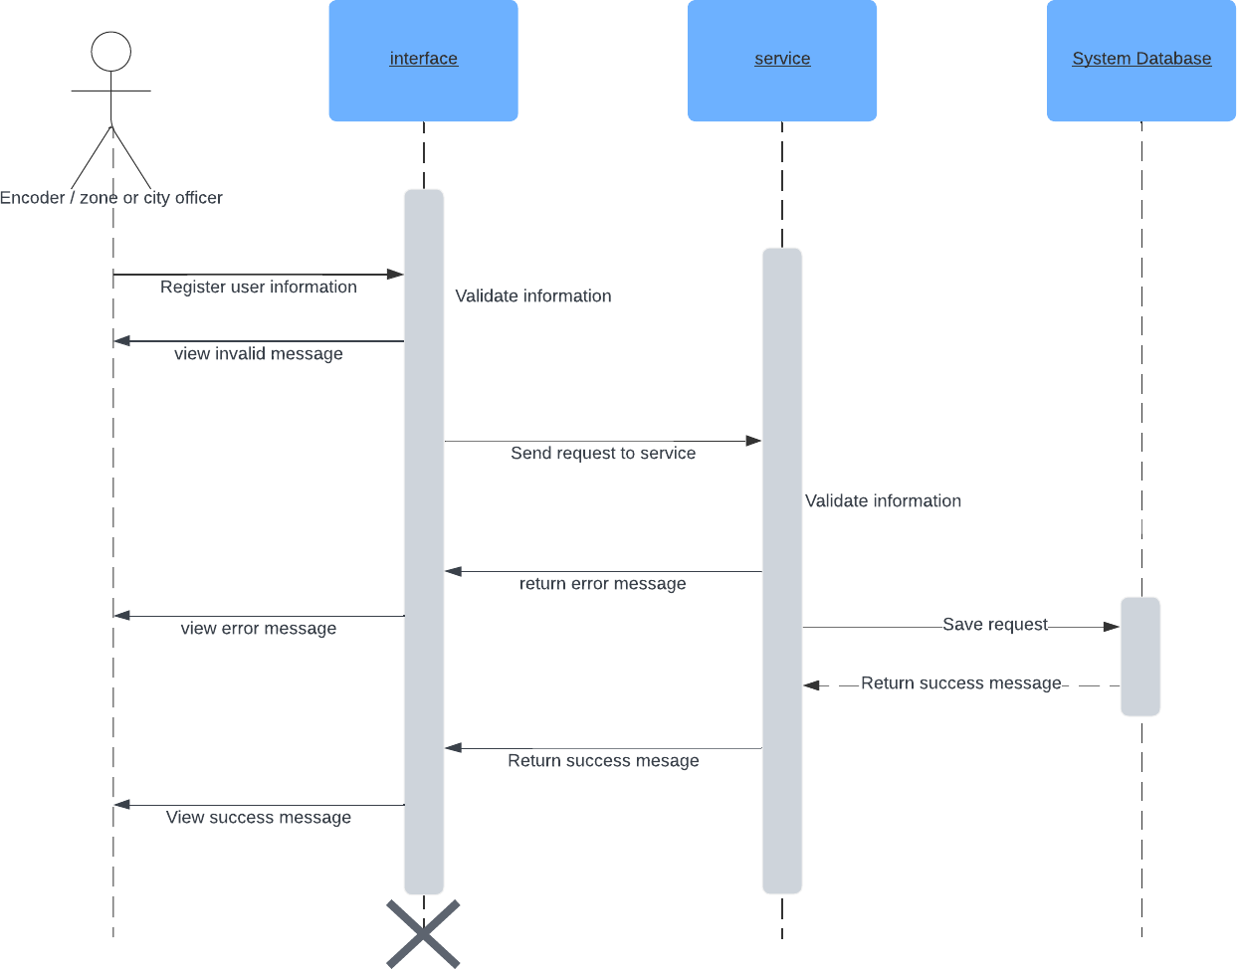Sequence Diagram

*Figure 31 user information sequence diagram*

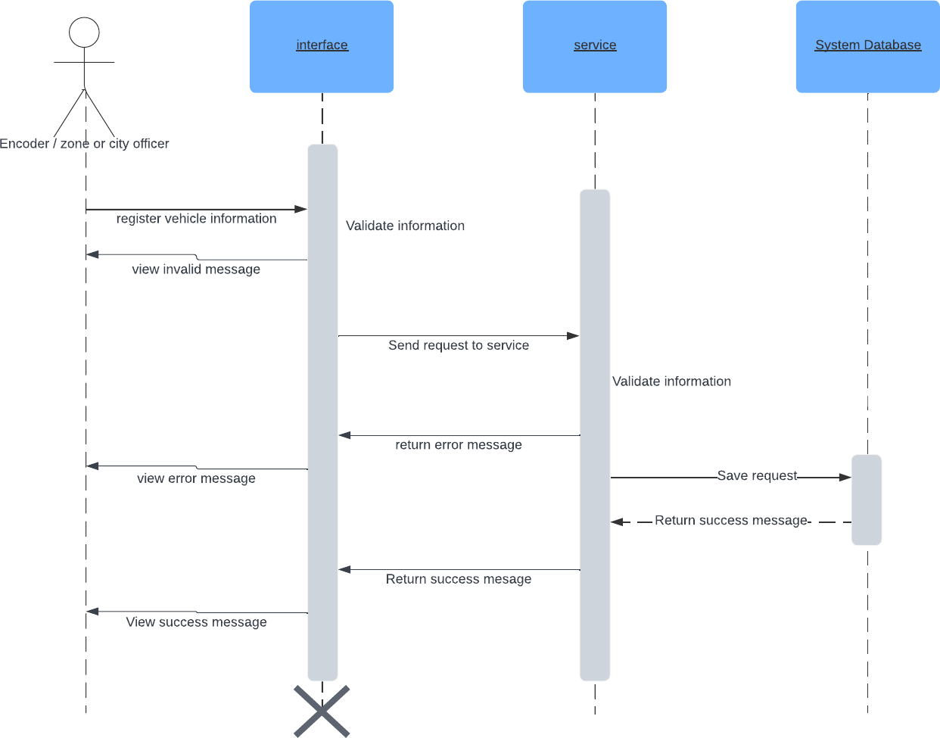

*Figure 32 register vehicle sequence diagram*

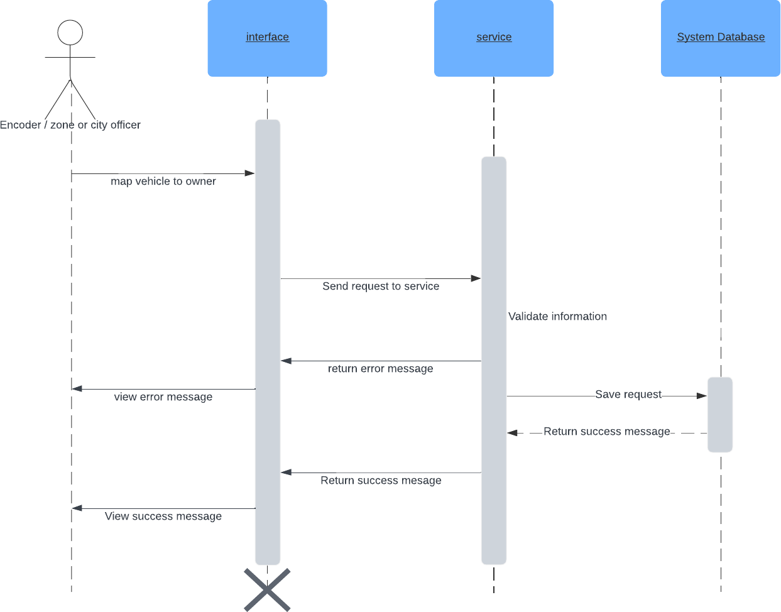

*Figure 33 map vehicle to owner sequence diagram*

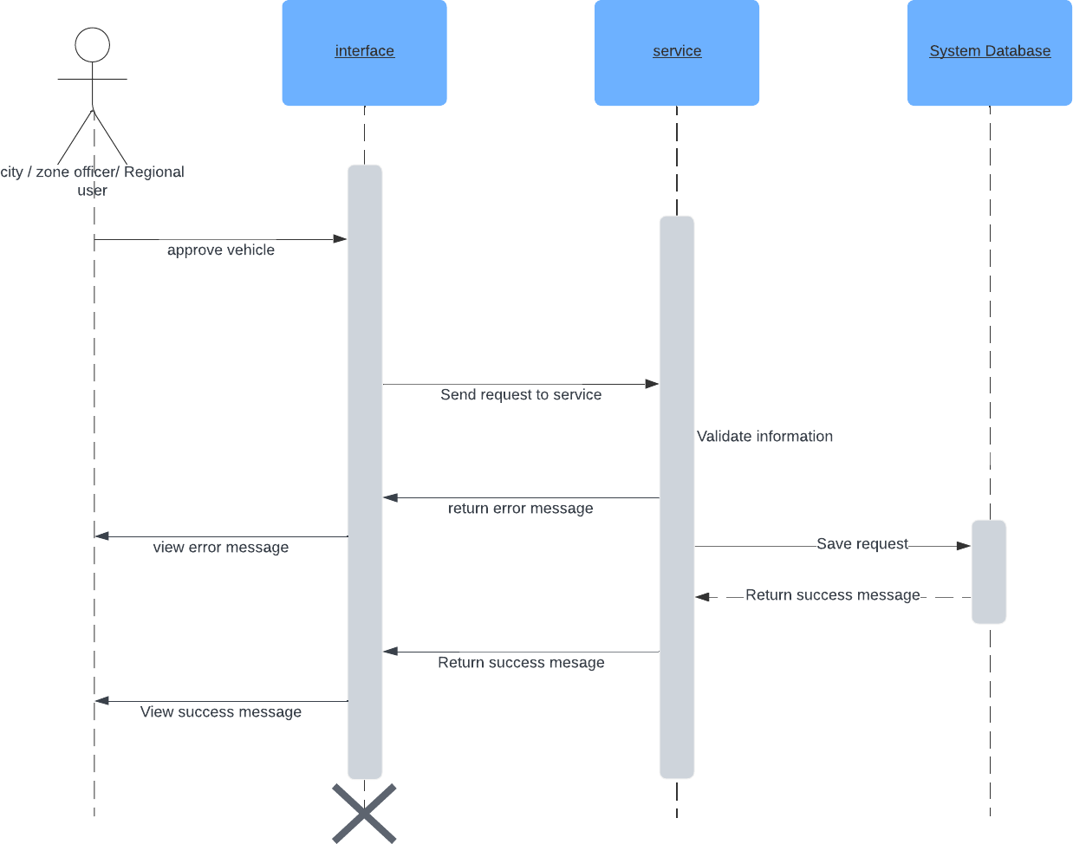

*Figure 34approve vehicle sequence diagram*

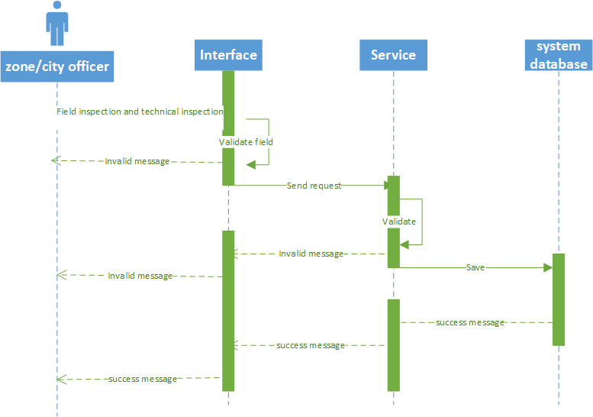

## 2024

*Figure 35 field and technical inspection sequence diagram*

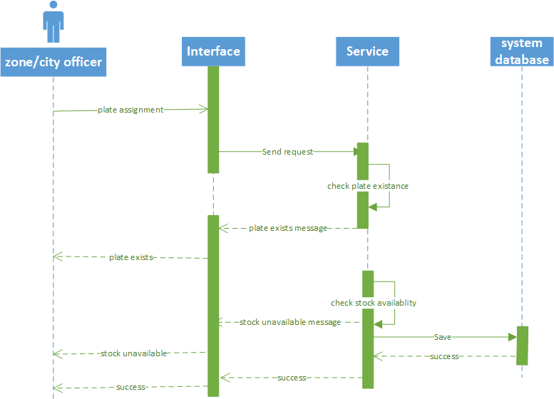

*Figure 36 plate assignment sequence diagram*

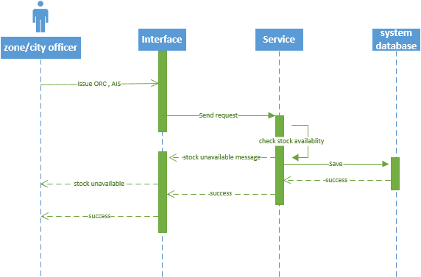

*Figure 37 issue ORC and AIS sequence diagram*



**2024**



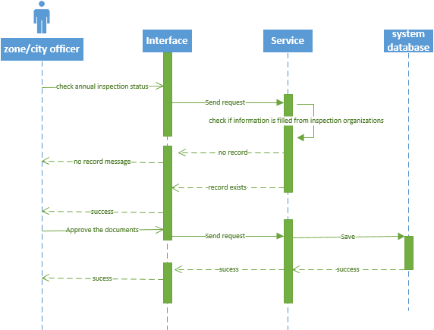

*Figure 38 annual inspection sequence diagram*



*Figure 39annual inspection sequence diagram*

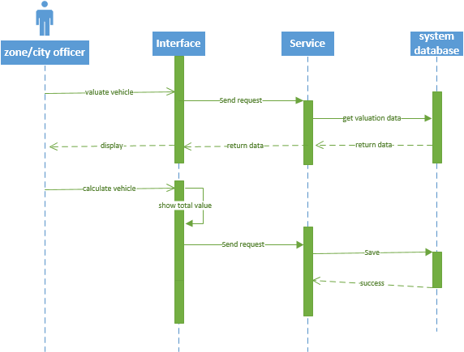

*Figure 40 valuation sequence diagram*

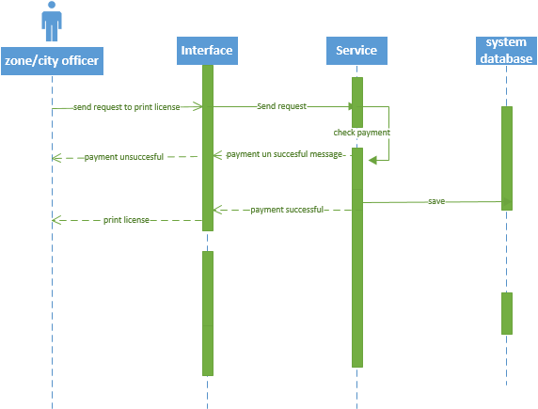

*Figure 41operator license sequence diagram*



**2024**



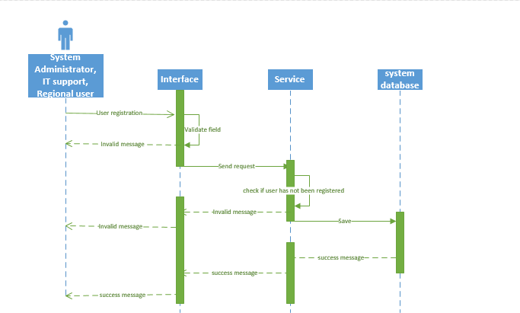

*Figure 42user registration sequence diagram*

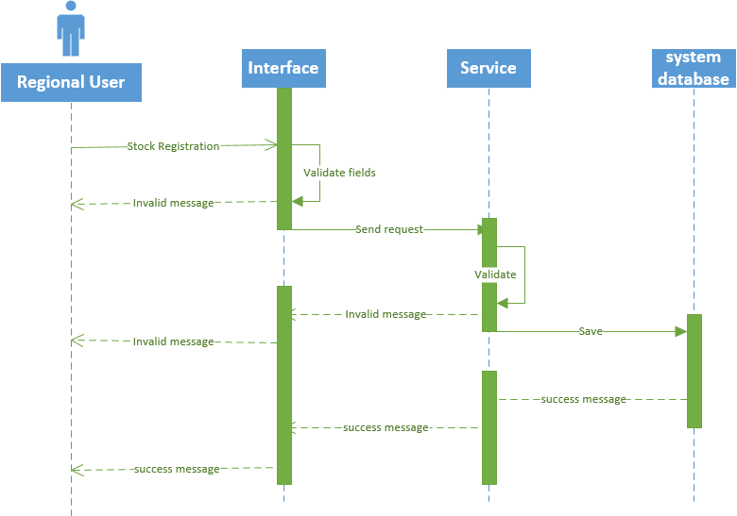

*Figure 43stock registration sequence diagram*

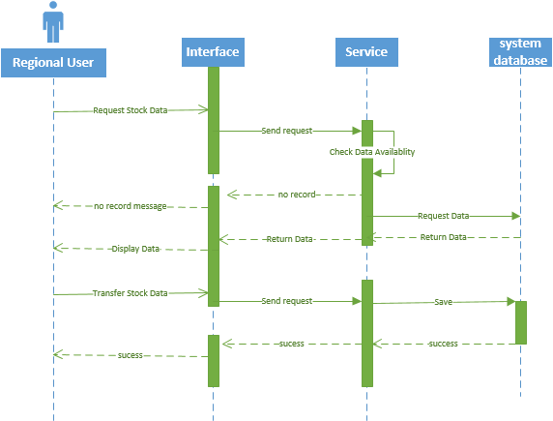

*Figure 44 stock data sequence diagram*



**2024**



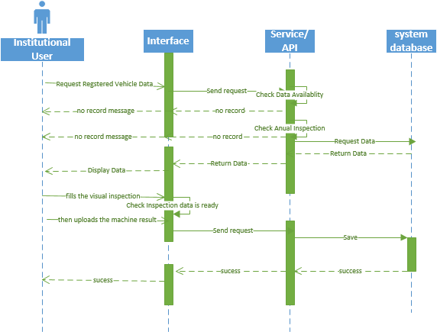

*Figure 45 inspection organization sequence diagram*

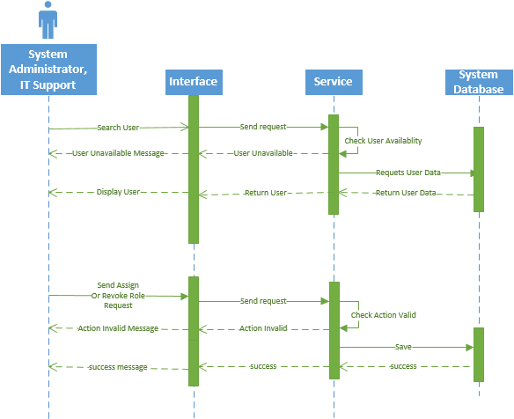

*Figure 46user registration sequence diagram*

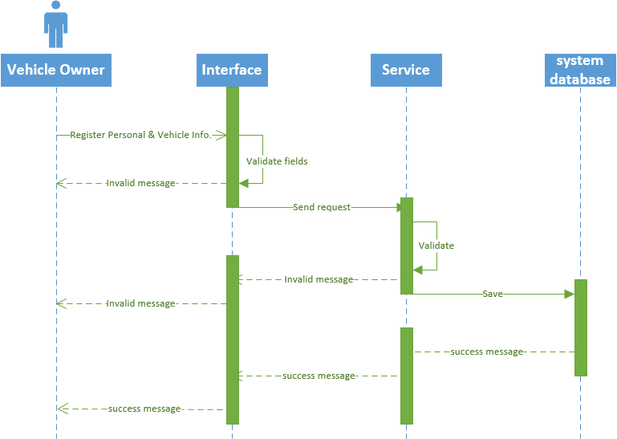

*Figure 47register vehicle information sequence diagram*

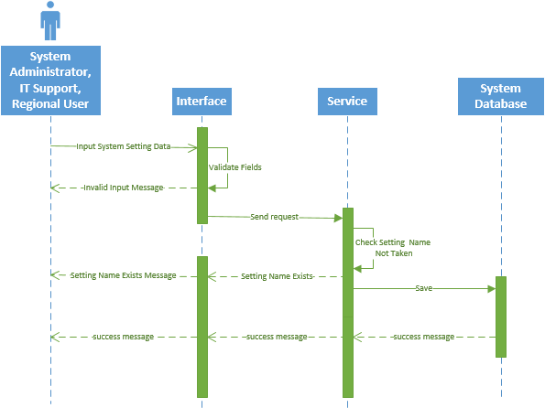

*Figure 48system setting sequence diagram*

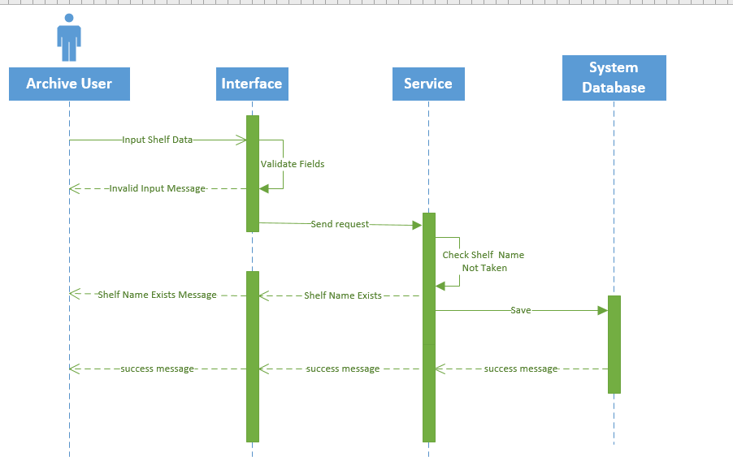

**2024**

*Figure 49shelf data sequence diagram*



**2024**



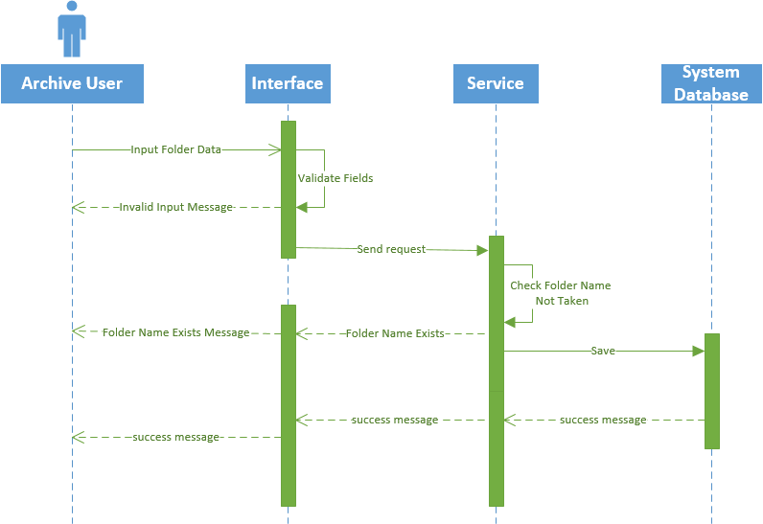

*Figure 50 folder registration sequence diagram*

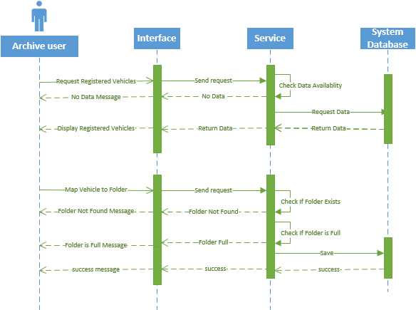

*Figure 51map vehicle sequence diagram*

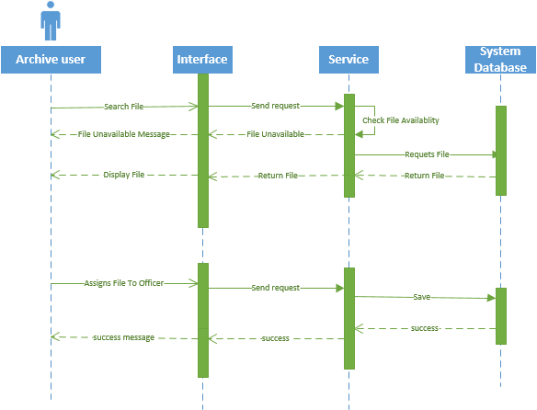

*Figure 52 find file sequence diagram*



**2024**



7. Project Risk and Mitigation Strategies General Statement

TMS as a software development and implementation project has a much more reduced risk compared with most similar projects.

Development of a new version of existing operational systems generally has a much lower risk than development of the first version of a system. It should however be noted that the new system will be using a radically different set of technology than the ones we currently have. In that respect, there will be a slight and very manageable risk associated with employing a new technology.

The risk in the implementation aspect of the project is also reduced due to combined experience of the joint venture in implementation and operation of MIS for water services. However, because of the sensitivity of the implementation work to external factors such as infrastructure and human resource capacities of the services and security situations around the location of the services, the implementation work has a more elevated risk compared with the software development work which is performed mainly at the office of the joint venture.

Detailed Risk and Mitigation

|  |  |  |
| --- | --- | --- |
| Risk | Description | Mitigation |
| Bad Scheduling (Timing) | The project performance might be affected by delays such as   * delivery of hardware * arranging important meetings * unforeseen technical difficulties | We will apply agile methodologies, ensure the maximum involvement of all team members in planning and estimating, receive feedback at all stages, starting from the earliest ones And involve all stakeholders. |
| We will also be able to temporarily increase our staff size to compensate for any delay. It has to be noted that we believe the project 9 month time has sufficient allowance for absorbing Delays in some activities. |
| Unexpected Eternal Risks | Unpredictability is another enemy that can be encountered while running a digital project. External risks in software development are not so rare as to exclude them from the general list, because it is impossible to be immune to:   * Sudden market changes (Inflation); * Security Issues | The risk from sudden unexpected external risk such as deterioration of the security situation is mitigated by using cloud storage of all our work products including source code and Documentations. |
| This allows us to preserve our work and even continue working remotely even in Cases we lose access to our office. |
| Moreover, we will give technical support To the services to properly backup their data and avoid accidental data losses. |
| Inaccurate | Though estimations are an often- | To mitigate this risk, we will take the following measures   * Elaborate only the work that has immediate priority; |
| Estimation | unavoidable part of software |
|  | development (because of the |
|  | pressure from customers or other |

|  |  |  |  |
| --- | --- | --- | --- |
|  | stakeholders to obtain a price or |  |  |
|  | timeframe), they can create risk if the estimations create expectations that can’t be met.  Inaccurate estimations occur when the length of a project, milestone or iteration is underestimated by the project group. Software estimations can cause problems that can lead to increase project timeframes, and therefore also project expenses.  From our own experience, and the experience of external projects done by our partners, this particular risk has been identified as very likely to occur, and cause severe impact  to project delivery if it does. | * Include Tech Spikes in your estimations (i.e. an allocation of time for developers to research and de-risk a particularly complex or unfamiliar part of the project); * Add an allocation factor to the estimation (i.e. a calculated time factor that a development team spends during the work week on task outside of the project); and * Consider the Cone of Uncertainty when estimating. | |
| Scope Variation | Scope variations occur when the scope of an iteration changes after a timeframe had been agreed upon. Due to the value from receiving frequent customer feedback, stakeholders or product owners will often ask to vary the scope of a project.  However, scope variation creates a severe risk to projects. When a scope varies, it significantly impacts the ability of the developers to stick to the original timeline of a project. | To mitigate this risk, we will take the following measures   * Short, manageable iterations (or using the Agile methodology) allow for more frequent opportunities to reflect upon and vary the project scope; and * Elaboration of only prioritized work. | |

|  |  |  |
| --- | --- | --- |
| Risk | Description | Mitigation |
|  | From our experience, using a variation metric to measure the scope changes, allows for greater visibility to the customer of how the requests have impacted the project. |  |
| End-User Engagement | This risk is where a product is released to the client but the users are resistant to change, or there is conflict between users.  Why is user engagement important? Ensuring that the users of a product will actually adopt the software will directly link to its success. | To mitigate this risk, we will take the following measures:   * User testing and surveys; * Focus groups; * Frequent releases; and * Beta testing.   These mitigation strategies are far easier to apply using the agile development methodology we will follow.  The chance of poor end-user engagement is far more likely for projects following a waterfall methodology. This is because these types of projects are unable to adapt to end-user feedback during development. The nature of waterfall development requires no scope variations. |



**2024**



|  |  |  |
| --- | --- | --- |
| Stockholders Expectations | Though we have talked about managing stakeholder expectations as a mitigation strategy, the uptake of this strategy can in itself become a project risk.  So, what is a stakeholder in Software development?  Stakeholders are any person or | To mitigate this risk, we will take the following measures:   * Effective communication; * Obtain frequent approval and acknowledgment of important decisions from relevant stakeholders; |
|  | group who can either impact, or | * Involve stakeholders in important meetings; and * Ensure stakeholders maintain reasonable response lines for communication with development teams. |
| will be impacted by an outcome of |
| the software project. The |
| stakeholder of this project are: |
| * The ministry of water and   energy |
| * The services |
| * The customers of the services |
| * The joint venture |
| It is this close relationship to the |
| project outcome that make |
| managing the expectations of each |
| of these stakeholders a challenge. |
| Inadequate Human Resource | Occasionally a stakeholder or development team member must leave a project unexpectedly. This can create a risk to the project, particularly if project knowledge is not adequately documented. | To mitigate this risk, we will take the following measures:   * Maintain up-to-date documentation; * On-board new or replacement stakeholders with a learning guide; and * Monitor the invoice schedule |
|  |  | and team utilization frequently. |

*Table 34 risk management*



**2024**



References

(n.d.). *Oromia Transport Agency* [Interview *Oromia Transport Agency* ]. (n.d.). *TMS system* [Review of *TMS system*]. DAFTech social ict solution.

*The Use Case Model - UML Tutorial | Sparx Systems*. (n.d.). Sparxsystems.com. [https://sparxsystems.com/resources/tutorials/uml/use-case-](https://sparxsystems.com/resources/tutorials/uml/use-case-model.html#%3A~%3Atext%3DA%20Use%20Case%20Model%20describes) [model.html#:~:text=A%20Use%20Case%20Model%20describes](https://sparxsystems.com/resources/tutorials/uml/use-case-model.html#%3A~%3Atext%3DA%20Use%20Case%20Model%20describes)

# *Use case modeling*. (n.d.). Www.cs.uct.ac.za. https://[www.cs.uct.ac.za/mit_notes/software/htmls/ch03s05.html](http://www.cs.uct.ac.za/mit_notes/software/htmls/ch03s05.html)

*Use-case diagrams*. (2020, September 25). Www.ibm.com. https://[www.ibm.com/docs/en/rational-soft-arch/9.7.0?topic=diagrams-use-](http://www.ibm.com/docs/en/rational-soft-arch/9.7.0?topic=diagrams-use-) case

*Sequence diagrams*. (n.d.). Www.ibm.com. <https://www.ibm.com/docs/en/rsas/7.5.0?topic=uml-sequence-diagrams>

(2024). *Requirement analysis document* [Review of *Requirement analysis document* ].

# TOP link.

(2024). In *Requirement Analysis document template*. INSA.



**2024**



Appendix A (Reports)

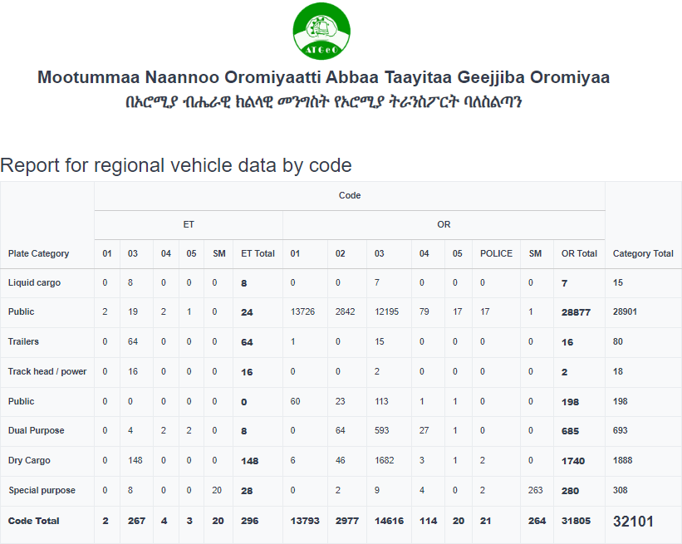

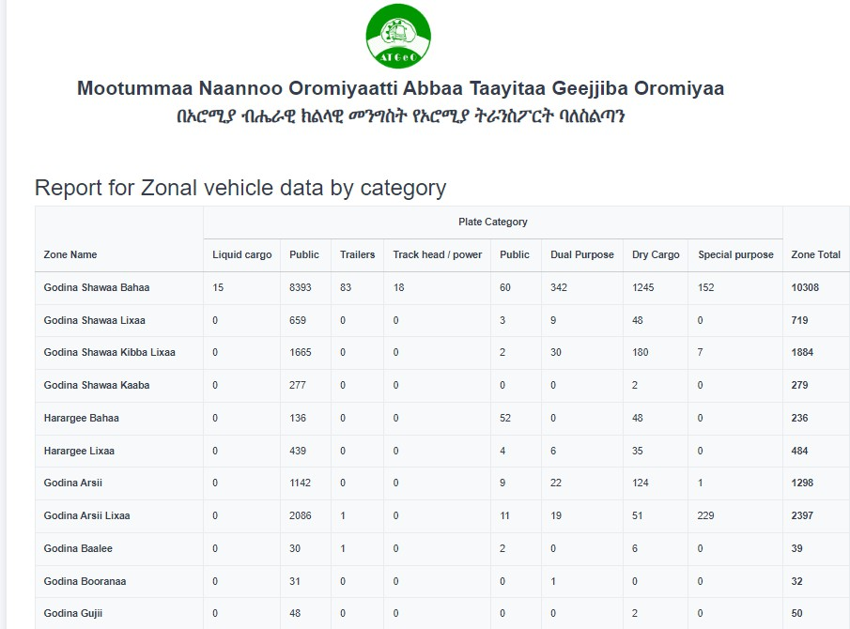

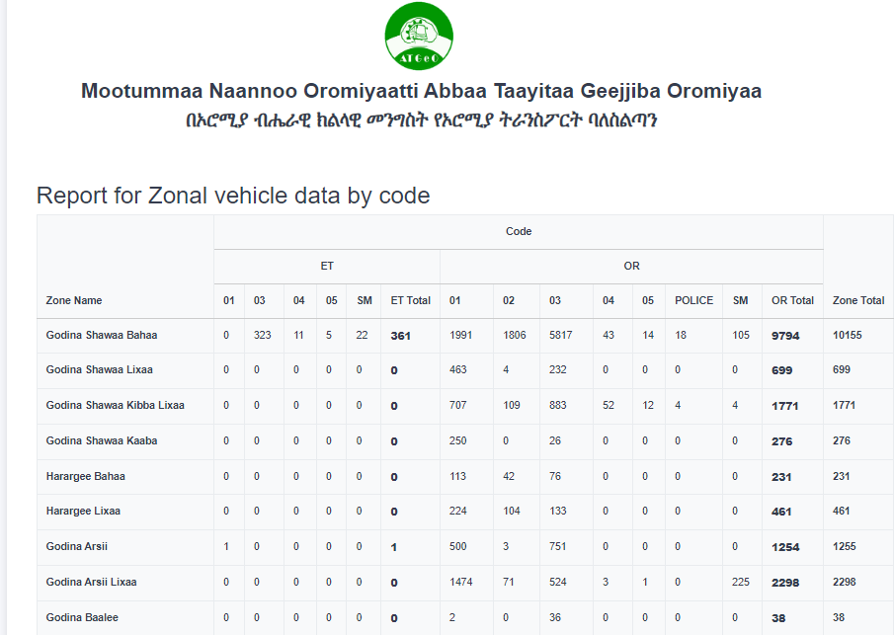

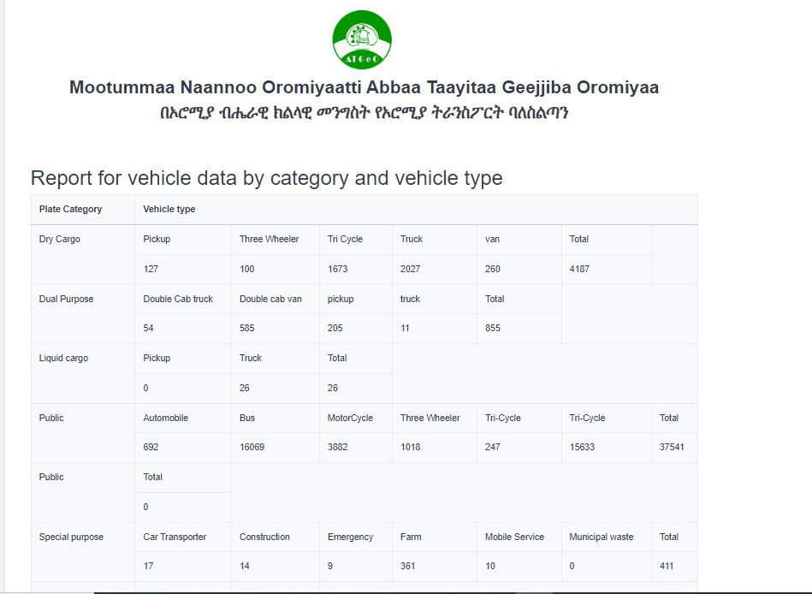

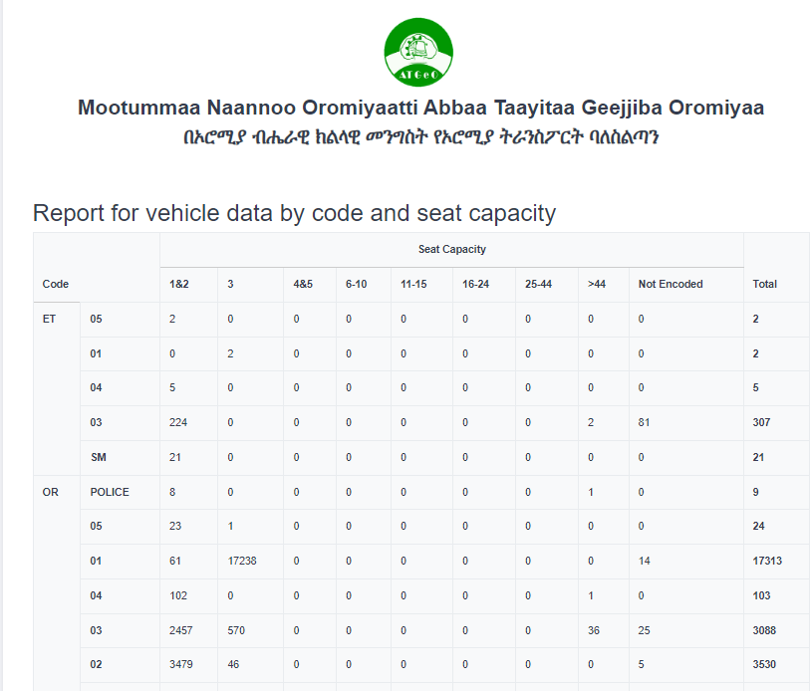

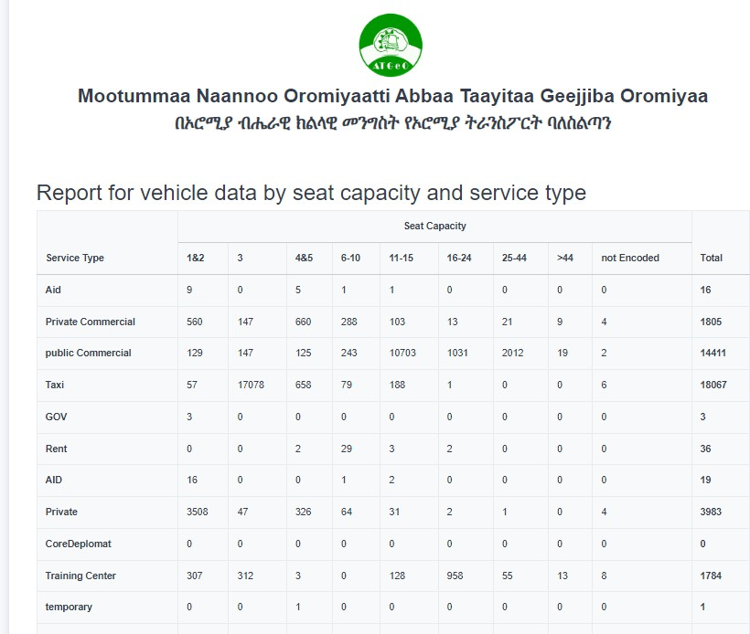

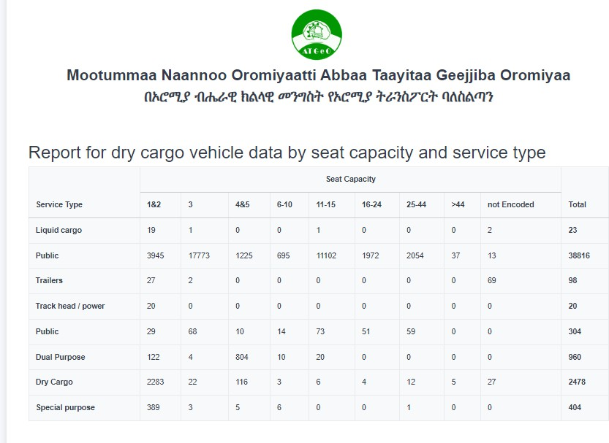

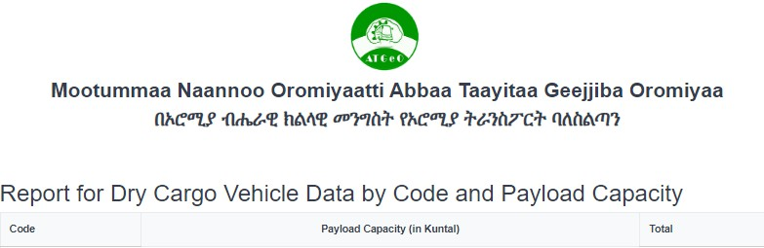



**2024**



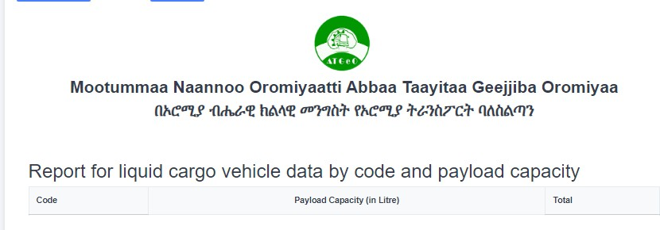

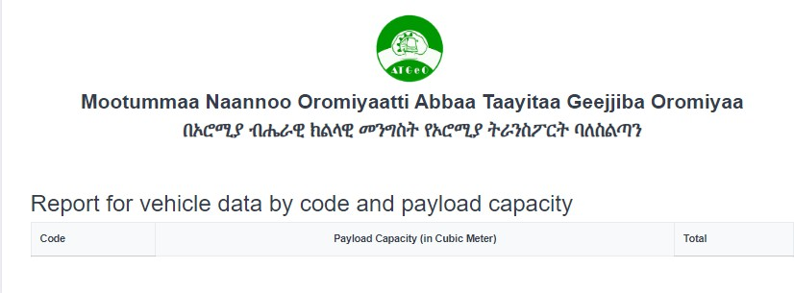

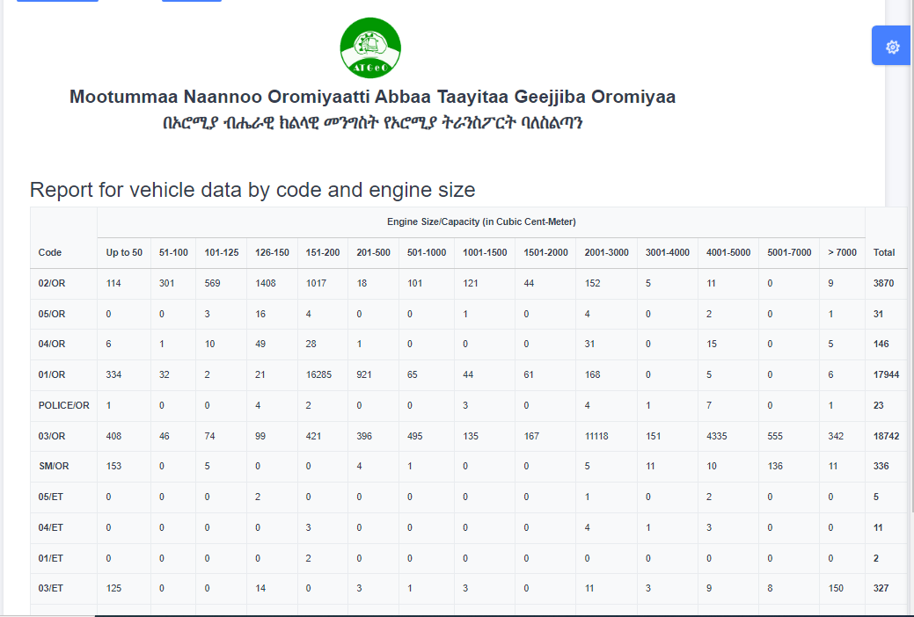

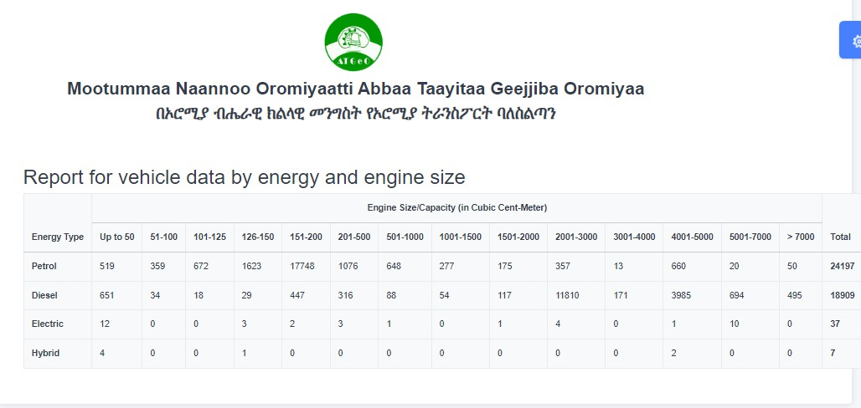

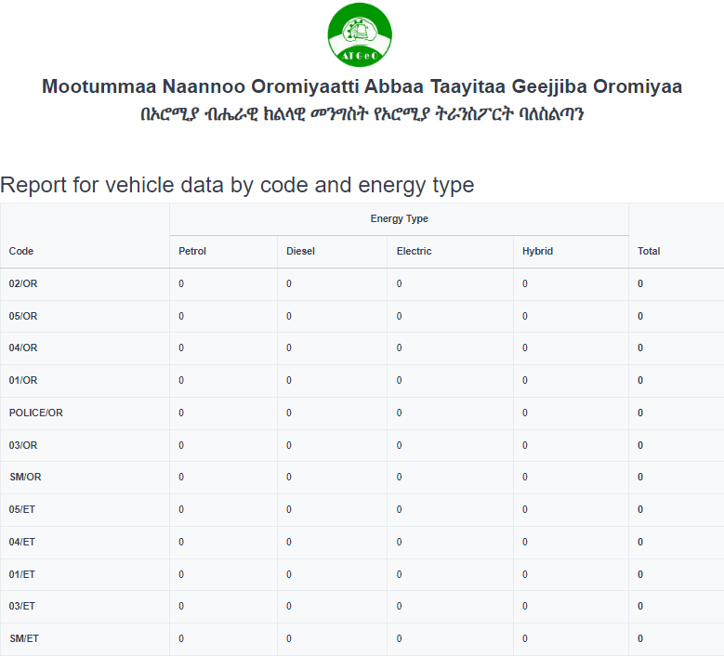



**2024**



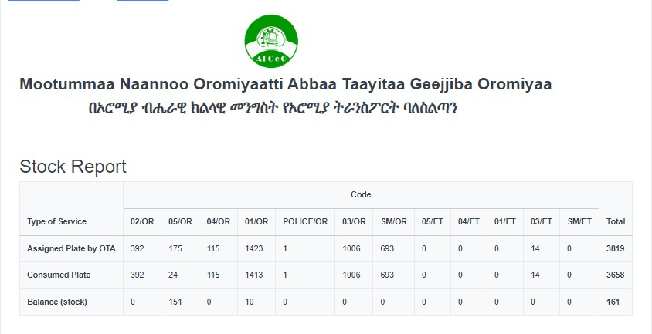

2

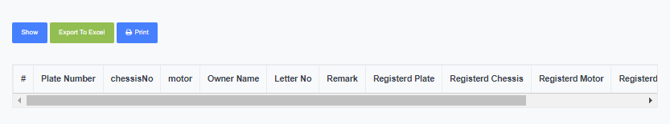

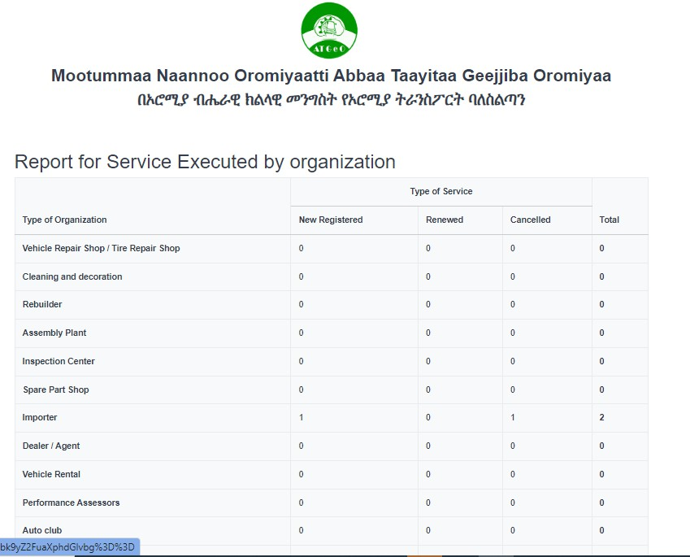

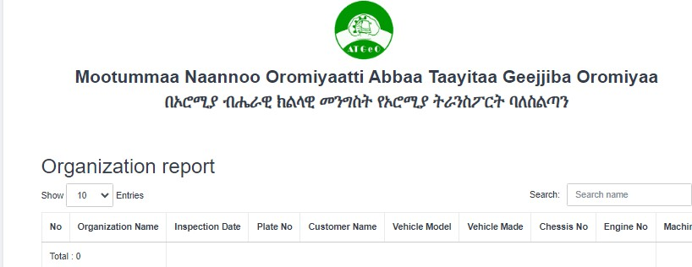

In addition to the above reports the system will generate

* Payment report by vehicle item type
* Report by plate given
* Report by AIS and ORC given
* Report by each service
* Report by evaluation of vehicle
* Report by annual Inspection vehicle
* Penalty report
* Debit credit report for VRMS
* Report Total payment by zone/city revenue collected
* Report Total payment as a region revenue collected.